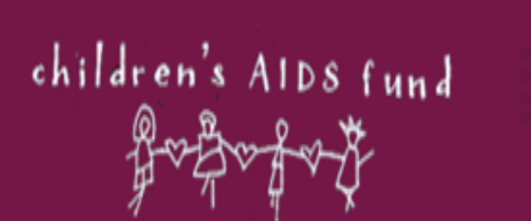

ANNUAL REPORT 2020
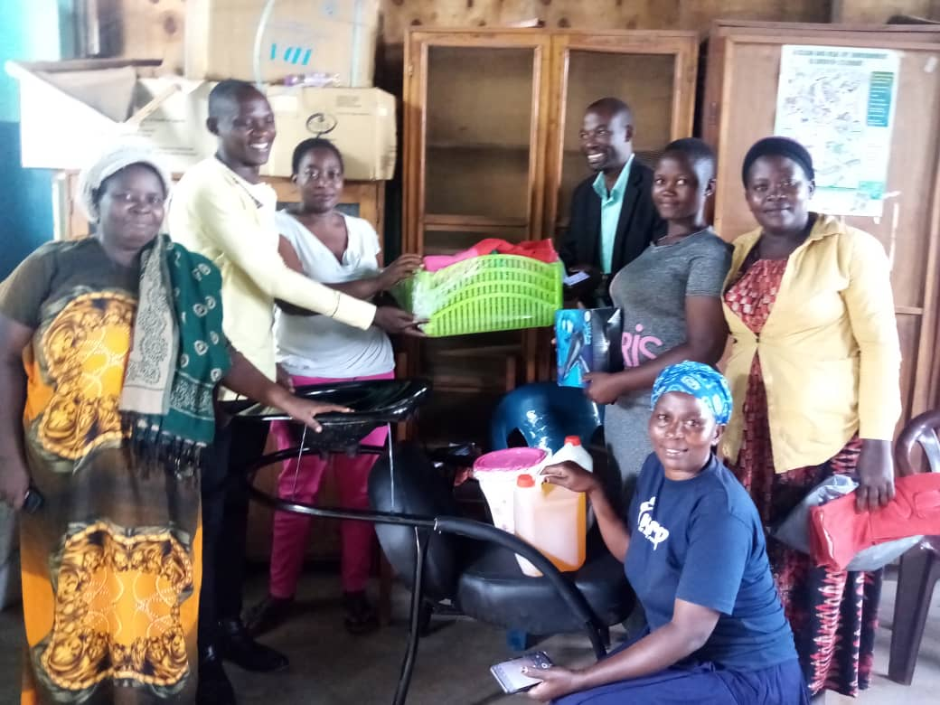 | 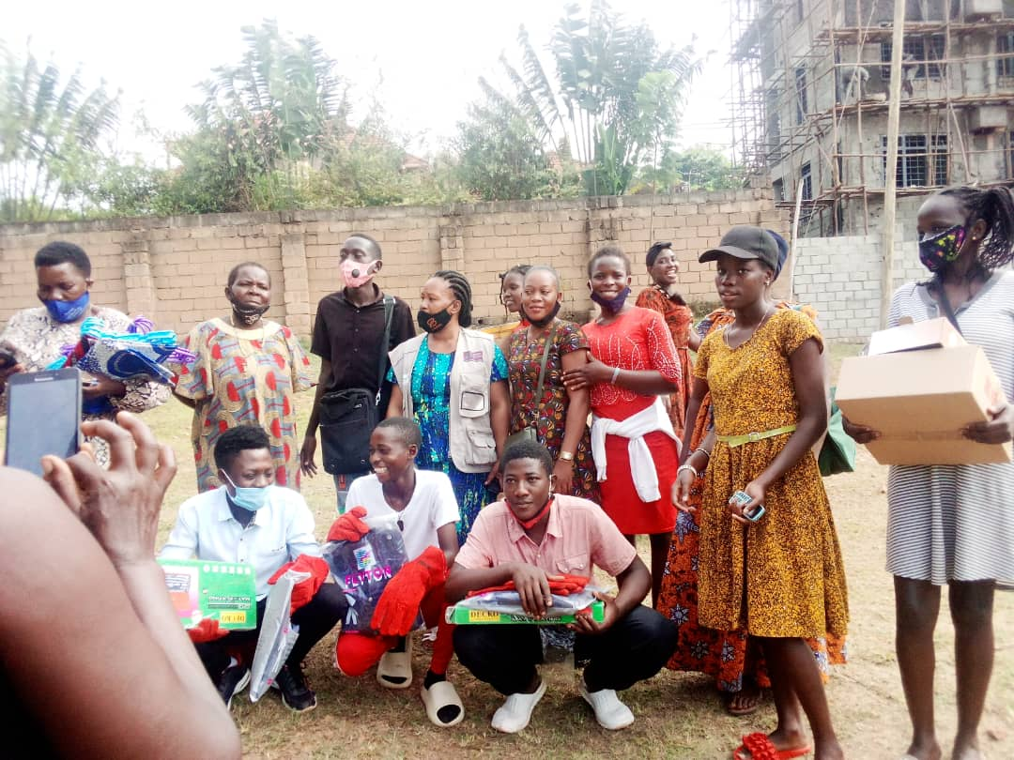

Contact Information:
Dr. Jackson Bitarabeho
Executive Director
jbitarabeho@cafu.ug
+256759758983

OCTOBER 2020

Table of Contents
ACRONYMS 3
EXECUTIVE SUMMARY 4
1.0 INTRODUCTION 6
2.0 PERFORMANCE ACHIEVEMENT OVER THE REPORTING PERIOD 7
2.1 HIV TESTING SERVICES 7
2.1.2 HTC among the Key population and priority population 8
2.2. CARE AND TREATMENT 9
2.2.2 USAID/UPMB/LSDA project. 11
2.2.3 SUFA-SABA Project 11
2.2.4 Nutrition for PLHIV 12
2.3 PSYCHO SOCIAL SUPPORT (OVC PROGRAMING) 12
2.4 FINANCES AND ADMINISTRATION 14
3. CHALLENGES & PROPOSED ACTIONS 15
3.1 Contextual 15
3.2 Strategic/programmatic 15
3.3 Operational 15
4. LESSONS 16
4.1 Use of community structures 16
4.2 Community referral systems for GBV, OVC 16
4.3 Collaboration and learning 16
4.4 Performance improvement and adaptation 16
5.0 SUPPORT AND ADMINITRATIVE ISSUES 16
5.1 Governance &Management (Events such as, meetings campaigns and inaugurations) 16
5.2 HR contracts and situation, -expiry, canceled in progress 16
5.3 Monitoring and Evaluation 17
5.4 Capacity building 17
5.4.1 Trainings 17
5.4.2 Laboratory systems strengthening 17
6. PLANNED INTERVENTIONS/RECOMMENDATIONS FOR NEXT YEAR 2021. 18
7. SUMMARY OF FINANCIAL REPORT 19

ACRONYMS

AIDS | Acquired Immune Deficiency Syndrome
AMS | Alive Medical Services
ART | Anti-Retroviral Therapy
BMC | Bushenyi Medical Centre
CAF | Children’s AIDS Fund
CAF I | Children’s AIDS Fund International
CAFU | Children’s AIDS Fund Uganda
CDC | Centers for Diseases Control and Prevention
FHCJ | Family Hope center Jinja
FHCK | Family Hope Center Kampala
HIV | Human Immune deficiency Virus
IDI | Infectious Disease Institute
IHFs | Indigenous Health Facilities
KCRC | Kabwohe Clinical Research Center
KHP | Kampala Regional HIV Project
NA | Nurture Africa
NESHU | National Expansion for Sustainable HIV/TB services in Uganda
NFSC | Namugongo Fund for Special children
NGO | Non-Government Organisation
OVC | Orphans and Vulnerable Children
PAFC | Positive Action Fund for Children
PEPFAR | President’s Emergency Plan for AIDS Relief
PMTCT | Prevention of Mother to Child Transmission
RHITES-EC | Regional Health Integration to Enhance Services East Central
SP | Strategic Plan
SUFA SABA | Support the Family and Save the Baby (SUFA-SABA)
TASO | The AIDS Support Organisation
TB | Tuberculosis
US | United States
USAID | United States Agency for International Development
UGX | Uganda Shillings
ViiV | ViiV Health Care

EXECUTIVE SUMMARY
This report provides the annual progress, achievements challenges, lessons and best practices for the year 2020.
In the reporting period, CAFU received and utilized grant funds from the IDI-KHP Project implemented at FHCK, and NFSC and OVC activities in Kampala and Wakiso Districts; USAID/RHITES-EC Project at FHCJ, USAID/UPMB/LSDA project at FHCJ and Positive Action for Children Fund (PAFC)/ViiV Health Care grant for the SUFA-SABA project supporting PMTCT and EID services in Buvuma Island district. Below were the key achievements and progress over the reporting period: -
USAID/RHITES-EC funded by USAID through URC
Over the reporting period, HIV prevention for the pre-exposure prophylaxis, an achievement of 70% for new clients and 119% for total clients under preventive therapy were registered. However, HIV positivity rate was lower at 46% compared to the overall HTC target while 29% of the total clients were new clients and started on Anti-retroviral treatment. Community based testing and access to the facility (FHCJ) was greatly impacted by the COVID-19 lockdown. Despite all above factors, the clinic was able to surpass the targeted retention of clients on ART by 5% (4003 clients in care against a target of 3804). This increment was attributed to the adoption of novel strategies such as community Client led ART delivery (CCLAD) and boda-boda riders transporting medicines to clients in their communities. Overall, the viral load suppression rate and the ultimate treatment success indicator was at 83% below the expected 90%.
KEY HIGHHLGHTS OVER THE REPORTING PERIOD
Average HTS was at 96% above the COP target of 90%
Positivity rate 46%
Viral suppression 86%
Average Client retention under care 97% above COP targets
- Elimination of mother to child transmission was a key highlight of the year at 99% with No positive PCR at the age 18 months.
- 9735 OVC beneficiaries were identified and supported
- 138 mother-baby pairs of different age brackets were reached and assessed for EID eligibility
- 59 positive mothers delivered at health facilities and only 3 had home deliveries.
- 4 HIV positive women groups were economically supported and liberated

SUMMARY
USAID/UPMB/LSDA project targeted 4,275 clients in care at the end of the funding period. About 5,205 clients were tested for viral load with at least 90% virally suppressed. However, funding was received late and no significant grant expenditures were possible in this period.
IDI-KHP project:
Overall, the project achieved 76 % of the COP target for HTS from both NFSC and FHCK with 19% positive yield. Avaeragely,96% of clients were enrolled and maintained under care from both facilities. The viral suppression was at 85% below the 90%. Overall HIV testing, New HIV positive clients identified and enrolled on care and viral suppression were low, attributed to the COVID-19 challenges. Notably, the retention in care was high (98% at NFSC and 94% at FHCK boosted by using novel strategies such as Community Client led ART delivery (CCLAD) and boda-boda riders transporting medicines to clients in their communities.
A total of 1587 households were reached from Kampala and Wakiso for OVC; and about 9735 OVC beneficiaries were served with food supplements especially those between 0-5 years, sanitary pads for the girls between 10-17 years and business skills development such as SINOVUYO positive parenting skills training, backyard garden training and delivering lesson instructions and revision materials for the scholars stuck at home due to COVID. However, there was some remarkable improvement in household incomes through savings and cohesion between the caretakers and OVC. About 1768 OVC who tested positive were linked to care and treatment with an average viral load suppression rate of 86%.

“Support the Family and Save the Baby (SUFA SABA) Project
The Project was targeting HIV positive pregnant and breast-feeding mothers and their babies to improve access to and utilization of HIV care and support services for better health outcomes. Over the reporting period, a total of 138 mother-baby pairs of different age brackets (17-19,20-24, and 25 years and above) were reached and those eligible for follow up were enrolled for EID. About 62 HIV pregnant mothers were reached and supported for facility fertility with 59 mothers delivering at health facilities and only 3 had home deliveries.
Also 4 HIV positive women groups were earmarked for Economic empowerment could only be oriented on business skills and financial literacy to manage their business after partial re-opening of the country.
Finances and administration
In the period under review, CAFU utilized grant funds from the IDI-KHP Project being implemented at FHCK, and NFSC and OVC activities in Kampala Districts, USAID/RHITES-EC Project at FHCJ, USAID/UPMB/LSDA project at FHCJ and Positive Action for Children Fund (PAFC)/ViiV Health Care grant for the SUFA-SABA project supporting PMTCT and EID services in Buvuma Island district. Below are detailed activities for each of the projects over the Audit period. The total income received during the year was UGX 3,031,628,558 (2019: Ushs3,983,634,391) and the expenditure incurred amounted to UGX 3,424,311,538 (2019: UGX 3,375,738,999) resulting in a deficit for the year of UGX 392,682,980 (2019: Surplus of UGX 607,895,392).
Implementation was generally challenged by COVID-19 restrictions and some funds could not be released thereby hampering travel logistics and causing social-economic instability coupled with preparations for political campaigns in readiness for general elections in January 2021.
Despite all the challenges and bottlenecks, CAFU was still on the right trajectory and adopted novel strategies which assisted in maintaining the clients on care with full scale functionality of the health facilities and competent staff.

1.0 INTRODUCTION

Children’s AIDS Fund Uganda (CAFU) was established in 2002 and formally registered in 2005 with the Uganda National NGO Board registration number S.5914/5933 and now registered with the NGO Bureau Number INDR59333085NB. In 2019, CAFU adopted a new strategic plan with a revised Vision as” A healthy and productive HIV free population” and the revised Mission “To create an enabling environment for families to access comprehensive integrated HIV and priority health services through promotion of sustainable development approaches for a healthy and productive population in Uganda and beyond.”

The strategic plan 2019/2020-2023/2024 has five interactive goals that are essential for the achievement of the CAFU mission and vision;

- Strengthening Institutional Capacity for CAFU to achieve its mission and ensure Quality of Services
- Improved access to HIV/AIDS and healthcare services for infected and affected individuals, families, and communities through family centered approaches
- To establish and strengthen operational research capacity for continuous quality improvement for health service delivery
- To provide skills and capacity development for other organizations in similar business based on lessons learnt and changing service delivery environments
- To provide integrated and sustainable health services including improving livelihoods among households

Although CAFU envisions expansion and transition of the strategic goals into program areas ,. The advent of COVID has interrupted some of the efforts. However, deliberate efforts will continue to be made to expand the scope of the current HIV/AIDS programs, integrate HIV/AIDS with other programs (e.g. nutrition, ASRH, and child and maternal health), operational research as well as gradually and steadily addressing the challenging socio-economic components. This report is guided by the funded projects and reflects project achievements against set targets.

CAFU employed both the facility and community-based models to provide HIV Prevention and Treatment as well as OVC services through its 3 facilities; Family Hope Centre Kampala (FHCK), Family Hope Centre Jinja (FHCJ) and Namugongo Fund for Special Children (NFSC) in Wakiso. The community-based arm was greatly impeded by the COVID 19 pandemic.

Despite the pandemic, CAFU registered 100% patient Retention in care and treatment under all the age bands adults, adolescents and key populations. Elimination of mother to child transmission was a key highlight of the year at 99% with No positive PCR at the age 18 months of graduation. However OVC activities were muted under
Covid 19 lock down restricting community services.
Nonetheless, innovations including bike riders that provided medicines to patients at home and client follow up electronically with call reminders ensured continued care.

PERFORMANCE ACHIEVEMENT OVER THE REPORTING PERIOD
The annual achievements are outlined below under thematic interventions areas of HIV and AIDS prevention, care and treatment, psycho social support through the OVC and health systems (laboratory and supply chain management).

2.1 HIV TESTING SERVICES
The overall HTS performance was slightly below the COP targets by 4 % as a result of the COVID 19 pandemic that greatly affected the community-based care model. The result reflect mainly facility based interventions and outreach services that reached KPs and PPs were largely not conducted. The graph below illustrates the HTS performance by age categories and the yield among the communities.
Figure 1
HIV was more prevalent among the adults over the reporting period (Figure 1). It was likely that the onset of covid 19 triggered the diagnostic testing among the adult category and the positive yield was higher in the January –March quarter. There were fluctuations in the HTS performance during the different quarters, the same occurred in the service facilities. For instance, there was HTS performance improvement at FHCK by 7.2% in January –march quarter 2020 compared to the previous trends, while more than 9.4% in FHCJ and a sharp decline in the subsequent quarter FHCK. About 335 new clients on Prophylactic treatment for HIV prevention in the project areas
The challenge of repeat testers at the outreaches remains. However, facilities would continue to sensitize personnel in the outreach facilities on targeted testing to reduce repeat testers. Annual linkage to care of (114 out of 144) was achieved by the end of September 2020. The 21% non-linked to care was due to non- disclosure of those already on ART, not ready to start treatment coupled with non-existent client contacts in our records that hinder follow ups.

2.1.2 HTC among the Key population and priority population
During the project year, CAFU tested 718 and identified 59 positives giving a very low positive yield of 0.01%. Despite the insignificant yield, 71.2 % of the positive yield were linked to care as indicated by the table 1. Demand for STI drugs, PrEp and Cervical Cancer screening as a condition to accept HIV testing among the KPs and PPs has remained a significant challenge

Quarter | HTC_TST | HTC_TST POS | Known Entry Positive | Newly identified Positives | HTC_TST Negative | Linked to HIV treatment
Jan-Mar 20 | 79 | 12 | 2 | 10 | 67 | 10
Apr-June 20 | 2 | 2 | 0 | 2 | 0 | 2
July-Sept 20 | 523 | 40 | 4 | 36 | 483 | 20
Oct –Dec | 718 | 67 | 8 | 49 | 651 | 42
Total | 1322 | 121 | 14 | 97 | 1201 | 42
Figure 2: HTC services among the key population in the project area
While HIV prevalence was significant among the key population reached, there was negligible prevalence rate among the priority population reached in the year 2020. Nonetheless, CAFU would still integrate peer programs, life planning skills, client empowerment involving identifying and training PLHIV KPs to support newly identified positives to enroll for care and treatment in the health facilities. Continued treatment of STIs and gave basic information about the STIs among FSWs. Three promising practices individual client support, participatory KP groups and targeted treatment of STIs were identified for reaching the KPs. At NFSC there were similar contributions of HTS performance for both community and Facility while FHCK Facility remains the principle model of HTS and in the remaining period targeted HTS for priority groups will be strengthened.

2.2. CARE AND TREATMENT
In care and treatment, despite a slight downward trend of active clients from quarter two to end of quarter four, the average cumulative total on treatment was 90% corresponding to the COP 19 target. There was a likelihood of surpassing the target had it not been the 42 days of total lockdown which led to a rise in missed appointments. Notably, 100 % of the new positive cases were retained in care.
By the end of 4th quarter COP19, the cumulative ever enrolled at FHCK had increased from 5101 in the previous quarter to 5132. About 63% of the newly identified HIV positives at FHCK in the last quarter of the project year were started and retained on ART. By the end of September, FHCK had achieved 84% of the COP 19 Txcurr annual target while NFSC was at 90%, as indicated by the graph

Figure 3: FHCK annual ART performance against the target
These achievements were possible due to modified drug deliveries to elderly, children and distant clients through the community peers and bike riders to mitigate COVID-19. Where possible, clients were linked the nearest health facilities of choice and while pre calling clients for drug refills and scheduled clinic appointments worked well for the facility clients, However., this measure negatively impacted on the Viral load monitoring due to failure of taking timely blood samples.
Graph 2.3.1 Viral suppression among the OVC

The graph shows the trend in viral suppression during the reporting year. There was a marked decline during the April- June quarter as covid 19 pandemic was at its peak and very difficult to instantly align with the restrictions and guidelines. However, it remained more or less consistent thereafter.

2.2.2 USAID/UPMB/LSDA project.
On ART were 542 (87%) individuals on the target 542 of whom 19 (21%) individuals were new on ART on the target of 141. For PMTCT 3 (16%) women on the target of 19 were on ART for PMTCT.

2.2.3 SUFA-SABA Project
This was a two year’s project with the aim of improving access to and utilization of HIV care and support services for better health outcomes. The project was implemented in Buvuma islands targeting HIV positive pregnant and breast-feeding mothers and their babies. CAFU worked with and through the district local government systems to engage community structures for planned interventions.
The EID services were scaled up through tracing and identification of exposed Infants, their follow up and retention in care up to 18 months while HIV positive pregnant women were followed up to complete the recommended 4 ANC visits. A total of 138 mother-baby pairs were reached and the eligible ones were enrolled and monitored for EID. The mother pairs were categorized in various age ranges of 17 years and 19 years, 20 years to 24 years, above 25 years comprising 7 mothers, 32 mothers and 99 mothers respectively.
62 HIV pregnant mothers were reached and supported and 59 mothers delivered at health facilities and only 3 had home deliveries. All the HIV Exposed infants (HEIs) were started on Nevirapine syrup and followed up to complete the EID cascade.
Key drivers/approaches/lessons developed by SUFA SABA project
Key SUFA SABA Approaches used
- All-inclusive stakeholders’ engagement
- Strong Health worker –client relationship
- Community ‘financial empowerment
- Community led interventions and ownership
- Health and financial literacy

SUFA SABA IMPACT
Total Social –Economic Transformation

2.2.4 Nutrition for PLHIV
During the reporting period, only 2724 clients were assessed for nutrition out of the total 4333 as many clients were getting their refills through courier services because of high transports cots due to COVID 19 lock down. However, they were being encouraged to resume attending in person to receive this service.
According to DHIS2/HMIS 106a,2724 clients were assessed for nutrition status and only one HIV positive client received nutrition supplementary /therapeutic feeds during the reporting year.

2.3 PSYCHO SOCIAL SUPPORT (OVC PROGRAMING)
The OVC program was implemented in Kawempe, Makindye and Nakawa in Kampala city and Kyengera, Busukuma, Gombe and Namayumba in Wakiso. Overall, a total of 1587 households were reached from Kampala and Wakiso during the implementation year. About 6735 OVC beneficiaries were served with food supplements especially those between 0-5 years, sanitary pads for the girls between 10-17 years and business skills development such as SINOVUYO positive parenting, skills training, apprenticeship, income generating activities, backyard garden training; and delivering lesson instructions and revision materials for the scholars stuck at home due to COVID.

Graph showing OVC services during the year

The trainings offered to the OVC and caretakers resulted into improving household incomes through savings, strengthening cohesion between the caretakers and OVC; and generally improved quality of life. 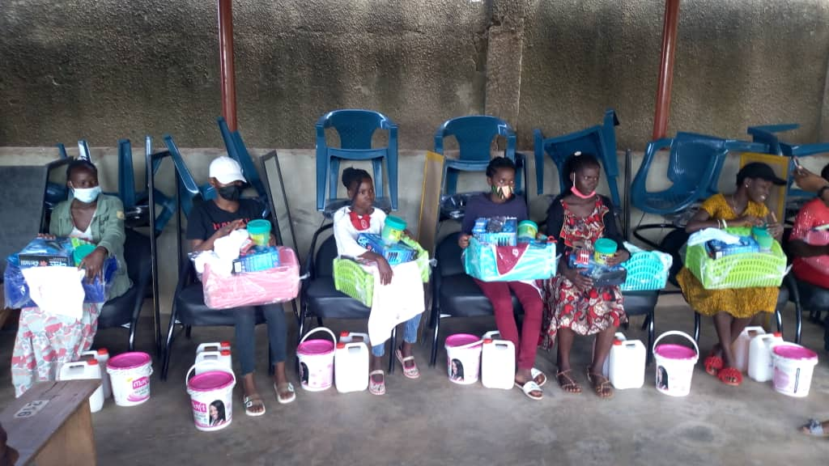
The youth (OVC) in Kawempe receives startup capital
About 1768 OVC were linked to care and treatment with an average viral load suppression rate of 86% as reflected by the graph below
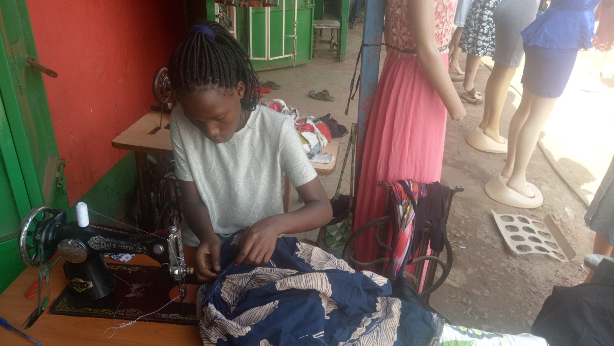
During the project year, the OVC program contributed to better quality of life of the clients. For instance, during the reporting period, 36 VSLA groups with a total of 1229 members of whom 706 members had individual income generating activities (IGA)

The Overall Average Savings per members was UGX 137,500 down from UGX 221,090 in the previous quarter resulting from irregular savings by members over the COVID-19 lockdown. While some members’ incomes had reduced others were unable to save for fear of contracting COVID-19 through travel and group gatherings. Some members with established IGAs temporarily closed them due to limited markets and supplies. Below are some of the experiences and testimonies on the key interventions during the lockdown
Story 2: Apprenticeship
Over the reporting period, 39 youth were identified and assessed for apprenticeship and placement form Gombe, Kyengera, Kawempe and Busukuma divisions were verified. However, COVID-19 has negatively impacted on placements where identified vocational, institutions and artisans’ business were still closed including hair dressing saloons. CAFU has identified Individual Artisans who shall train few selected Apprentices.
Testimony 1: Child with unsuppressed viral load
A 15 years old girl in boarding school had refused to disclose her status to the school authority in fear of the stigma from fellow students. she was inconsistent in taking medication and thus unsuppressed viral load. During the CAFU follow up visit and dialogue, she confessed to the field officers and appreciated the need for regular taking of medicine. She was consequently referred to Nabutiti health Centre III during the lockdown for intensive adherence, counseling and monitoring. She is currently living positely and happily

The OVC program was as well challenged in the following ways: -
- Some HIV Positive OVC had challenges accessing ART facilities for medicine refills during the lock down due no means of transport. Some of these were linked to VHTs to assist pick their refills.
- Many OVC households had no income to provide basic needs for the OVC with the number of meals reduced from two to one a day, and many households had no food which affected adherence to ART.
- GBV and Child protection cases were found common in the households and some caregivers were generally stressed and very bitter about everything in their life
Other key drivers to improving the OVC quality of life and welfare included training of OVC caretakers in IGA; identified and supported households with soya as food supplement; apprenticeship, monitoring of regular school attendance; case conference within the reporting period

One caregiver lamented during the distribution of education script and exercise books as quoted”CAFU, do you think our children eat books, why didn’t you use the money for books to buy for them food, what will they gain from the home work on an empty stomach. Food first.”

2.4 FINANCES AND ADMINISTRATION
In the period under review, CAFU utilized grant funds from the IDI-KHP Project being implemented at FHCK, and NFSC and OVC activities in Kampala Districts, USAID/RHITES-EC Project at FHCJ, USAID/UPMB/LSDA project at FHCJ and Positive Action for Children Fund (PAFC)/ViiV Health Care grant for the SUFA-SABA project supporting PMTCT and EID services in Buvuma Island district. Below are detailed activities for each of the projects over the Audit period. The total income received during the year was UGX 3,031,628,558 (2019: Ushs3,983,634,391) and the expenditure incurred amounted to UGX 3,424,311,538 (2019: UGX 3,375,738,999) resulting in a deficit for the year of UGX 392,682,980 (2019: Surplus of UGX 607,895,392).

3. CHALLENGES & PROPOSED ACTIONS

3.1 Contextual
- Funds could not be released due both COVID-19 restrictions that were still in force affecting travels and logistics and social-economic instability due to political campaigns carried out in readiness for general elections in January 2021.
- Weak institutional capacity and funding constraints during this transition period, a limited set of non-HIV services will be implemented
- Continuous transition of OVC beneficiaries as required by donor has affected consistent services provision and follow-up of the beneficiaries to graduation level to track notable outcomes
Proposed actions: CAFU should seek for local partnership/collaboration and NO cost extension implementation to successfully finalize the ending projects but also transition/mainstream the OVC beneficiaries to ministry of Gender, Labour and Social development.

3.2 Strategic/programmatic
- COVID19 related limitations from 2020-2021 slowed down implementation of the project and a lot of time was lost during the lockdown period.
- The project struggled with other associated challenges Including economic setbacks, relocations, closure of business, education institutions closed of beneficiaries which all increase pressure and demands of beneficiaries.
- Prior to Covid-19 pandemic schools, churches and sub-county halls were used as free spaces for trainings and meetings but the closure of such places meant opting for open places which required hiring of tents for the participants.
Proposed action: CAFU should continue and advance the local innovations and adaptation to the local challenges. For instance, working with the local structures(community health workers and boda boda riders to deliver medicine for refills

3.3 Operational
- Support to Community HIV testing was hampered by the advent of COVID-19pandemic with associated lockdown while the Behavioral Change communication (BCC) intervention for school going children could not be implemented due to COVID-19 related school closures.
- COVID-19 prevented High level supportive supervision and negatively impacted on the C3 activities
- High material and financial expectations from stakeholders and beneficiaries posed a challenge to implementation progress.
- Some beneficiaries expected and demanded for handouts rather than knowledge and skills. This mind-set frustrated the process of work.
- Increased costs of project operation costs for example clustering beneficiaries in small groups as measure for COVID -19 SOPs adherence.
Increased mobility/ relocation of direct beneficiaries for example 24 HHs relocated in Entebbe without communication to the project team, this compromises the efforts made to families

4. LESSONS

4.1 Use of community structures
Using home visits and phone calls, social workers and counselors noted that inadequate food was a common issue among the OVC households over the lock down period.
Ability of the community structures to handle child protection cases the project registered increase in competence and commitment of community-based Volunteers to implement child care activities. Throughout the project period, volunteers have identified, managed and referred over 26 child protection and SGBV cases from the community with minimal CAFU involvement from identification to closure.

4.2 Community referral systems for GBV, OVC
Referrals were made to police and other child protection actors for appropriate services thus Improved Services and Support Systems:
Most importantly knowledge on where to seek legal assistance increased from 77.7% to 98.2% among the OVC Households members.

4.3 Collaboration and learning
Through collaboration with local leaders, some households received government food support although HH complained that it was not adequate to sustain the nutritional needs. However, caregivers in VSLA were encouraged to borrow from the VSLA welfare funds to supplement their food resources

4.4 Performance improvement and adaptation
The project successes were hinged on improving the performance of frontline workers and volunteers using simple and more cost effective system which could significantly impact house hold coverage and quality of OVC services.
Investment in community led services and initiatives will create jobs, increase educational access and expand the revolving cash grants for the beneficiaries.

SUPPORT AND ADMINITRATIVE ISSUES

5.1 Governance &Management (Events such as, meetings campaigns and inaugurations)
The board is the overall governance structure of CAFU and over the reporting period, the board held ----meetings and gave strategic direction on …………………………
Photo of the board meeting or event with key remarks

5.2 HR contracts and situation, -expiry, canceled in progress
Total professional capacity Number of employees, status of their contracts and projections in the coming year

5.3 Monitoring and Evaluation
The organizational framework for monitoring and evaluation of projects and programs
The existing of M&E system develop or the need to develop the system

5.4 Capacity building

5.4.1 Trainings
Workshop for the community health workers, field workers, caretakers, IGAs for OVC and caretakers

5.4.2 Laboratory systems strengthening

This section focused on two main streams of work: building strong laboratory system and supply chain management (Testing kits, slides, Reagents, cartridges and laboratory supplies Drugs (Medicines including all the required regimen of ART)
Equipment: CD4 Machine, Gene X-pert machine, strong hub system
Performance of the Laboratory systems -an extract of October –December 2020 quarter summarizing the Crag Screening test and treatment during the reporting period
Table: Proportion of Newly initiated clients on ART (TX_NEW) with a CD4 <200, offered a serum

Performance parameter | Name of the Facility |  | Remarks
 | FHCK | NFSC
# of PLHIV newly enrolled in Care (Care_New) in the quarter | 31 | 13
Number of newly enrolled (Care_New) patients offered baseline CD4 test | 26 | 10
% offered a baseline CD4 Test | 86 | 77
Number of Care_New patients with CD4 <200(Newly enrolled) | 10 | 4
# of new PLHIV with CD4 <200 who received CrAg screening test | 10 | 0
% screened with serum crag | 100 | 0
# of new PLHIV with CD4<200 and CrAg positive | 2 | 0
% Serum crag positive | 20 | 0
# of Serum CrAg positive PLHIV started on Fluconazole | 2 | 0
Number of Care_NEW patients with CD4 <200 started on ART | 9 | 4
# of PLHIV newly enrolled in Care (Care_New) in the quarter | 30 | 13

At FCK, 26 out of the 32 (81%) care new clients were offered baseline CD4 testing. 4 clients (13%) were started on ART from our new outreach clinics without requesting for the baseline CD4 samples in July and August. Of the two CrAg positive screened clients and offered fluconazole, one was admitted for further management before ARVs on the 15th of October 2020.
NFSC enrolled 13 clients on ART. Out of 13 clients, 10 clients were offered baseline CD4 test which contributed to 77%. 3 clients were not offered baseline CD4 due to lack of cartridges.
Key challenges for the laboratory system included delayed turnaround time for Gene-Xpert results, inadequate logistics like sputum containers, limited supply of cartridges hence affecting our baseline CD4 percentage

PLANNED INTERVENTIONS/RECOMMENDATIONS FOR NEXT YEAR 2021.
Despite the covid 19 interruption and other challenges, the reporting year 2020 recorded a number of achievements. The year 2021 is hoped to consolidate the gains in the year 2020 while focusing on the new strategic direction /plan of CAFU to implement/ scale up the lifesaving interventions. CAFU is hopeful of attracting new funding partnerships and opportunities to implement the strategic plan for 2019/2020 -2023/2024.the following interventions will be undertaken:
- Conduct project end line evaluation and organize a close out phase for the IDI Kampala project and compile the final report to the donor
- Draw and implement a vigorous resource mobilization plan to scale up interventions and implement the strategic plan
- Conduct operational research on the ongoing projects and inform policy at national and subnational level
- Negotiate and seek for renewal of the Buvuma project while implementing no cost extension.
- Re- activate the CAFU web site
- Continuously engage at national and international to develop strong partnerships and collaboration with other national actors with similar vision of CAFU
- Plan for mid -term review of CAFU strategic plan.

7. SUMMARY OF FINANCIAL REPORT

STATEMENT OF INCOME AND EXPENDITURE FOR THE YEAR ENDED 31 DECEMBER2020
 | Note | Actual  2020 | Budget  (Unaudited)  2020 | Variance | Actual  2019 | Budget  (Unaudited)  2019 | Variance
 |  | Ushs ‘000 | Ushs ‘000 | % | Ushs ‘000 | Ushs ‘000 | %
Income
Receipts and interest | 4 | 3,031,628 | 4,036,237 | (25) | 3,983,634 | 4,188,007 | (5)
Expenditures
Salaries and wages | 5 | 1,582,306 | 1,700,810 | (7) | 1,409,206 | 1,659,746 | (15)
Fringe benefits and allowances | 6 | 396,137 | 409,738 | (3) | 316,728 | 425,395 | (26)
Supplies | 7 | 126,050 | 111,062 | 13 | 140,865 | 146,031 | (4)
Travel and perdiem | 8 | 14,821 | 38,848 | (62) | 13,968 | 56,728 | (75)
CAF other (ViiV programme costs) | 9 | 70,883 | 222,941 | (68) | - | 225,243 | (100)
Other direct costs | 10 | 1,234,114 | 1,552,838 | (21) | 1,494,972 | 1,674,864 | (11)
Total expenses |  | 3,424,311 | 4,036,237 | (15) | 3,375,739 | 4,188,007 | (19)
Surplus for the year |  | (392,683) | - |  | 607,895 | -

STATEMENT OF FINANCIAL POSITION AS AT 31 DECEMBER 2020
 | Notes | 2020 |  | 2019
 |  | Ushs ‘000 |  | Ushs ‘000
ASSETS
Current assets
Cash and bank | 11 | 406,750 |  | 761,857
Prepaid expenses | 12 | 173,705 |  | 192,304
Staff and other advances | 13 | 1,755 |  | 4,701
Total assets |  | 582,210 |  | 958,862
LIABILITIES
Current liabilities
Payables | 14 | 148,766 |  | 114,529
Fund balance | 15 | 433,444 |  | 844,333
Total liabilities |  | 582,210 |  | 958,862

List of Table
Table 1: Showing HTC services among the key population in the project area
Table:2 Nutrition Cascade from DHIS2/HMIS 106a

List of graphs
Graph 2.1.2 Showing the HTC quarterly performance against targets

