AN EVALUATION OF; *PRESERVING THE AFRICAN FAMILY IN THE FACE OF HIV/AIDS THROUGH PREVENTION* PROJECT (2005-2010)

**Assoc. Prof. Anne R Katahoire**

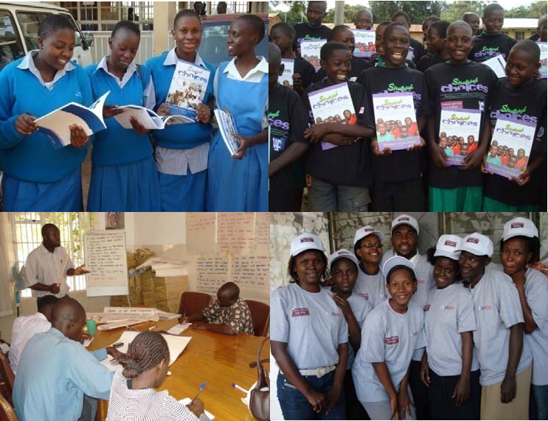

1

**Dr. David Kyaddondo**

**Dr. Cecily Banura**

**Mr. John Arube -Wani**

**Ms Susan Ajambo Dr. Anthony Batte Ms Phoebe Kajubi**

**----------------------------------------- Child Health and Development Centre, Makerere University , Kampala** [**akatahoire@chdc.mak.ac.ug/**](mailto:akatahoire@chdc.mak.ac.ug) [**www.chdc.mak.ac.ug**](http://www.chdc.mak.ac.ug)

**April 2011**

**Funded by the Children’s AIDS Fund**

**CONTENTS**

**1.0 BACKGROUND ..................................................................................................................... 10**

**1.1 Introduction ............................................................................................................................................ 10**

**1.2 Project on Preserving the African Family in the Face of HIV/AIDS through Prevention ................................ 12**

1.2.1 Project Goal and Objectives................................................................................................................. 13

1.2.2 Project Implementation................................................................................................................. ...... 14

1.2.3 Target Audiences ............................................................................................................................... .. 16

1.2.4 Project Management ........................................................................................................................... 16

**2.0 METHODOLOGY .................................................................................................................. 19**

**2.1 Evaluation Questions ............................................................................................................................. 19**

**2.2 Evaluation Design................................................................................................................................... 19**

**2.3 Evaluation Sites...................................................................................................................................... 20**

**2.4 Study Populations .................................................................................................................................. 20**

**2.5 Sampling ................................................................................................................................................ 21**

**2.6 Data Collection Methods ........................................................................................................................ 26**

**2.7 Field Work ............................................................................................................................................. 27**

**3.0 FINDINGS .............................................................................................................................. 29**

**3.1 Outcomes.................................................................................................................................................. 29**

3.1.1 Key Concerns in the National Strategic Plan on HIV/AIDS Addressed .................................................. 29

3.1.2 Increased Responsiveness by Youth to ABY Messages......................................................................... 30

3.1.3 Increased Knowledge on HIV/AIDS and STI Prevention........................................................................ 33

3.1.4 Positive Attitudes Towards Abstinence................................................................................................ 41

3.1.5 Increased Awareness of Sexual Risky Behavior .................................................................................... 50

3.1.6 Increased Parent‐Child Communication .............................................................................................. 55

3.1.7 Developed Life Skills ............................................................................................................................ 62

3.1.8 Increased Self Worth ........................................................................................................................... 67

3.1.9 Reduced Vulnerability among Poor Girls ............................................................................................. 70

3.1.10 Positive Changes in Gender Based Beliefs and Attitudes...................................................................... 71

3.1.11 Increased Access by Youth to Care and Support Services..................................................................... 72

**3.2 The Effectiveness of Approaches Used in Implementing the Project........................................................ 73**

3.2.1 Community Based ............................................................................................................................... 73

*Preserving the African family in the face of HIV/AIDS*

*Child Health and Development Centre Page 1*

3.2.2 Curriculum Based ............................................................................................................................... . 74

3.2.3 School Based ............................................................................................................................... ........ 74

3.2.4 Facilitator Based ............................................................................................................................... ... 79

3.2.5 Partnership Approach.......................................................................................................................... 80

**3.3 Activities Planned and Implemented to Achieve the Objective................................................................ 80**

**3.4 Effectiveness of the Monitoring and Supervision mechanisms ............................................................ 82**

3.4.1 Support Supervision ............................................................................................................................ 83

3.4.2 Spot Checks ............................................................................................................................... .......... 83

3.4.3 Monthly Review Meetings ................................................................................................................... 84

3.4.4 Monitoring Forms............................................................................................................................... . 85

3.4.5 Monthly Reporting .............................................................................................................................. 86

3.4.6 Technical Meetings.............................................................................................................................. 86

3.4.7 Utilization of Monitoring Data ............................................................................................................. 86

3.4.8 Challenges ............................................................................................................................... ............ 87

**3.5 Sustainability ......................................................................................................................................... 88**

3.5.1 Recruitment of Community Based Facilitators..................................................................................... 88

3.5.2 Formation of Community Based Organizations ................................................................................... 89

3.5.3 Training of Teachers in the Use of the *Smart Choices* Curriculum ........................................................ 89

3.5.4 Integration of Project Activities into the Sub County Work Plans ........................................................ 89

3.5.5 Establishment of Community Structures ............................................................................................. 90

**4.0 CONCLUSIONS ...................................................................................................................... 91**

**Lessons Learned .............................................................................................................................................. 94**

**5.0 REFERENCES ........................................................................................................................ 96**

**6.0 APPENDICES ........................................................................................................................ 98**

**6.1 Data Collection Strategy .................................................................................................................... 98**

**6.2 List of Districts and Parishes Visited for Data Collection ................................................................... 100**

**6.3 Data Collection Tools ........................................................................................................................ 102**

**6.4 Implemented Activities against the Planned Activities ...................................................................... 103**

***LIST OF TABLES AND FIGURES***

**TABLE 1: YOUTH SAMPLED FOR THE EVALUATION BY PARISH AND BY DISTRICT** ...................................................................... 22

**TABLE 2: SAMPLED YOUTH BY SEX AND BY DISTRICT** ......................................................................................................... 22

**TABLE 3 : PROPORTION OF IN‐ AND OUT‐OF‐SCHOOL YOUTH SAMPLED BY DISTRICT** ................................................................. 23

**TABLE 4: SAMPLED YOUTH BY AGE AND BY DISTRICT**........................................................................................................ 23

**TABLE 5: NUMBER OF FACILITATORS SURVEYED BY DISTRICT** .............................................................................................. 24

**TABLE 6 : FACILITATORS BY SEX AND BY DISTRICT** ............................................................................................................. 24

**TABLE 7 : FACILITATORS BY AGE AND BY DISTRICT** ............................................................................................................ 25

**TABLE 8 : DURATION SERVED BY FACILITATORS IN THE PROJECT BY DISTRICT** .......................................................................... 25

**TABLE 9: RESPONDENTS AND NUMBERS OF FOCUS GROUP DISCUSSIONS CONDUCTED WITH EACH** ............................................. 26

**TABLE 10: RESPONDENTS AND NUMBERS OF KEY INFORMANT INTERVIEWS CONDUCTED WITH EACH** .......................................... 26

**TABLE 11: NUMBER OF IN‐DEPTH INTERVIEWS BY RESPONDENTS** ......................................................................................... 26

**TABLE 12 : PEER FACILITATORS’ KNOWLEDGE OF HIV/ AIDS AND OTHER STIS**...................................................................... 31

**TABLE 13 : FACILITATORS’ RESPONSES TO FACILITATION SKILLS STATEMENTS** ........................................................................ 32

**TABLE 14 : EVALUATION OF FACILITATORS BY THE YOUTH**.................................................................................................. 33

**TABLE 15 : YOUTH’S KNOWLEDGE OF HIV/AIDS**............................................................................................................. 34

**TABLE 16 : YOUTH’S KNOWLEDGE OF HIV TRANSMISSION** ................................................................................................. 36

**TABLE 17 : YOUTH KNOWLEDGE OF HIV PREVENTION**....................................................................................................... 39

**TABLE 18 : ATTITUDES TOWARDS ABSTINENCE** ................................................................................................................ 42

**TABLE 19 : INTENTIONS TO ABSTAIN** ............................................................................................................................. 45

**TABLE 20 : SOCIAL NORMS WITH REGARD TO DELAYED INITIATION OF SEXUAL ACTIVITY FOR FEMALE YOUTH**............................... 48

**TABLE 21 : YOUTH ATTITUDES TOWARDS SOMETHING FOR SOMETHING LOVE** ........................................................................ 51

**TABLE 22 : RECOGNITION OF RISKY SITUATIONS AND BEHAVIORS** ....................................................................................... 52

**TABLE 23 : PARENT‐CHILD COMMUNICATION** ................................................................................................................. 56

**TABLE 24 : COMMUNICATION SKILLS** ............................................................................................................................. 60

**TABLE 25 : LIFE SKILLS AMONG YOUTH** .......................................................................................................................... 63

**TABLE 26 : DECISION MAKING SKILLS** ............................................................................................................................ 65

**TABLE 27 : SELF WORTH** ............................................................................................................................... .............. 68

**TABLE 28 : GENDER AND HIV** ............................................................................................................................... ....... 71

**TABLE 29 : SOURCES OF INFORMATION FOR THE FEMALE YOUTHS** ........................................................................................ 75

**TABLE 30: SOURCES OF INFORMATION FOR MALE YOUTHS** ................................................................................................. 76

**FIGURE 1: MAP OF UGANDA SHOWING PROJECT AREA (DISTRICTS)** ....................................................................... 13

**FIGURE 2: PROJECT ACTIVITIES** ............................................................................................................................... ..... 15

**FIGURE 3: PROJECT PROGRESS TOWARDS ACHIEVING THE TARGETED NUMBER OF YOUTH REACHED**................... 81

***ACRONYMS***

A&B Abstinence and Be Faithful

AB Abstinence, Be Faithful

ABY Abstinence, Behavior Change for Youth ADRA Adventist Development & Relief Agency AF Adult Facilitator

AFUPA Action for Unity and Poverty Alleviation AIDS Acquired Immune Deficiency Syndrome AMREF African Medical Research Foundation

ANPPCAN African Network for Prevention and Protection against Child Abuse and

Neglect

ARVs Antiretroviral (s)

CAF Children’s AIDS Fund

CBO Community Based Organization

DC District Coordinator FGD Focus Group Discussion FY Fiscal Year

HIV Human Immunodeficiency Virus

IEC Information, Education & Communication KAP Survey Knowledge, Attitudes and Practice Survey KI Key Informant

LAC Local Advisory Committee

LC Local Council

MDD Music Dance and Drama MOE&S Ministry of Education and Sports MOH Ministry of Health

MOU Memorandum of Understanding MPISEFO Mpigi Private Sector Foundation NGO Non‐governmental Organization ORC Macro ORC Macro International

OVCA

PF Peer Facilitator

PIASCY Presidential Initiative on AIDS Strategy for Communication to Youth

SO1 Strategic Objective 1

SO2 Strategic Objective 2

SO3 Strategic Objective 3

STD Sexually Transmitted Disease STI Sexually Transmitted Infection TASO The AIDS Support Organization TOT Training of Trainers

UAC

UNAIDS Joint United Nations Program on HIV/AIDS

UNESCO United Nations Educational, Scientific and Cultural Organization

UN United Nations

UNGASS United National General Assembly Special Session

UNICEF United Nations Children’s Fund

UPE

USAID United States Agency for International Development

USE

VCT Voluntary Counseling and Treatment

WHO World Health Organization

***EXECUTIVE SUMMARY***

**Background**

The Project *Preserving the African Family in the Face of HIV/AIDS through Prevention* was initiated by Children’s AIDS Fund (CAF) and United States Agency for International Development (USAID) in 2005. It was a five year Project implemented from 2005 to 2010. The main goal was to reach 350,000 youths aged 10-24 with interventions that promoted abstinence before marriage and faithfulness in marriage. The Project objectives were to:

1. Engage in- and out of- school youth aged 10-24 in activities that focus on life skills, goal setting, character development, self-respect, vocational skills, HIV/AIDS and other STIs prevention with a focus on abstinence and fidelity.

2. Educate and equip adults and peers who influence youth (pastors, parents, community leaders, teachers and peer mentors) with skills to reinforce the abstinence and be faithful messages.

3. Emphasize sexual responsibility in targeted programs for male youth and adults to reduce the incidence of coercive, cross generational and transactional sex and increase the number of males who practice abstinence before marriage and fidelity within marriage.

**Evaluation Questions**

The summative evaluation sought to answer the following key questions: How relevant were the Project objectives to the needs of the young people in the Project area and in the nation as a whole? What were the outcomes of the Project? How effective were the activities undertaken and the approaches adopted? How effective were the mechanisms used in the monitoring and supervision of the Project activities and what strategies were put in place for the sustainability of the Project beyond the funding period? What are the key lessons learnt from the Project?

**Evaluation Methodology**

A cross sectional design was adopted where both qualitative and quantitative methods were used to facilitate in-depth understanding. Data collection took place in five districts namely; Kampala, Wakiso, Mukono, Luwero and Mpigi. A total of 2903 youth and 113 Facilitators participated in a survey. Furthermore 25 focus group discussions were held with local advisory committee members, community leaders, Peer Facilitators and parents. In addition 106 key informant interviews were conducted with district officials, officials working with NGOs and CBOs, CAF Uganda headquarters staff and district coordinators. In-depth interviews were conducted with 13 vulnerable girls. The methodology adopted ensured triangulation at the different phases of data collection and analysis and ensured full and representative participation of the different categories of the study populations.

**Evaluation Findings**

The goal of the Project was to reach 350,000 youths aged 10-24 with interventions that promote abstinence before marriage and faithfulness in marriage between 2005 and 2010. By December

2010, the Project had attained its target of reaching 350,000 youth.

Survey and reports by stakeholders in the districts revealed the Project had contributed positively to youths’ responsiveness to AB messages. The youth scored highly on the knowledge questions on HIV/AIDS and STI prevention. Both parents and youths reported increased parent child communication, self-worth and development of life skills. Furthermore the Project was able to reduced vulnerability to transactional and cross generational sex by enabling girls to become more economically independent.

Adults who participated in parenting workshops, forum theatres and dialogues gained skills in communication and parenting which they found useful when dealing with adolescents. These activities implemented by the adult Facilitators sought to create a supportive family and community environment that reinforced the abstinence and faithfulness messages.

The different approaches adopted by the Project were very appropriate for the complex intervention implemented. The use of community based Facilitators and the involvement of the communities eased the implementation of the Project and its acceptance. The common curricula used enabled the delivery of set skills and knowledge and replication of their delivery in districts.

The use of schools as venues for the delivery of the curriculum was strategic. In-school youth were more accessible and easier to organize into educational groups. It was evident that the majority of youth reached by the Project were in school. The use of external Facilitators to deliver the curriculum instead of teachers was perceived by the youth and teachers alike to be an advantage because the youth were more responsive and open with the Facilitators than with their teachers. The formation of partnerships with organizations providing services such as VCT, treatment and counseling was highly appreciated because it enabled young people reached by the Project to access services outside of the scope of the Project.

In recognition of the fact that youth as individuals would need support both at home and in their communities in sustaining healthy sexual behaviors, the Project implemented parenting workshops, stakeholders meetings, and sports activities among others geared towards strengthening adult’s capacities to perform these supportive roles at home and in the community. This was a good strategy which was perceived by most stakeholders as having worked well.

The establishment of a monitoring system with staff at the Kampala Project office was commendable. Numerous data was generated by various monitoring tools that were used by the Project during monthly review meetings, staff meetings, yearly planning meetings, and quarterly reports.

Various strategies were adopted by the Project for sustainability purposes. These included the recruitment of community based Facilitators, the training of teachers in the *Smart Choices* curriculum, establishment of LACs as community structures and the integration of the Project activities into some sub county work plans. Throughout the life of the Project key stakeholder meetings were held with local and district leaders to update them on the program and discuss its future.

**Lessons Learned**

HIV and AIDS prevention has multiple strands. However, the focus on specific aspects of prevention (in particular prevention information) delivered through a set curriculum was a good practice. The Project focused on both in- and out of-school youth aged 10-24 years with a focus primarily on abstinence and fidelity for HIV prevention. The age-specific focus allowed a comprehensive discussion among the youth, which enabled them to gain good knowledge on HIV and AIDS, life skills, goal setting, character development, and self-respect.

The focus on both in- and out-of-school youth was commendable. The majority of young people in Uganda are now in schools as a result of UPE and USE. Therefore schools remain strategic for reaching young people aged between 10 and 18. However, inclusion of out-of-school youth remains important since there is a high drop-out rate in the country. The focus on both in- and out-of-school youth was also important in addressing the Project objective of emphasizing sexual abstinence, secondary abstinence and faithfulness within marriage. It would probably have been less effective if only one category (either in-school or out-of-school youth) was targeted.

Participation of young people in identifying and addressing their needs is essential to an informed HIV and AIDS response. The peer based approach, with young people participating in the delivery of prevention information was a good strategy that helped to respond to the felt needs of young people. Most of the issues addressed by the Project were in tandem with the felt needs except for condom access, which was outside the Project objective and activities. Through its various partnerships with other organizations the Facilitators were able to refer youths who needed condoms to organizations where they could access them.

In implementation of information related Projects, standardization of messages is a good quality control mechanism. The use of the *Smart Choices* curriculum by the Project helped in ensuring that youth across the different districts were exposed to the same knowledge and skills. It also helped to uphold standards and facts in delivered messages. However, quality and standards could have been further strengthened if training manuals were translated into the local language. Facilitators reported that they were more comfortable conducting the sessions in the local language and if the materials were translated this would have eased the process and strengthened the quality of communication.

Partnerships with organizations with variations in activities but with the same targets, is a good approach to carry out activities that have comparative advantage, while building synergy. Partnership between schools and peers was important in increasing access to information by young people. There were some obvious advantages to having Peer Facilitators who were not part of the school system because the youth found them more approachable and open. In areas of partnerships with other NGOs such as AMREF, ANPPCAN etc, synergy and mutual support was reported.

The establishment of a comprehensive monitoring and evaluation system at the CAF Uganda office was commendable. Numerous data was generated and used in review meetings, work plans, monthly reports on activities among others. Not all the data generated however was

analyzed. A framework for routinely analyzing and utilizing data collected would have further strengthened its effectiveness and utilization.

Incorporation of an exit plan is a good practice – not only for sustainability and phase out, but also for the preparation of the beneficiaries for the post Project period.

This has been one of the few very comprehensive ABY Projects focusing on in- and out- of- school youths implemented in central Uganda. The Project adopted several innovative strategies and approaches to address its objectives. It attained its target number of youth, achieved positive changes in youth’s reported behavior and created a more supportive environment in their communities. It therefore provides a good case study on how to design and implement an ABY Project. It had all the key elements in its design, although not all were implemented as planned.

**1.0 BACKGROUND**

**1.1 Introduction**

Young people remain vulnerable to HIV infection. Globally the number of young people (15-24 years old) living with HIV declined slightly from 5.2 million in 2005 to 5.0 million in 2009, the rate of new infections of 890,000 reported in 2009 (WHO, 2010; UNAIDS, 2010a) is still high. According to UNAIDS nearly half of all new HIV transmissions occur among young people aged 15‐24 years, particularly in sub-Saharan Africa. In Uganda 4.3% of young women and 1.1% of young men aged 15‐24 years were living with HIV in 2005 (MoH and ORC Macro

2006) suggesting that young women were about four times more likely to be infected with HIV

than their male counterparts. The survey further revealed that HIV prevalence among young people increased with age from 1.1% among those aged 15‐17 to 5.7% among those aged 23‐24. The paucity of information on the prevalence of HIV among those aged 10‐14 years is worth noting since most serosurveys track persons aged 15 years and above.

Both risk and contextual factors contribute to vulnerability to HIV and AIDS among young people. The 2009 report on HIV Prevention Response and Modes of Transmission Analysis (UAC and UNAIDS, 2009), reports transactional and intergenerational sex, multiple partners and inequity in access to prevention among the factors that contribute to the continued spread of HIV. Data from the 2004/5 sero-behavioural survey showed that 4.8% of young people who lived in urban areas reporting more than 2 sexual partners in the 12 months preceding the survey. Those aged 20 years and above were more likely to be infected with HIV than their younger counterparts (MoH and ORC Macro 2006).

Early sexual debut is a significant driver of HIV infection among young people, particularly among females. Monarsh and Mahy (2006) report early sexual debut, early marriages; sexual coercion and violence as key factors in HIV transmission among females. In developing countries, where the vast majority of young people living with HIV are found, 6 % of males and

11 % of females aged 15–19 report having had sex by age 15 (UNAIDS 2010b). A National Adolescent Survey conducted in Uganda in 2004 reported that among the 12-14 year olds, 15% of males and 8% of females reported having had sexual intercourse (Nemma et al 2006). The Uganda National HIV/AIDS sero‐behavioral survey (MoH and ORC Macro 2006); reported that

68% of females and 58% of males aged 15‐24 years had ever had sex. The proportion of those who had ever had sex increased with age from 17% of women and 23% of men by age 15, to

81% and 65% among women and men, respectively by age 19. Furthermore the majority of the sexual encounters reported by these young people were largely non‐marital. This evidence underscores the vulnerability of young people in Uganda to HIV infection and other sexual and reproductive health problems.

According to UNAIDS, the ages of 10-14 years are a time of maximum vulnerability, change and opportunity for adolescents to learn and develop competencies and skills to help them build

patterns of health-maintaining behaviors. It is also a time when they can best be protected from potential risks by parents and other adults who are closely involved in their lives (UNAIDS

2004). A growing body of literature suggests that while young people generally have access to

information on HIV/AIDS from various channels, misconceptions about HIV/AIDS still prevail, and many young people do not have comprehensive knowledge about HIV/AIDS transmission and prevention. The Uganda National HIV/AIDS Sero-Behavioral Survey found that only 30% of females and 35% of males aged 15-24 years had comprehensive knowledge of HIV/AIDS.

Globally, comprehensive knowledge among young people, both females and males has slightly increased since 2008 to about 34% but this is far below the UNGASS target of 95% (UNAIDS,

2010b). A study commissioned by UNESCO in Eastern and Southern Africa confirmed low knowledge levels among youth in the upper-primary school grades despite the existence of good-quality curricula to educate young people about HIV and AIDS (Stéphanie and Ross,

2010). A recent synthesis of HIV modes of transmission and prevention response analysis in Uganda shows that both in-school and out-of-school youths are not adequately covered by HIV/AIDS education and as a result, misconceptions about HIV transmission still prevail among young people (UNAIDS and UAC, 2009).

The evidence above underscores the need for young people in Uganda to access comprehensive knowledge of HIV/AIDS as one of the strategies for averting the HIV/AIDS epidemic. UNAIDS recommends increasing comprehensive knowledge of HIV to at least 80 % of young people in-and out-of-school and that prevention information and programming should be delivered through a continuum of age (UNAIDS, 2010b). Interventions that are implemented early into the beginning of adolescence can have a significant impact in decreasing the proportion of young people engaged in sexual relations before marriage.

Young people are perceived to be central to the strategy and actions to avert the HIV epidemic. As recommended in the Joint UN report on Children and AIDS (UNAIDS 2010a; UNAIDS

2010b), young people must be engaged in the fight against AIDS given their important role in

behavior change. Evidence suggests that sexuality education interventions targeting young people can have a significant impact on risk‐taking behaviors. The reported global decline in HIV prevalence is in part due to expanded access to information, education and communication programs (WHO/UNICEF/UNAIDS, 2010).

Two earlier studies conducted in Uganda on school‐based health education produced conflicting findings. One conducted in Masaka district, found little effect of school‐based AIDS education on the students’ behaviors. This was attributed to the shortage of classroom time and teachers’ fear of controversy over condom use or role play exercises associated with condom use (Kinsmanet al. 2001). Another study implemented in Soroti district revealed that pupils who were exposed to a school‐based health education intervention and were sexually active fell from

42.9% in 1994 to 11.1% two years later, but no similar reductions were observed among

students who served as the control group and not targeted by the intervention (Shuey et al.

1999). The Soroti intervention demonstrated increased sexual abstinence as a result of school

health education. This supports the notion that promotion of sexual abstinence among young people is feasible as well as possible.

An evaluation of the impact of mass media initiatives for the Straight Talk Foundation (STF) Campaign in Uganda found that male youth exposed to educational materials were less than half as likely to engage in sexual activity and three times more likely to resume abstinence if they had previously had sex compared to those not exposed. Female youth exposed to the same materials were twice as likely to report high self‐confidence and four times more likely to abstain from sex if they had a boyfriend compared to their unexposed counterparts (Adamchak et al, 2007). Collectively, these findings suggest that targeted sex education interventions can increase safer sexual practices among those reached with messages.

There is compelling evidence to suggest that interventions targeting young people remain critical in the prevention of HIV infection. The evidence suggests that youth participation in health programs on HIV/AIDS and sexuality can result in significant reductions in risk‐taking behaviors and contribute to a reduction in HIV acquisition/transmission. Evidence suggests that sex and HIV education programs based on a written curricula and implemented among youth in schools, clinics or other community settings are a promising type of intervention for reducing sexual risk‐taking behaviors (Kirby *et al.* 2005). The Project *Preserving the African Family in the Face of HIV/AIDS through Prevention* was one such program initiated to respond to youth vulnerability to the risk of HIV infection in Central Uganda.

**1.2 Project on Preserving the African Family in the Face of HIV/AIDS**

**through Prevention**

The Children’s AIDS Fund (CAF), through a cooperative agreement signed with the United States Agency for International Development (USAID), in 2005 initiated the implementation of a Project named P*reserving the African Family in the Face of HIV/AIDS through Prevention*. The Project was implemented from 2005 to 2010. It utilized funds from the President’s Emergency Plan for AIDS Relief (PEPFAR) awarded through USAID. CAF the prime grantee provided overall Project implementation and fiscal management and served as the coordinating entity. The Project was implemented in conjunction with Uganda Youth Forum (UYF), an NGO with previous expertise in community mobilization for HIV prevention. At the time of implementation, UYF was already working with out-of-school youth and young adults in Kampala district. During the implementation UYF continued to work with youth in central and Kawempe divisions in Kampala district and Kira and Nangabo divisions in Wakiso district, while CAF Uganda spread out to neighboring districts. By the end of the five years, the Project was operational in seven districts in central region, namely Kampala, Wakiso, Luwero, Mpigi, Mukono, Buikwe and Gomba.

**FIGURE 1: MAP OF UG ANDA SHOW ING PROJECT AREA (DISTRICT S)**

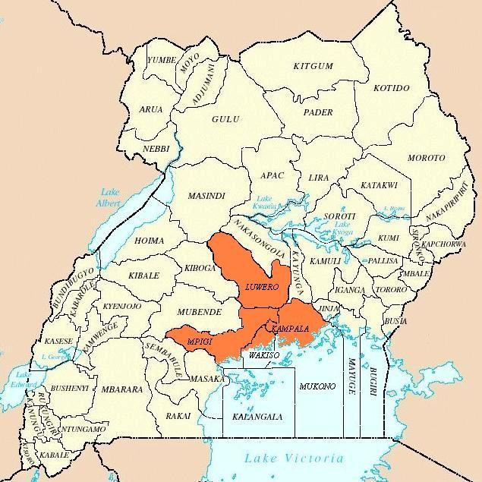

**Key:**

District boundary

Project areas

***Note****: Gomba and Buikwa districts are new districts which were part of Mpigi and Mukono until year 2010.*

CAF also had a contract with Campus Alliance to Wipe out AIDS (CAWA). CAWA had been subcontracted to provide AB messages to university students through its existing campus newspaper; the *Prime Timer*. During 2007 however, CAF terminated its contract with CAWA due to persistent non - compliance with United States Government policies and guidelines and failure to meet its contractual obligations in printing and distributing the newspaper. This affected the planned campus-wide outreach to different universities (MTR report, 2008, Annual report, 2006/2007).

***1.2.1 Project Goal and Objectives***

The main goal of the Project was to reach 350,000 youths aged 10-24 with interventions that promote abstinence before marriage and faithfulness in marriage within a period of 5 years (2005-2010). The Project activities focused on three strategic objectives;

**SO1:** Engage in- and out-of-school youth aged 10-24 in program activities that focus on life skills, goal setting, character development, self-respect, vocational skills, HIV/AIDS and other STIs prevention with a focus primarily on abstinence and fidelity for HIV prevention.

**SO2:** Educate and equip adults and peers who influence youth (pastors, parents, community leaders, teachers and peer mentors) with skills to reinforce the abstinence and be faithful messages.

**SO3:** Emphasize sexual responsibility in targeted programs for male youth and adults to reduce the incidence of coercive, cross generational and transactional sex and increase the number of males who practice abstinence before marriage and fidelity within marriage.

***1.2.2 Project Implementation***

The plan was for the Project to begin in October, 2005. USAID approval of the work plan and Project concurrence from Ugandan Government was not secured until January, 2006. This resulted in delays in budget approvals, setting up the country office, establishment of communication systems, procurement of key equipment and recruitment and orientation of key personnel. The Project was rolled out in July 2006. Due to initial delays, Project implementation was slow during the first two years. The numbers of youth reached were below the expected targets (Project annual report, 2006/2007, MTR report, 2008). Progress on most activities was during 2008. The midterm review reported that of the cumulative number of youth reached between October 1, 2005 and July 31, 2008, 73% were reached in 2008 alone. The Project developed more rapidly in the remaining two years of its duration and undertook activities that included: community dialogues to mobilize against exploitative sex, training in livelihood skills to reduce economic vulnerability of young girls, peer facilitator refresher trainings and the referral component of the Project (Annual report, 2008/2009).

Project implementation was based on: communities and schools, set curricula, peer and adult Facilitators and partnerships. Communities were involved in the identification and selection of Peer Facilitators and vulnerable girls; Community leaders in particular were involved in the mobilization of youth especially those out-of-school. They also provided public support for the Project’s abstinence and faithfulness prevention messages, developed related local policies and providing support supervision for the PFs. The rest of the community members were targeted as part of the Project’s outreach efforts conducted by the adult Facilitators. Community members were involved in events such as sports, competitions, forum theatres and music, dance and drama.

Schools were the most common venues utilized by the Project to reach in-school youths. The Project utilized set curricula for youth. The curricula had 12 modules that focused on life skills, goal setting, character development, self-respect, HIV/AIDS and STI prevention. The curricula were designed to be covered in six sessions of two hours each. The curricula underwent some changes as the Project evolved. The Project began by implementing the *No Apologies* curriculum that was already being implemented by UYF developed by Focus on the Family for youth aged 10-16 years and implemented with out-of-school youth. USAID then questioned the relevance of its content for the audience targeted by the Project. With guidance from USAID the *Choose Life* curriculum was adopted for use by both UYF and CAF (Annual report, 2006/2007). This curriculum was developed by World Relief funded through a USAID ABY prevention

grant and it was divided into ages 10-14 and 15-24. This curriculum was implemented by the Project during 2008. In 2009 the Project incorporated additional messages from Young Empowered and Healthy (YEAH) into the curriculum. These gender-based messages included:

‘*Something for Something Love’* and ‘*Be a Man’.* Their integration into the *Choose Life* curricula resulted in the development of a new curricula named *Smart Choices. Smart Choices* curricula were implemented by the Project starting with 2009 (Annual report, 2008/2009). Since the primary content of *No Apologies*, *Choose Life* and *Smart Choices* all focus on life skills, goal setting, character development, HIV/AIDS prevention, abstinence and fidelity, CAF’s core messages were consistent throughout the Project. While there were changes introduced into the curricula as the Project evolved, the core messages of abstinence and fidelity for HIV prevention cut across the curricula.

All facilitators underwent preparatory training prior to being deployed in their respective communities to mobilize and educate youth based on the designed curricula. Adult Facilitators organized three hour sessions with adults in their various communities and implemented the *Parenting Curricula*. In their sessions they also drew on messages from *Something for Something Love* and *Be a Man*. They emphasized sexual responsibility in targeted programs for male youth and adults to reduce the incidence of coercive, cross generational and transactional sex. Figure 1 shows the implementation model adopted by the Project.

**FIGURE 2: PROJECT ACTIVIT IES**

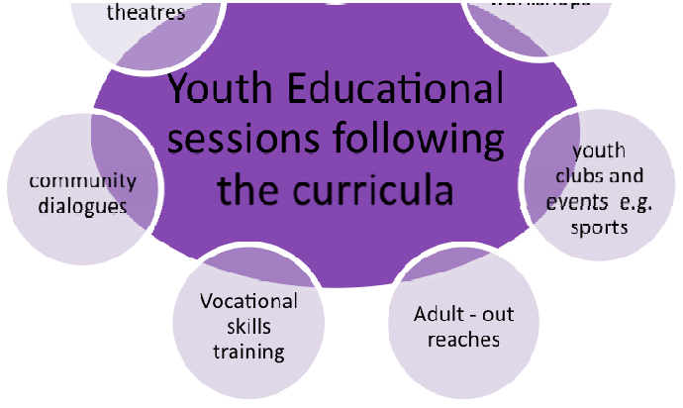

Peer Facilitators in addition to implementing the *Smart Choices* curriculum, supported the formation of youth clubs. The clubs were meant to facilitate the development of leadership

skills. Through the clubs, the youth engaged in music, dance, drama, skills development, sports, outreach events, debates and other activities intended to amplify the Project at the community level. Peer Facilitators also partnered with some service organizations, local government and a few CBOs in the districts where they referred youth for services such as counseling, reproductive health concerns (STI diagnosis and treatment, for example), VCT and in some cases treatment. The Project established MOUs with 50 organizations and 131 schools and vocational institutions.

***1.2.3 Target Audiences***

The Project’s primary audience was youth aged 10 to 24 years. The Project, as previously discussed also targeted adults in the community that included church leaders, youth pastors, teachers, parents and other community members as secondary audiences.

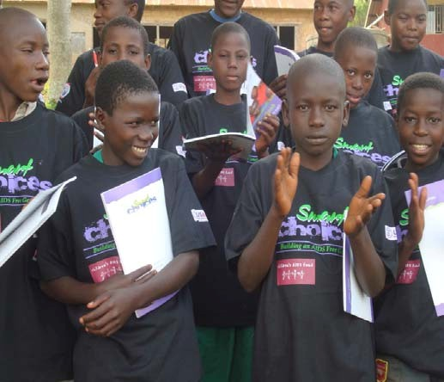

Following the recommendations from the Mid-Term Review, the Project’s target audience was expanded in 2009 to include young married individuals, those in long-term relationships and/or previously married youth ages 15-

29.This was intended to address the challenges of married youths, who were not consistently reached with activities that enhanced their life skills (Annual report, 2008/2009).

*Some of the youth reached by the Project using the Smart Choices l*

***1.2.4 Project Management***

*Preserving the African Family in the Face of HIV/AIDS through Prevention* Project was awarded to CAF; a US based non-profit NGO founded in 1987. This funding mechanism was established in the initial years of the President’s Emergency Plan for AIDS Relief (PEPFAR) as a Track 1.0 grant, in which US based organizations were funded to implement programs through local partners in the countries of operation. Four members of the Project management team were based at CAF Headquarters in the US and were responsible for program oversight, management and compliance. They reported on the Project and financial issues to USAID. Direct Project implementation in Uganda was the responsibility of CAF Uganda staff, which managed country-level program activities, finances and the sub-contract with UYF.

**CAF MANAGEMENT STRUCTURE**

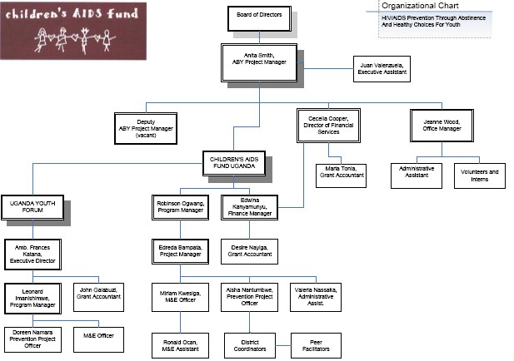

*Preserving the African family in the face of HIV/AIDS*

*Child Health and Development Centre Page 17*

The Project had nine full-time staff and five to six full-time interns based at its central offices in Kampala responsible for the field activities. The team was led by the Prevention Manager who provided day-to-day management and administrative oversight in addition to being the key person for UYF activities within CAF Uganda. A Monitoring and Evaluation Coordinator provided overall monitoring and evaluation oversight to the Project and was supported by a Monitoring and Evaluation Officer. A Project Officer was responsible for the supervision of field activities supported by Peer Mentors. Three members of the finance department managed the Project’s finances and procurements. At the district level there were District Coordinators who were responsible for the supervision of the Peer and Adult Facilitators in each district.

During 2006, CAF undertook a review of the monitoring and evaluation tools in response to USAID suggestions and input on the monitoring and evaluation concept design. This resulted in the devolution of management and oversight responsibilities from CAF Headquarters US to CAF Uganda and in the termination of the agreement with the monitoring and evaluation contractor based in the US emphasis was then placed on the development of a country based monitoring and evaluation plan, processes and expertise (Annual Report, 2006/2007).

The functions of Project planning, implementation, reporting, monitoring and evaluation were devolved to the country level beginning 2008. While the CAF US office continued to provide overall Project management, financial management, compliance, technical assistance and capacity building. CAF Uganda central office staff was responsible for overseeing, managing and supporting the activities at field level. They were also responsible for conducting monthly reviews with field staff, site visits, providing technical assistance and other forms of support

*Preserving the African family in the face of HIV/AIDS*

*Child Health and Development Centre Page 18*

**2.0 METHODOLOGY**

The evaluation design and methodology including the methods used and the rationale for their choice are presented in this section.

**2.1 Evaluation Questions**

The evaluation sought to answer the following key questions:

• How relevant were the Project objectives to the needs of the young people in the Project area?

• What activities were undertaken by the Project to achieve the Project objectives?

• What approaches were used in the implementation of the Project activities and how effective were they?

• How effective was the S*mart Choices* curricula in achieving the Project objectives?

• How effective were the mechanisms used in the monitoring and supervision of the Project activities?

• What are the key outcomes of the Project?

• What strategies are in place for the sustainability of the Project beyond the funding period?

• What are the key lessons learnt from the Project?

**2.2 Evaluation Design**

A cross sectional study design was adopted where both qualitative and quantitative methods were used to facilitate in depth understanding of the Project processes and outcomes. The methodology adopted ensured triangulation of approaches at the different phases of data collection and analysis and ensured full and representative participation and integration of views and experiences of the different categories of study population.

**2.3 Evaluation Sites**

The evaluation was conducted in five districts namely: Kampala, Wakiso, Mukono, Luwero and

Mpigi.

**2.4 Study Populations**

The study populations included: youth aged 10 – 24 years, the Smart Girls, parents/guardians, local leaders, local advisory committees, community members, teachers, district officials, representatives from NGOs, peer and Adult Facilitators, district coordinators and Project staff.

*Youth in and out-of school aged 10-24* were the primary target audience for the Project*.* The youth were considered to be important sources of information relating to the Project outcomes in terms of their knowledge of HIV/AIDS transmission and prevention, behavior and attitudes towards abstinence and fidelity. *Smart Girls* were also targeted because they were supported by the Project for training in vocational skills. They were a vital source of information relating to the vocational skills training component of the Project. The *Smart Teens* were also included because they were trained as part of the Project’s sustainability strategy to carry out peer education in their schools.

*Parents/guardians and other community members* were secondary target audiences for the Project. They were reached by the Project with messages aimed at enabling them to support and care for the youth. They also participated in the mobilization of the out-of-school youth. They were thus considered vital sources of information.

*Teachers* worked with Peer Facilitators in organizing educational activities in schools. Their observations regarding pupils and students in school and about the program as a whole were considered significant in assessing the achievements of the Project.

*Local leaders/Local Advisory Committees (LAC)* participated in the identification of Peer Facilitators and in mobilization of communities for Project activities. The LACs participated in the implementation of the *Smart Girls* training. They were, thus, essential sources of information regarding the *Smart Girls* training.

*NGO Representatives* partnered with the Project in the implementation of its activities especially the referral component. As Project partners they were considered to be vital sources of information on Project activities and their sustainability.

*District Officials* were considered to be vital sources of information regarding the sustainability of changes made by the Project in the districts.

*Peer and Adult Facilitators* were central in implementing Project activities at the community level. They provided information on the Project implementation strategy, the approaches used,

activities implemented and the Project outcomes. As key implementers, their knowledge and attitudes were considered important.

*District Coordinators* supervised Peer and Adult Facilitators and all community based activities. They provided information relating to monitoring and supervision strategies and gave an overview of activities, approaches and methods used, challenges encountered and the sustainability of the Project. CAF and UYF staff were overall managers of the Project implementation.

**2.5 Sampling**

The in- and out-of school youth aged 10 –24, were randomly selected while other respondents were purposively selected based on their knowledge, experience, and understanding of issues relating to the Project.

The sampling of the in- and out-of-school youth aged 10-24 years was based on the database provided by CAF listing all parishes and venues where the Project was implemented and numbers of youth reached at each venue. A representative probability sample of 3036 youth was selected in the 5 districts. In Kampala, a slightly bigger sample size (1,000 youth) was targeted to cater for areas the Project covered by CAF and UYF. The sample size targeted in each of the other 4 districts was (500 youth each).

In consultation with the LACs, 2 *Smart Girls* were identified in each district and two teachers, one senior man and one senior woman were sampled from each school visited. Altogether, 73 parishes were randomly selected and a multi-stage sampling procedure used to select schools. Three steps were followed in the sampling of schools:

**Step 1:** All schools with less than 25 participants were excluded because the target sample per venue was at least 25 participants.

**Step 2:** In each parish, four schools were randomly selected.

**Step 3:** In the sampled schools youth were stratified by sex then simple random sampling used to get an equal number of each. In the single-sex schools, systematic sampling was used to select the sample. Where a randomly selected youth declined to assent, he was replaced by another youth from the same class.

Youth clubs comprised of out-of-school youths were purposely sampled in each district. Interviews were conducted with all members present on that particular day. Tables 1-8 present the distribution of youth and Peer Facilitators by district and their demographic characteristics.

*In- and Out-of School Youth*

**TABLE 1: YOUTH SAMPLED FOR TH E EV ALUAT ION B Y PARISH AND BY DIST RICT**

|  |  |  |
| --- | --- | --- |
| **District** | **Parishes sampled n (%)** | **Participants n (%)** |
| Kampala | 16 (21.9) | 916 (31.6) |
| Wakiso | 17 (23.3) | 497 (17.1) |
| Mukono | 06 (8.2) | 505 (17.4) |
| Luwero | 18 (24.7) | 503 (17.3) |
| Mpigi | 16 (21.6) | 482 (16.6) |
| Total | 73 (100) | 2,903 (100.0) |

Twenty youths (0.7%) were excluded because they reported that they were reached before the

Project started (2003-2005). Thus, 2903 youth were included in the analysis.

**TABLE 2: SAMPLE D YOUTH BY SEX AND BY DISTRICT**

|  |  |  |  |  |  |  |
| --- | --- | --- | --- | --- | --- | --- |
|  | **Kampala** | **Wakiso** | **Mukono** | **Luwero** | **Mpigi** | **Total** |
| Sex | **n (%)** | **n (%)** | **n (%)** | **n (%)** | **n (%)** | **n (%)** |
| Males | 425 (46.4) | 264 (53.1) | 241 (47.7) | 260 (51.7) | 228 (47.3) | 1,418 (48.8) |
| Females | 483 (52.7) | 233 (46.9) | 264 (52.3) | 241 (47.9) | 254 (52.7) | 1,472 (50.9) |
| Missing | 8 (0.9) |  |  | 2 (0.4) |  | 10 (0.3) |
| Total | 916 (100) | 497 (100) | 505 (100) | 503 (100) | 482 (100) | 2,903 (100) |

Although a deliberate attempt was made to include an equal number of males and females, the overall survey sample had slightly more females 1,490 (50.9%) than males 1,430 (48.8%). There was variation in the distribution of sex of participants by district. The sample from Wakiso and Luwero districts had slightly more males than females while Kampala, Mukono and Mpigi had slightly more females.

**TABLE 3 : PROPORTION OF I N- AND OUT-OF-SCHOOL YOUT H SAMPLE D BY DIST RICT**

|  |  |  |  |  |  |  |
| --- | --- | --- | --- | --- | --- | --- |
|  | **Kampala** | **Wakiso** | **Mukono** | **Luwero** | **Mpigi** | **Total** |
| Schooling status | **n (%)** | **n (%)** | **n (%)** | **n (%)** | **n (%)** | **n (%)** |
| In-School | 845 (92.2) | 413 (83.1) | 394 (78.0) | 393 (78.1) | 398 (82.6) | 2,443 (84.2) |
| Out-of- School | 69 (7.5) | 83 (16.7) | 111 (22.0) | 106 (21.1) | 83 (17.2) | 452 (15.6) |
| Missing | 2 (0.2) | 1 (0.2) |  | 4 (0.8) | 1 (0.2) | 8 (0.3) |
| Total | 916 (100) | 497 (100) | 505 (100) | 503 (100) | 482 (100) | 2,903 (100) |

In all districts, more youths were reached by the Project in-school 2,443 (84.2%) than out-of- school 452 (15.6%).

**TABLE 4: SAMPLED YOUTH BY AGE AND BY DISTRICT**

|  |  |  |  |  |  |  |
| --- | --- | --- | --- | --- | --- | --- |
|  | **Kampala** | **Wakiso** | **Mukono** | **Luwero** | **Mpigi** | **Total** |
| **n (%)** | **n (%)** | **n (%)** | **n (%)** | **n (%)** | **n (%)** |
| Age group(years) |  |  |  |  |  |  |
| 10 -14 | 499 (54.5) | 223 (45.1) | 213 (42.2) | 200 (39.8) | 241 (50.0) | 1,376 (47.3) |
| 15 -24 | 416 (45.5) | 272 (54.9) | 292 (57.8) | 302 (60.2) | 241 (50.0) | 1,523 (52.5) |
| Missing | 1 (0.0) | 2 (0.4) |  | 1 (0.2) |  | 4 (0.1) |
| Total | 915(100) | 495 (100) | 505 (100) | 502 (100) | 482 (100) | 2,903 (100) |
| Median age  (yrs) (range) | 14 (10-30) | 15 (9-25) | 15 (10-25) | 15 (10-26) | 14.5(1024) | 15.2 (9-30) |

The overall mean age for the sampled youth was 15.2 years. The sample from Kampala district was slightly younger than the other 4 districts. Females were slightly younger than males with a mean age of 14 years and 15 years respectively.

*Peer and Adult Facilitators:*

Project documents reviewed showed that the Project had a total of 149 Facilitators. The plan was to include all of them in the evaluation. On request by the evaluators, all peer and adult Facilitators from the 5 districts were invited to one venue for a meeting. Out of the 149, 113 attended and were included in the survey.

**TABLE 5: NUMBER OF FACIL ITATO RS SURVEYED B Y DISTRICT**

|  |  |
| --- | --- |
| **District** | **No. of PFs/AFs n (%)** |
| Kampala | 40 (35.4) |
| Wakiso | 30 (26.5) |
| Mukono | 19 (16.8) |
| Luwero | 15 (13.3) |
| Mpigi | 09 (08) |
| Total | 113 (100) |

**TABLE 6 : FACILIT ATORS BY SEX AND BY DISTRICT**

|  |  |  |  |  |  |  |
| --- | --- | --- | --- | --- | --- | --- |
|  | **Kampala** | **Wakiso** | **Mukono** | **Luwero** | **Mpigi** | **Total** |
| Sex | **n (%)** | **n (%)** | **n (%)** | **n (%)** | **n (%)** | **n (%)** |
| Males | 25 (62.5) | 16 (53.3) | 07 (36.8) | 08 (53.3) | 05 (55.6) | 61 (54.0) |
| Females | 14 (35.0) | 14 (46.7) | 11 (46.7) | 6 (40.0) | 4 (44.4) | 49 43.4) |
| Missing | 1 (2.5) |  | 1 (5.3) | 1 (6.7) |  | 3 (2.7) |
| Total | 40 (100) | 30 (100) | 19 (100) | 15 (100) | 09 (100) | 113 (100) |

More than half (54%) of the Facilitators were males. The Project attempted to recruit an equal number of males and females as Facilitators.

**TABLE 7 : FACILIT ATORS BY AGE AND B Y DISTR ICT**

|  |  |  |  |  |  |  |
| --- | --- | --- | --- | --- | --- | --- |
|  | **Kampala** | **Wakiso** | **Mukono** | **Luwero** | **Mpigi** | **Total** |
|  | **n**  **(%)** | **n**  **(%)** | **N (%)** | **N (%)** | **n**  **(%)** | **n**  **(%)** |
| Age group  (years) | | | | | | |
| 19-29 | 34 (85.0) | 23 (76.7) | 12 (63.2) | 13 (86.7) | 07 (77.8) | 89 (78.8) |
| 30-40 | 6  (15.0) | 07  (27.3) | 6  (31.6) | 1  (6.7) | 02  (22.2) | 22  (19.5) |
| 41+ |  |  | 1 (5.3) | 1 (6.7) |  | 2 (1.8) |
| Total | 40  (100) | 30  (100) | 19  (100) | 15  (100) | 9  (100) | 113  (100) |
| Mean age  (yrs) (range) | 26.3  (19-35) | 25.5  (20-32) | 29.5  (22-49) | 26.3  (21-52) | 28  25-30) | 26.8  (19-52) |

The majority of Facilitators were quite young between 19 and 29 years, which was appropriate given the ages of their target audience.

**TABLE 8 : DUR ATIO N SERVED BY FACILI TATORS IN TH E PROJECT B Y DISTRICT**

|  |
| --- |
| **Kampala Wakiso Mukono Luwero Mpigi Total** |
| **n n n n N n**  **(%) (%) (%) (%) (%) (%)** |
| **Length of time served (months)** |
| **< 12** 2 3 5 (5.0) (10.0) (4.4) |
| **12-24** 30 27 15 13 9 94 (75.0) (90.0) (78.9) (86.7) (100.0) (83.2) |
| **25+s** 8 4 2 14 (20.0) (21.1) (13.3) (12.4) |
| **Total** 40 30 19 15 09 113 (100) (100) (100) (100) (100) (100) |
| 25.5 20.3 25.2 24.3 19.1 23.4  **Mean (range)** (5-60) (8-24) (13-60) (18-48) (12-21) (5-60) |

More than three quarters of the Facilitators had served the Project for duration of between 12 to

24 months.

**2.6 Data Collection Methods**

The evaluation used several data collection methods that included focus group discussions; key informant interviews; in-depth interviews and survey questionnaires. The specific data collection methods used and numbers interviewed by category are summarized in the tables that follow.

**TABLE 9: RESPOND ENT S AND NUMBERS O F FO CUS GROUP DISCUSSIO NS COND UCTED WITH EACH**

|  |
| --- |
| Respondents **Number of Focus Group Discussions** |
| **LAC** 5 |
| **Community Leaders** 3 |
| **Peer Facilitators** 9 |
| **Parents** 8 |
| **Total 25** |
|  |

**TABLE 10: RE SPONDE NT S AND NUMBERS OF KEY INFO RMANT INTERVIEWS COND UCTE D WITH EACH**

|  |
| --- |
| Respondent **Number of Key Informant Interviews** |
| **District Coordinators** 10 |
| **District Officials** 16 |
| **Adult Facilitators** 14 |
| **Peer Facilitators** 4 |
| **NGO Representatives** 8 |
| **Teachers** 51 |
| **CAF Staff** 3 |
| **Totals 106** |

**TABLE 11: NUMBE R O F IN- DEPTH INTERVI EW S BY RESPON DENT S**

|  |
| --- |
| Respondents **Number of in-depth interviews** |
| ***Smart Girls*** 11 |
| ***Smart Teens*** 2 |
| **Totals** 13 |

Focus group discussions conducted with the peer Facilitators, local leaders, LACs and parents explored the operations of the Projects, its achievements, challenges and sustainability.

The in-depth interviews with the *Smart Girls* explored how the vocational skills training had impacted their lives while those with the *Smart Teens* explored their preparation to carry on with educational activities after the Project closed.

Two questionnaires were used in the survey *(see Appendix).* Both questionnaires were developed based on the content of the *Smart Choices* curricula and pre-tested before they were finalized. One self-administered questionnaire was completed by the Facilitators. The other, which was interviewer administered, was used to collect data from the in- and out-of-school youths. While the questionnaire completed by the Facilitators was in English the one administered to the youths was both in English and Luganda, the most common language spoken in all of the Project’s 5 target districts.

The questionnaire for the youth collected information on their demographic characteristics, knowledge about HIV/AIDs and other STIs, life, decision making and communication skills, parent - child communication, self-worth, perceptions about risky sexual behavior, gender and HIV, attitudes and intentions to abstain from sex and sources of information.

Project reports and materials were also reviewed as part of the evaluation.

**2.7 Field Work**

Each district had a team of interviewers led by a supervisor. Team leaders and interviewers were trained and participated in pre-testing and translation of the questionnaires. Random sampling methods were used in selecting samples for pre-testing of the questionnaires to familiarize the interviewers with what was expected of them during the survey. During data collection, each team leader ensured that the interviewers followed all the procedures. At the end of each day, each of the supervisors met with their team to discuss the day’s work and to go through the questionnaires. All questionnaires were checked for errors and missing information in the field. Completed questionnaires were then stored at Child Health and Development Center at the end of each day.

The FGDs were transcribed fully in Luganda prior to being translated into English. The transcribed FGDs and interviews were then word-processed. The core team members read through and reviewed all the FGDs and interviews identifying key themes and sub-themes in order to construct coding schemes. In order to manage this large data set, the teams adopted a team based approach to data analysis using Atlas Ti version 5.0 computer assisted qualitative data analysis software to facilitate the management and analysis of this data. Texts were coded and clustered along themes and sub-themes for subsequent analysis.

Survey data was entered using EPI DATA version 2.The cleaned database was then exported to SPSS version 10 for analysis. Univariate analysis was done to obtain descriptive statistics. Thereafter, data was stratified by sex and independent variables were cross tabulated with participant characteristics to come up with summary tables. At the end of data cleaning, less

than 5% of questionnaires had missing data. During the analysis there was a deliberate effort to triangulate the qualitative and quantitative data and to integrate them in the report.

It is important to note that some sampling errors may have occurred due to measurement or response errors. For instance, some of the respondents may not have understood the questions or may have given socially acceptable responses given that the questionnaire was not self- administered. Some participants had limited understanding of English and Luganda. Consequently, this could have resulted in misunderstanding the questions leading to measurement errors.

**3.0 FINDINGS**

**3.1 Outcomes**

The evaluation sought to determine the Project’s achievements and outcomes. Qualitatively it explored stakeholders’ perceptions of Project achievements and outcomes both expected and unexpected. It also assessed quantitatively youth’s knowledge, skills, beliefs and attitudes to abstinence and fidelity in marriage based on the content covered in the *Smart Choices* curriculum. The survey covered a wider range of knowledge and skills than those originally assessed in the baseline survey. This was mainly because the *Smart Choices* curriculum was developed after the baseline was conducted. Consequently very few comparisons could be made based on the baseline data in terms of changes in knowledge, skills, beliefs and attitudes. The evaluation assessed youth’s current levels of knowledge, skills, beliefs and attitudes based on the *Smart Choices* curriculum and assumed that their performance was to a great extent indicative of what they learnt during their participation in the Project.

***3.1.1 Key Concerns in the National Strategic Plan on HIV/AIDS Addressed***

A review of the Project activities in light of the National Strategic Plan for HIV/AIDS 2007/08-

2011/12 revealed that the Project addressed key concerns in the National Strategic Plan in its objectives, primary target audience and key messages. One of the key objectives of the Plan is: *to accelerate the prevention of sexual transmission of HIV through established as well as new innovative strategies*. Furthermore, the National Strategic Plan identifies in- and out-of-school youths as one of the groups most vulnerable to HIV infection. In addition, the Plan highlights abstinence before marriage and fidelity within marriage as critical HIV prevention strategies. So the Project contributed directly to national efforts aimed at reducing HIV transmission among youth.

Stakeholders interviewed in the districts that included youth, parents, leaders and teachers among others reported that one of the most important contributions of the Project to their communities was its focus on the youth and its emphasis on abstinence and faithfulness. In three districts, district leaders reported that prior to this Project there were no youth specific Projects addressing sexual and reproductive health of youths. A district official reported that:

*“We welcome the Project’s special focus on youth both in and out-of-school youth. Our district lacks such programs yet we know that our youth are vulnerable to sexually transmitted infections including HIV.”*

A community leader reported that:

*“In our district we are happy with this Project because of the messages it carries of abstinence and faithfulness... Youth in this community were engaging in sex at a very early age but now there seems to be a reduction. I even once overheard one of the youths saying to another that the facilitator told us not to engage in sexual activity at such a young age because it will spoil our future goals and plans.”*

Parents also expressed appreciation reporting they had seen some changes in their children’s behavior after being exposed to the educational sessions.

***3.1.2 Increased Responsiveness by Youth to ABY Messages***

Community leaders and parents commended the work done by the Facilitators in the communities. They acknowledged that the Facilitators had succeeded in areas where they had failed as parents because the youth were more responsive to them and to their messages. One of the community leaders explained:

*“We want to commend the Project for selecting and training young people from our communities instead of bring outsiders. We have seen that those that were trained as Facilitators have themselves changed; they are good role models for our youth and have done good work in educating their fellow youth….I think they were well prepared for the work.”*

The Project was also applauded for the innovative methodologies adopted that enabled youth to open up and discuss challenges they were facing. One of the teachers explained that:

*“You know many of our youth think that adults are old fashioned and do not understand modern love. When we try to talk to them they ignore us and end up in problems. . . .The Facilitators however have brought about positive changes in the attitudes of the youth mainly because they speak to them in a language which they understand so the use of Peer Facilitators was a good strategy.”*

Teachers appreciated the participatory methods and materials used by the Peer Facilitators as illustrated by the following quote:

*“You know discussions of issues relating to sexuality are not easy and many parents and even teachers are uncomfortable discussing such issues. But I noticed that the approach used by the Facilitators was very interactive and encouraged the youth to open up and reflect on their own lives …The methods and materials used were very good. Students were given workbooks to keep and study in their own time. They had questions and nice case studies. These will help students remember the messages even better.”*

Teachers also reported that young people enjoyed learning through recreation and entertainment and that this was one of the strategies that the Project exploited as reported by one of the teachers:

*“Given the nature of the messages that the Project was promoting i.e. abstinence and fidelity using music, dance and drama reduced some of the tension that often surrounds the discussion of such topics in a formal setting*.”

Several of the stakeholders interviewed reported that a number of clubs were formed by youth both in- and out-of-school to fulfill their needs for recreation and/or entertainment once they had gone through the *Smarts Choices* curriculum with the Peer Facilitators. The recreation and entertainment supported through

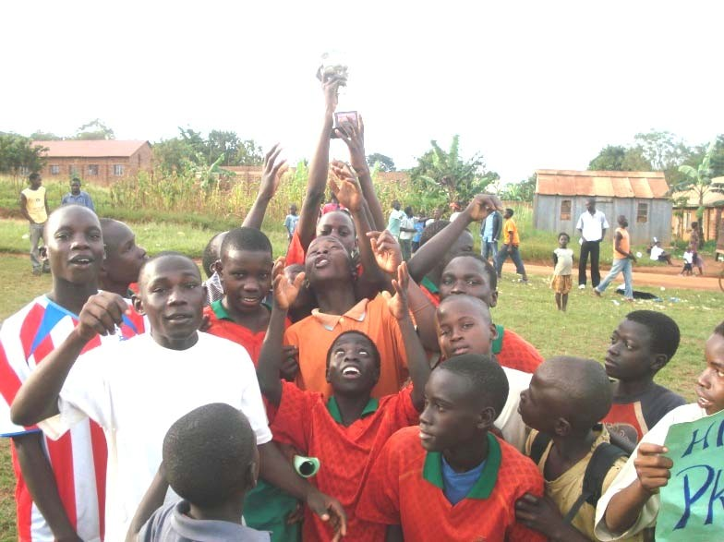

the Project included sports galas, games like football, forum theatres and music, dance and drama, all of which reinforced the messages of abstinence and fidelity.

*Youth jubilate after participating in a football match organized by the Project*

Since the Facilitators were central to the core Project activities, the evaluation assessed their preparedness for the task. The survey explored the Facilitators’ knowledge with regard to HIV/AIDS and STIs prevention, their skills as Facilitators and youth’s assessment of their work as Facilitators. Tables (12 – 14) present these findings.

**TABLE 12 : PE ER FACIL IT ATO RS’ K NOWL EDGE OF HIV/ AIDS AND OTHER STIS**

|  |
| --- |
| **Females Males** |
| % of No. of % of No. of  **Statement** respondents respondents respondents respondents with “True” with “True”  response response |
| **HIV does not cause death but** 95.5 47 96.7 59  **invades the immune system and slowly destroys it reducing its ability to fight off infections** |
| **Only people who look sick can** 16.7 08 1.6 1  **spread the AIDS virus** |
| **Most people who have AIDS** 16.3 08 6.6 4  **show signs of being sick right away** |
| **You can get AIDS from kissing** 38.8 19 34.4 21  **an infected person** |
| **HIV can only be transmitted by** 42.9 21 63.9 39  **ways that give it direct access to** |

|  |
| --- |
| **cells especially immune cells** |
| **Strategies for prevention of** 83.7 41 91.8 56  **STIs are similar to those for prevention of HIV** |
| **STIs greatly increases one’s** 95.9 47 93.4 57  **risk of HIV** |
| **HIV is not like a cold; we have** 69.4 34 70.5 43  **to go out of our way to get it.** |
| **There is no cure for STIs** 2.0 1 3.3 2 |

As shown in Table (12) the Facilitators’ level of knowledge of HIV/AIDS and other STIs was very high. The majority was knowledgeable about HIV transmissions and prevention and understood the link between HIV and STIs. This suggests that they were well prepared for the educational tasks that they performed.

**TABLE 13 : FACILIT AT ORS’ RESPO NSE S TO FACILITAT ION SKILL S STATEME NT S**

|  |
| --- |
| Statement **Yes Not sure n (%) n (%)** |
| **Facilitation does not necessarily involve being** 35 (31.0) 3 (2.7)  **focussed on the desired outcomes and generally maintaining a poisitive flow** |
| **Setting the ground rules is a way of guiding and** 110 (97.3) 1 (0.9)  **controlling a session** |
| **Facilitators intervene only if absolutelyrequired** 48 (42.5) 4 (3.5) |
| **It is not the resposibility of a facilitator to ensure** 6 (5.3) 1 (0.9)  **that participants hear, see and understand the information that is presented.** |
| **There is need to retain social distance between the** 53 (46.9) 1 (0.9)  **facilitator and the learner** |
| **The worst thing that can happen to a facilitator is** 40 (35.4) 1 (0.9)  **when a learner asks a question and he/she doesn’t know the answer** |
| **Effective facilitation involves knowing when to take** 99 (87.6) 1 (0.9)  **leadership, when to be neutral and when to take a back sit.** |
| **It is not important for a facilitator to understand** 14 (12.4) 1 (0.9)  **the different characteristics of group members in order to work with them effectively** |
| **It is okay to offer too much information too fast in a** 13 (11.5) 1 (0.9)  **bid to mind other people’s time** |
| **Communication with others usually starts with our** 111 (98.2) 1 (0.9)  **thoughts, resulting in words, tonality and body language.** |
| **Listening is just as important to communication as** 111(98.2)  **speaking** |
| **It is inevitable for the source of message to be** 90 (79.6)  **confident that what they are communicating is** |

**useful and accurate.**

**If the first few words do not capture the attention of a listener, they rapidly drift off to think of somethng else.**

**To improve ones communication skills, there is need to listen instead of assuming what others are saying.**

94 (83.2)

111 (98.2)

As shown in Table (13) the majority of the Facilitators understood their roles as Facilitators. Nearly all understood that setting ground rules is a way of guiding and controlling a session; that it was their responsibility to ensure their audiences heard, saw and understood the information presented. They also understood the importance of capturing the attention of listerners with the first few words and of being confident that what was being communicated was useful and accurate information.Youth in the survey were also asked to assess the Facilitators and Table (14) shows their responses.

**TABLE 14 : EVAL UATION OF FACILITATOR S B Y THE YOUTH**

|  |
| --- |
| Question **Yes Sometimes n (%) n (%)** |
| **Did you know him or her before becoming** 797 (22.7)  **a PF?** |
| **Was he or she friendly towards you?** 2521 (86.0) 85 (2.9) |
| **Was the peer facilitator knowledgable** 2805 (95.7) 53 (1.8)  **about HIV/AIDS** |
| **Could the facilitator answer the questions** 2814 (96.0) 56 (1.8)  **and comments addressed to him/her?** |
| **Did the facilitator divide you into small** 1736 (59.3) 117 (4.0)  **groups and lead small group discussion?** |
| **Did the facilitator use humor or jokes?** 2256 (77.0) 181 (6.2) |
| **Did the facilitator narrate his or her own** 2244 (76.6) 102 (3.5)  **feelings and personal experience?** |
| **Did the facilitator learn to use your names?** 1907 (65.1) 304 (10.4) |

Nearly all the youth (96%) reported that the Facilitators were knowledgeable and that they answered their questions. The majority of the youth also reported that they were friendly to them. Teachers during the interviews expressed appreciation of the knowledge and skills displayed by the Facilitators. They reported that the Peer Facilitators provided an environment of trust that enabled the youth to open up and receive the support that they needed when they opened up.

***3.1.3 Increased Knowledge on HIV/AIDS and STI prevention***

Increased knowledge on HIV/AIDS and STI prevention was highlighted by nearly all the stakeholders in the districts as major contributions made by the Project. A teacher explained:

*“We learnt new facts about HIV protection… our students benefitted because they lacked detailed information about HIV/AIDS and STI which we do not cover in detail at school due to our tight schedule. Our whole staff supported the program because we realized it was addressing relevant gaps in the school curriculum.”*

An NGO official in one of the districts reported that:

*“For years, all messages on HIV have focused on treatment and positive living. So when the Project came with the message of infection and prevention targeting youth …. We welcomed it. Many youth were ignorant and lacked a lot of information that is important to guide their decision making.”*

The survey sought to determine youths’ knowledge of HIV/AIDS and STI prevention covered in the *Smart Choices* curriculum. Table 15 shows youth’s performance on the knowledge questions regarding HIV/AIDS.

**TABLE 15 : YOUTH’ S KNOWLEDG E OF HIV/AIDS**

|  |
| --- |
| **Number and percentage of Number and percentage of males females who gave a “True” who gave a “True” response response** |
| HIV is the People No. of HIV was People who No. of same as who have females the same as have AIDS males AIDS AIDS AIDS show signs  show right away  signs right away |
| **Participant n (%) n (%) n (%) n (%) Characteristics** |
| **Age (yrs)** |
| **10-14** 353 (45.4) 315 (40.5) 778 266 (44.7) 229 (38.5) 595 |
| **15-24** 297 (42.8) 159 (22.9) 694 333 (40.5) 211 (25.7) 822 |
| **Schooling status when first reached** |
| **In-school** 568 (43.7) 442 (34.0) 1300 461 (40.6) 362 (31.9) 1143 |
| **Out of-school** 84 (49.1) 31 (18.1) 171 136 (48.9) 75 (27.0) 283 |
| **No. of sessions**  **1-3** 365 (44.4) 255 (31.0) 822 333 (41.3) 241 (29.9) 806  **4-6** 286 (44.1) 218 (33.4) 652 266 (43.5) 199 (32.6) 611 |

|  |  |  |  |
| --- | --- | --- | --- |
| **District** |  | | |
| **Kampala** | 196 (40.6) 155 (32.1) 483 | 167 (38.7) 163 (37.7) | 432 |
| **Wakiso** | 101 (43.3) 59 (25.3) 233 | 112 (42.3) 31 (11.7) | 265 |
| **Mukono** | 101 (38.3) 86 (32.6) 264 | 91 (37.6) 68 (28.1) | 242 |
| **Luwero** | 106 (44.0) 59 (24.5) 241 | 128 (48.9) 88 (33.6) | 262 |
| **Mpigi** | 148 (58.3) 115 (45.3) 254 | 110 (48.0) 95 (41.5) | 229 |

More than half of the youth aged 10-14 knew that HIV was not the same as AIDS and approximately 60% knew that people who have AIDS do not show signs right away. At baseline, only 8.7% males and 7.2% females had comprehensive knowledge about HIV AIDS (Baseline Report 2005). In their own words young people wrote to CAF expressing appreciation for what they learned through their participation in the Project. The following is a sample of what one of the youth wrote:

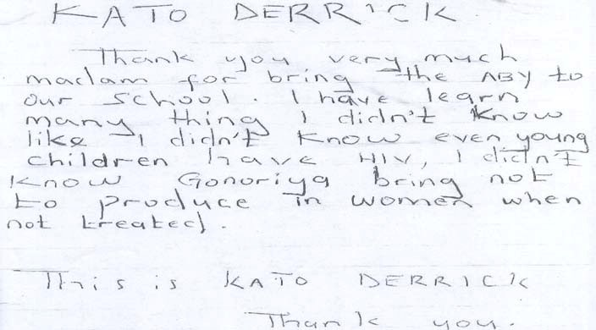

The survey also sought to determine youths’ knowledge of HIV/AIDS and STI transmission. Table 16 shows the youth performance on the knowledge questions regarding HIV/AIDS.

**TABLE 16 : YOUTH’ S KNOWLEDG E OF HIV T RANSMISSIO N**

|  |
| --- |
| **Number and percentage of females who responded “ *True*” to the Number and percentage of males who responded “ *True*” to the statements related to HIV transmission statement s related to HIV transmission** |
| Only Kissing Having Washi Sexual By a No. of Only Kissing Having Washing Sexual By a No. of people who an sexual ng intercour mosqui females people an sexual private intercour mosquit males look sick infected intercourse private se during to that who infected intercour parts se during o that  can spread partner with an parts menstrua has look partner se with with soda menstrua has the AIDS infected with tion bitten sick an tion bitten  virus partner soda an can infected an infecte spread partner infected d the person  person AIDS  virus |
| **Participant n n n n n n n n n n n n Characteristi (%) (%) (%) (%) (%) (%) (%) (%) (%) (%) (%) (%) cs** |
| **Age (yrs)** |
| **10-14** 333 (42.8) 446 718 131 301 409 778 267 308 556 108 211 297 595 (57.3) (92.3) (16.8) (36.7) (52.6) (44.5) (51.8) (93.4) (18.2) (35.5) (49.9) |
| **15-24** 159 (22.9) 342 643 69 122 232 694 214 404 768 91 168 288 822 (49.3) (92.7) (9.9) (17.6) (33.4) (26.0) (49.1) (93.4) (11.1) (20.4) (35.0) |
| **Schooling status when first reached** |
| **In-school** 449 (35.4) 700 1201 183 392 571 1,300 376 556 1063 157 317 457 1136 |

*Preserving the African Family in the Face of HIV/AIDS*

*Child Health and Development Centre Page 36*

|  |
| --- |
| (53.8) (92.4) (14.1) (30.2) (43.9) (33.1) (48.9) (93.6) (13.8) (27.9) (40.) |
| **Out of school** 43 (25.1) 87 159 16 31 70 171 102 153 258 42 60 128 276 (50.9) (93.0) (9.4) (18.1) (40.9) (36.7) (55.0) (92.8) (15.1) (21.6) (46.0) |
| **No. of sessions attended** |
| **1-3** 264 431 762 97 226 356 822 259 404 749 119 207 332 806 (32.1) (52.4) (92.7) (11.8) (27.5) (43.3) (32.1) (50.1) (92.9) (14.8%) (25.7) (41.2) |
| **4-6** 228 356 601 103 197 286 652 220 307 575 80 172 253 611 (35.0) (54.6) (92.2) (15.8) (30.2) (43.9) (36.0) (50.2) (94.1) (13.1) (28.2) (41.4) |
| **District** |
| **Kampala** 143 240 443 74 156 198 483 126 202 394 73 126 161 432 (29.6) (49.7) (91.7) (15.3) (32.3) (41.0) (29.2) (48.1) (91.2) (16.9) (29.2) (37.3) |
| **Wakiso** 66 117 219 20 65 94 233 80 119 249 34 71 105 265 (28.3) (50.2) (94.0) (8.6) (27.9) (40.3) (30.2) (44.9) (94.0) (12.8) (26.8) (39.6) |
| **Mukono** 75 139 245 29 52 112 264 72 119 229 34 58 89 242 (28.4) (52.7) (92.8) (11.0) (19.7) (42.4) (29.8) (49.2) (94.6) (14.0) (24.0) (36.8) |
| **Luwero** 77 132 222 20 45 93 241 94 147 244 28 59 113 262 (32.0) (54.8) (92.1) (8.3) (18.7) (38.6) (35.9) (56.1) (93.1) (10.7) (22.5) (43.1) |
| **Mpigi** 132 160 235 57 106 145 254 113 133 219 34 70 123 229 (52.0) (63.0) (92.5) (22.4) (41.7) (57.1) (49.3) (58.1) (95.6) (14.8) (30.6) (57.3) |

*Preserving the African Family in the Face of HIV/AIDS*

*Child Health and Development Centre Page 37*

The knowledge on HIV transmission through sexual intercourse with an infected partner was almost universal with levels ranging between 92.0% - 94%. However there were a few youth who still thought that only people who look sick can spread the AIDS virus, that washing private parts with soda can prevent HIV transmission and that HIV could be transmitted by a mosquito that has bitten an infected person. The following letter came from a youth who explains how he had been misled by his friends about HIV transmission

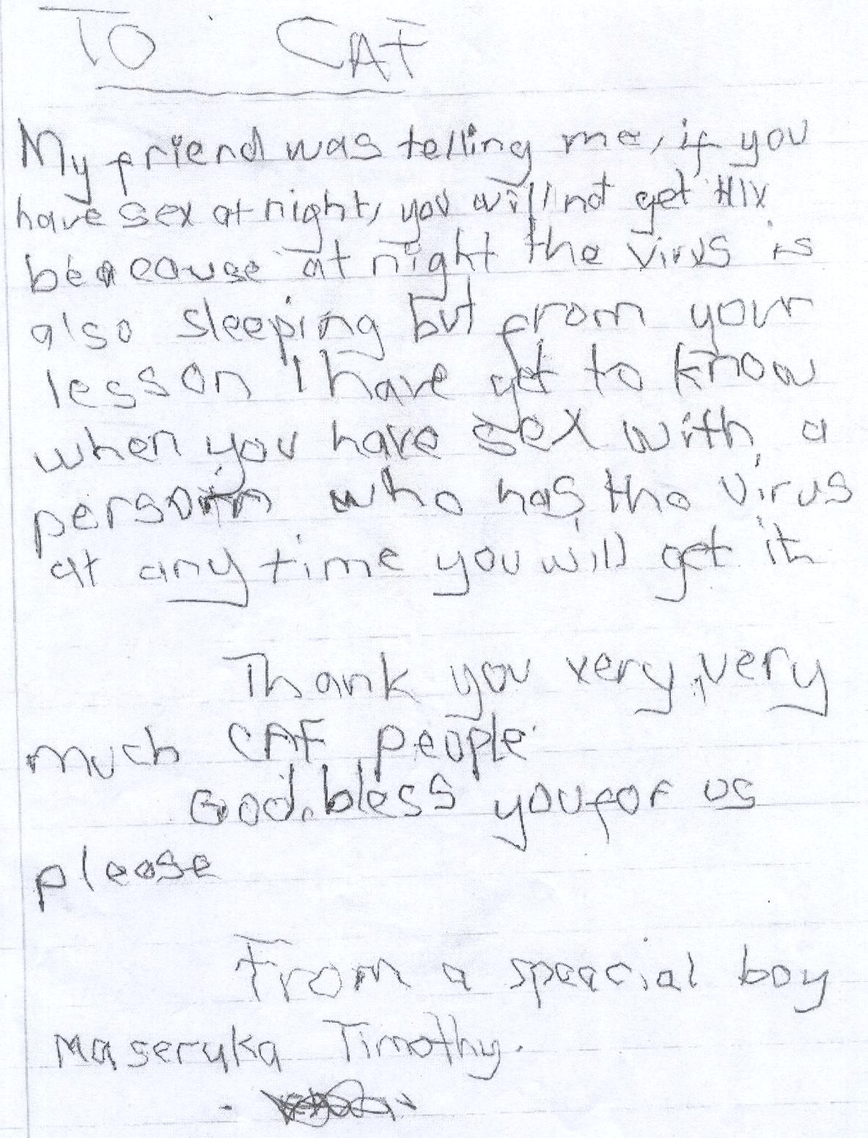

Knowledge about prevention through abstinence from sexual intercourse was also very high among the youth ranging from between 80.4% - 94.0% as shown in Table 17:

**TABLE 17 : YOUTH KNO WLE DGE O F H IV PREVE NTION**

|  |
| --- |
| **No. and percentage of females who No. and percentage of males who responded that HIV can be said that HIV can be prevented prevented by… by…** |
| **Participant** Abstinence Detect AIDS No. of Abstain Detect No. of  **Characteristic** from sex early and cure females from sex AIDS early males it and cure it |
| **n (%) n (%) n (%) n (%)** |
| **Age (yrs)** |
| **10-14** 658 (84.6) 386 (49.6) 778 512 (86.1) 294 (49.4) 597 |
| **15-24** 610 (87.9) 218 (31.4) 694 729 (88.7) 264 (32.1) 832 |
| **Schooling status when first reached** |
| **1n-school** 1114 (85.7) 546 (42.0) 1300 985 (86.7) 470 (41.4) 1136 |
| **Out of-school** 154 (90.1) 56 (32.7) 171 253 (91.0) 87 (31.3) 278 |
| **No. of sessions attended** |
| **1-3** 707 (86.0) 337 (41.0) 822 687 (85.2) 314 (39.0) 812 |
| **4-6** 563 (86.3) 267 (41.0) 652 554 (90.7) 245 (40.1) 617 |
| **District**  **Kampala** 396 (82.0) 198 (41.0) 483 368 (85.2) 191 (44.2) 432  **Wakiso** 219 (94.0) 74 (31.8) 233 241 (90.9) 78 (29.4) 265  **Mukono** 239 (90.5) 111 (42.0) 264 219 (90.5) 90 (37.2) 242  **Luwero** 213 (88.4) 102 (42.3) 241 227 (86.6) 111 (42.4) 262  **Mpigi** 204 (80.3) 119 (46.9) 254 197 (86.0) 96 (6.7) 229 |

However approximately 30-50% of the youth seemed not to know that AIDS cannot be cured irrespective of when it is detected. Other gaps in knowledge were further evidenced in the questions that they asked at the end of the evaluation. These included questions such as: *Can AIDS be cured? If an HIV infected person eats food and I eat it too, do I get AIDS? If you share a cup with an AIDS patient, do you get infected? If you wash infected persons clothes when you have a wound, do you get infected?*

In all, youth were very appreciative of the new knowledge that they had acquired through the Project as shown by the following extract from a letter written by a youth after going through the *Smart Choices* curriculum.

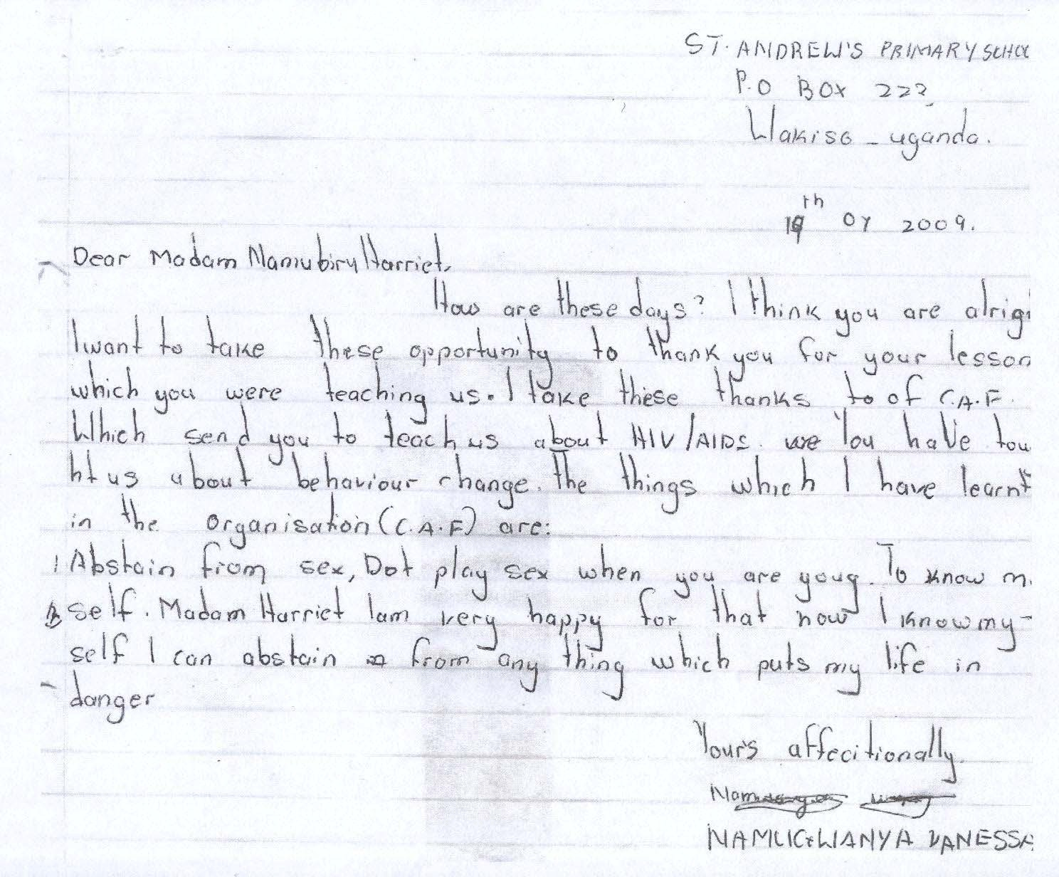

***3.1.4 Positive Attitudes Towards Abstinence***

Teachers, parents and community leaders commended the Project for having brought about changes in attitudes towards abstinence among the youth in their communities. Teachers interviewed in some of the schools explained that since the introduction of the Project they had observed that there were fewer girls dropping out of school due to pregnancy and fewer young people openly involving themselves in relationships. A teacher explained that:

*“This Project has brought about real changes in my school. We used to send girls away every term due to pregnancy but this has reduced. This year we have not sent any girl home yet and that is a new development. Another improvement has been in the area of relationships. Girls and boys in this school used to engage in sex and they did not care whether they got HIV or not. But now they are exercising more caution and they are even more focused than before which we welcome as a school.”*

A community leader who was also a member of the Local Advisory Committee reported that:

*“A lot of young girls used to engage in transactional sex for survival and they thought that it was okay to do this since they did not have money. But the messages on Something for Something love helped some of them check their behavior. Maybe they are continuing to engage in it secretly but I no longer see as many…*.”

The survey explored youth’s attitudes towards abstinence and their intentions to abstain as shown in Tables 18- 20;

**TABLE 18 : ATT ITUDES TOWARDS ABSTINEN CE**

|  |
| --- |
| **Percentage of females who said that … Percentage of males who said that HIV can be prevented by…** |
| **Characteristic** Sex is Having Useless to All Sex is If girl Total Sex is a Having Useless to All good Sex is If girl Total a sex talk about good the only does No. of natural sex talk about girls and the only does not No. natural creates abstinence girls way not females urge creates abstinence boys will way have sex of urge bond if one had and one can have that one bond if one had be taken one can early her males that sex before boys show sex cannot sex before by those show vagina  one will be love early control willing to love hardens cannot taken her have sex  control by vagina  those hardens willing  to have  sex |
| **n N n n n n N n n n n n**  **(%) (%) (%) (%) (%) (%) (%) (%) (%) (%) (%) (%)** |
| **Age (yrs)** |
| **10-14** 426 358 378 220 236 114 778 332 267 307 183 176 127 595 (54.8) (46.0) (48.6) (28.3) (30.3) (14.7) (55.8) (44.9) (51.6) (30.8) (29.8) (21.3) |
| **15-24** 323 325 239 96 125 57 694 449 453 306 179 188 124 822 (46.5) (46.8) (34.4) (13.8) (18.0) (8.2) (54.3) (54.6) (37.2) (21.8) (22.9) (15.1) |
| **Schooling status when first reached** |

*Preserving the African Family in the Face of HIV/AIDS*

*Child Health and Development Centre Page 42*

|  |
| --- |
| **In-school** 653 575 555 285 313 148 1300 618 545 501 301 284 200 1136 (50.2) (44.2) (42.7) (21.9) (24.1) (11.4) (54.4) (48.0) (44.1) (26.5) (25.0) (17.6) |
| **Out of-school** 95 108 64 31 46 22 171 157 170 110 59 78 50 278 (55.6) (63.2) (37.4) (18.1) (26.9) (12.9) (56.5) (61.2) (39.6) (21.2) (28.1) (18.0) |
| **No. of sessions attended** |
| **1-3** 417 372 346 178 199 97 822 438 405 357 196 200 147 806 (50.7) (45.3) (42.1) (21.7) (24.2) (11.8) (54.3) (50.2) (44.3) (24.3) (24.8) (18.2) |
| **4-6** 334 313 273 138 162 74 652 339 310 256 166 164 104 611 (51.2) (48.0) (41.9) (21.2) (24.8) (11.3) (55.5) (50.7) (41.9) (27.2) (26.8) (17.0) |
| **District** |
| **Kampala** 241 231 202 117 108 49 483 252 220 187 143 110 82 425 (49.9) (47.8) (41.8) (24.2) (22.4) (10.1) (59.3) (51.8) (44.0) (33.6) (25.9) (19.3) |
| **Wakiso** 94 87 83 37 32 29 233 118 104 101 34 35 29 264 (40.3) (37.3) (35.6) (15.9) (13.7) (12.4) (44.7) (39.4) (38.3) (12.9) (13.3) (11.0) |
| **Mukono** 127 119 114 50 52 27 264 123 124 96 62 54 39 241 (48.1) (45.1) (43.2) (18.9) (19.7) (10.2) (51.0) (51.5) (39.8) (25.7) (22.4) (16.2) |
| **Luwero** 144 126 98 46 77 31 241 157 132 115 60 82 50 260 (59.8) (52.3) (40.7) (19.1) (32.0) (12.9) (60.4) (50.8) (44.2) (23.1) (31.5) (19.2) |
| **Mpigi** 145 122 122 66 92 35 254 128 136 114 63 83 51 228 (57.1) (48.0) (48.0) (26.0) (36.2) (13.8) (56.1) (59.6) (50.0) (27.6) (36.4) (22.4) |

*Preserving the African Family in the Face of HIV/AIDS*

*Child Health and Development Centre Page 43*

It was encouraging to note that approximately three quarters of youth in the survey were able to dispel commonly held beliefs and attitudes about sex such as: *sex is the only way one can show love* and *if a girl does not have sex early her vagina hardens* and *all good girls and boys will be taken by those willing to have sex.*

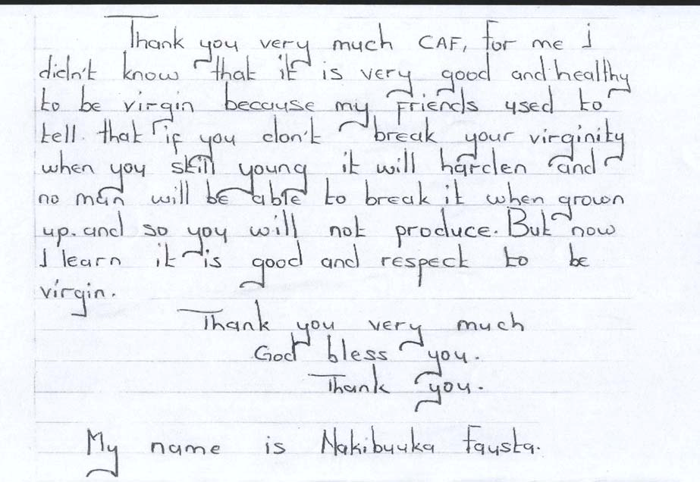

Nearly half (48.5%) of the female and 51.6% of the male youth aged 10-14 years reported that it was useless to talk about sexual abstinence if one has had sex before, an indication perhaps that they did not understand secondary abstinence. The Project in most cases seems to have successfully dispelled some of the misinformation circulating among young people as the following letter illustrates.

*Preserving the African Family in the Face of HIV/AIDS*

*Child Health and Development Centre Page 44*

**TABLE 19 : IN TE NTIO NS TO A BSTAIN**

|  |
| --- |
| **Number and percentage of females who responded “ *Yes*” to the Number and percentage of males who responded “ *Yes*” to the statements related to intentions to abstain statements related to intentions to abstain** |
| Change What Committed Kept Plan to Total Change What Committed Kept Plan to Total what will happens to commitment abstain No. of what will happens to commitment abstain No. of happen in life is abstinence to abstain until females happen in life is abstinence to abstain until males tomorrow just during the marriage tomorrow just during the marriage  by what is meant to life of by what is meant to life of done happen Project done happen Project  today today |
| **Participant** n n n n n n n n n n  **characteristic** (%) (%) (%) (%) (%) (%) (%) (%) (%) (%) |
| **Age (years)**  **10 -14** 601 574 740 754 759 778 495 443 550 554 556 597 (77.2) (73.8) (95.1) (96.9) (97.6) (83.2) (74.5) (92.4) (93.1) (93.4)  **15 – 24** 609 497 630 646 639 694 718 568 713 720 691 832 (87.8) (71.6) (90.8) (93.1) (92.1) (87.3) (69.1) (86.7) (87.6) (84.1) |
| **Schooling status when first reached**  **In-school** 1062 940 1219 1250 1248 1,300 966 797 1028 1042 1024 1136 (81.7) (72.3) (93.8) (96.2) (96.0) (85.0) (70.2) (90.5) (91.7) (90.1)  **Out of school** 149 131 150 149 150 171 244 212 232 229 220 278  (87.1) (76.6) (87.7) (87.1) (87.7) (87.8) (76.3) (83.5) (82.4) (79.1) |

**No. of sessions**

|  |  |  |  |  |  |  |  |  |  |  |  |  |
| --- | --- | --- | --- | --- | --- | --- | --- | --- | --- | --- | --- | --- |
| **attended**  **1-3** |  | | | | | | | | | | | |
|  | 679 | 599 | 757 | 775 | 776 | 822 | 682 | 564 | 716 | 721 | 705 | 812 |
| **4-6** | (82.6) | (72.9) | (92.1) | (94.3) | (94.4) |  | (84.0) | (69.5) | (88.2) | (88.8) | (86.8) |  |
|  | 533 | 473 | 615 | 627 | 624 | 652 | 542 | 458 | 557 | 565 | 554 | 617 |
|  | (81.7) | (72.5) | (94.3) | (96.2) | (95.7) |  | (87.8) | (74.2) | (90.3) | (91.6) | (89.8) |  |
| **District** |  |  |  |  |  |  |  |  |  |  |  |  |
| **Kampala** | 376 | 332 | 443 | 471 | 459 | 483 | 350 | 303 | 377 | 389 | 370 | 432 |
|  | (77.8) | (68.7) | (91.7) | (97.5) | (95.0) |  | (81.0) | (70.1) | (87.3) | (90.0) | (85.6) |  |
| **Wakiso** | 181 | 139 | 231 | 230 | 227 | 233 | 213 | 155 | 246 | 244 | 232 | 265 |
|  | (77.7) | (59.7) | (99.1) | (98.7) | (97.4) |  | (80.4) | (58.5) | (92.8) | (92.1) | (87.5) |  |
| **Mukono** | 236 | 193 | 254 | 258 | 256 | 264 | 223 | 172 | 219 | 226 | 222 | 242 |
|  | (89.4) | (73.1) | (96.2) | (97.7) | (97.0) |  | (29.1) | (71.1) | (90.5) | (93.4) | (91.7) |  |
| **Luwero** | 222  (92.1) | 196  (81.3) | 222  (92.1) | 220  (91.3) | 226  (93.8) | 241 | 244  (93.1) | 209  (79.8) | 236  (90.1) | 232  (88.5) | 227  (86.6) | 262 |
| **Mpigi** | 198 | 213 | 223 | 224 | 233 | 254 | 195 | 184 | 196 | 195 | 208 | 229 |
|  | (78.0) | (83.9) | (87.8) | (88.2) | (91.7) |  | (85.2) | (80.3) | (85.6) | (85.2) | (90.8) |  |

Nearly all the youth (more than 90%) reported that they were committed to abstinence during the life of the Project. A slightly higher number reported that they had kept their commitment. This suggests that there were a few who did not commit themselves to abstinence but did abstain all the same. It is encouraging to note that the plan to abstain from sex until marriage was almost universal among 10-14 (93.4%) and very high for 15-24 youth (84.1%) compared 60.6% males and 72.4% females at baseline.

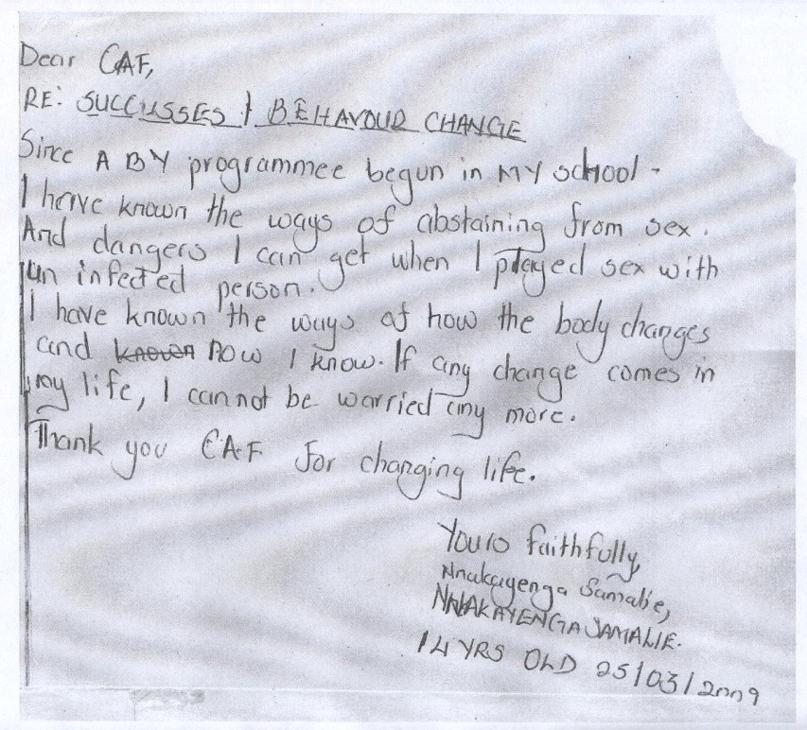

The evaluation also explored social norms among youth with regard to delayed initiation of sexual activity Table 19 above present the findings:

*Preserving the African Family in the Face of HIV/AIDS*

*Child Health and Development Centre Page 47*

**TABLE 20 : SOCIAL NORMS W ITH REG ARD TO DELAYE D INITIAT IO N OF SEX UAL AC TIVIT Y FOR FE MALE YOUTH**

|  |
| --- |
| **Number and percentage of females who responded “ *Yes*” to statements on social norms towards delayed initiation of sexual activity** |
| Most friends Most friends Most friends Most Most adults Parents would Having Having Total have had sex plan to think one friends discourage be upset if sex makes sex is cool Females  abstain until has to be think I people my found out I was boy or girl marriage married to should not age from having sex popular  have sex have sex having sex |
| **Participant n (%) n (%) n (%) n (%) n (%) n (%) n (%) n (%)**  **characteristic** |
| **Age (years)**  **10-14** 156 (20.1) 596 (76.6) 598 (76.9) 672 (86.4) 732 (94.1) 745 (95.8) 198 (25.4) 50 (6.4) 778  **15-24** 275 (39.6) 408 (58.8) 447 (64.4) 489 (70.5) 603 (86.9) 641 (92.4) 140 (20.2) 70 (10.1) 694 |
| **Schooling status when first reached**  **In-school** 334 (25.7) 917 (70.5) 936 (72.0) 1049(80.7) 1200 (92.3) 1253 (96.4) 294 (22.6) 83 (6.4) 1,300  **Out of-school** 96 (56.1) 88 (51.5) 109 (63.7) 112 (65.5) 135 (78.9) 134 (78.4) 45 (26.3) 36 (21.1) 171 |
| **No. of sessions attended**  **1-3** 234 (28.5) 551 (67.0) 576 (70.1) 650 (79.1) 751 (91.4) 772 (94.3) 178 (21.7) 68 (8.3) 822  **4-6** 197(30.2) 454 (69.6) 471 (72.2) 513 (78.7) 586 (89.9) 613 (94.0) 161 (24.7) 52 (8.0) 652 |
| **District**  **Kampala** 124 (25.7) 368 (72.6) 357 (73.9) 408 (84.5) 440 (91.1) 448 (92.8) 93 (19.3) 35 (7.2) 425 |

|  |  |  |  |  |  |  |  |  |  |
| --- | --- | --- | --- | --- | --- | --- | --- | --- | --- |
| **Wakiso** | 35 (15.0) 146 (62.7) 157 (67.4) 178 (76.4) 215 (92.3) 224 (96.1) 41 (17.6) 18 (7.7) 264 | | | | | | | | |
| **Mukono** | 93 (35.2) | 186 (70.5) | 188 (71.2) | 195 (73.9) | 229 (86.7) | 245 (92.8) | 57 (21.6) | 22 (8.3) | 241 |
| **Luwero** | 89 (36.9) | 142 (58.9) | 166 (68.9) | 180 (74.7) | 219 (90.9) | 222 (92.1) | 60 (24.9) | 18 (7.5) | 260 |
| **Mpigi** | 90 (35.4) | 164 (64.6) | 179 (70.5) | 202 (79.5) | 235 (92.5) | 250 (98.4) | 88 (34.6) | 27 (10.6) | 228 |

Most female youth (85% and more) reported that most adults discourage youth of their age group from having sex and more than 90% reported that their parents would be upset if they found out that they were having sex. More than three quarters of the girls aged 10-14 and about two thirds of those aged 15-24 reported that most of their friends thought that one had to be married to have sex and an equal number reported that their friends thought that they should not have sex. Approximately 77% of the girls aged 10-14 reported that their friends planned to abstain until marriage. In general, the majority of the youth held positive attitudes towards abstinence.

***3.1.5 Increased Awareness of Sexual Risky Behavior***

Stakeholders including youth reported that there was now increased awareness of sexual risky behavior among the youth unlike in the past.

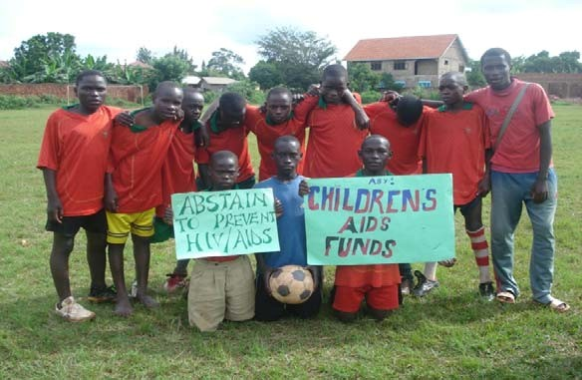

*Youth display placards of HI V prevention messages*

Youth were now reportedly more cautious about the way they behaved and where they went. Transactional and cross generational sex were some of the risky behaviors reported across the five districts. Parents complained about the boda- boda riders, while others expressed concern about plantation workers.

The evaluation explored youth’s attitudes towards transactional sex. The findings are presented in Table 21:

*Preserving the African Family in the Face of HIV/AIDS*

*Child Health and Development Centre Page 50*

**TABLE 21 : YOUTH ATT IT UDES TOWARDS SOMETHING FO R SO METHING LO VE**

|  |  |
| --- | --- |
| **Number and percentage of females who responded “ *True* ” to Number and percentage of males who responded “ *True*” to statements on “Something for Something love” statements on “Something for Something love”** | |
| Fair game if sugar Teacher who Something Total No. Fair game if Teacher who Something Total No. of daddy/mummy as ask for sex for of females sugar ask for sex from for males  pay back for sex from a student something daddy/mummy a student should Something  should be love is better as pay back for be arrested love is better arrested than sex than  prostitution prostitution | |
| **Participants n (%) n (%) n (%) n (%) n (%) n (%)**  **characteristics** | |
| **Age (years)**  **10 -14**  **15 -24** | 46 (5.9) 750 (96.4) 334 (42.9) 778 20 (3.4) 560 (94.1) 286 (48.2) 595  43 (6.2) 664 (95.7) 247 (35.6) 694 47 (5.7) 781 (95.0) 312 (38.1) 822 |
| **Schooling status when first reached**  **In-school** 77 (5.9) 1248 (96.0) 517 (39.8) 1,300 55 (4.8) 1073 (94.5) 505 (44.5) 1136  **Out-of-school** 12 (7.0) 165 (96.5) 62 (36.3) 171 12 (4.3) 265 (95.3) 93 (33.5) 278 | |
| **No. of sessions attended**  **1-3** 49 (5.9) 798 (96.3) 331 (39.9) 829 47 (5.8) 758 (94.0) 361 (44.8) 806  **4-6** 41 (6.2) 633 (95.9) 256 (38.8) 660 20 (3.3) 583 (95.4) 236 (38.6) 611 | |
| **District** 49(10.1) 462 (95.7) 185 (38.3) 483 31 (7.3) 391 (92.0) 203 (47.8) 425  **Kampala** 06 (2.6) 226 (97.0) 75 (32.2) 233 13 (4.9) 254 (96.2) 99 (37.5) 264  **Wakiso** 13 (4.9) 248 (93.9) 104 (39.4) 264 9 (3.7) 224 (92.9) 80 ( 33.2) 241  **Mukono** 11 (4.6) 233 (96.7) 93 (38.6) 241 10 (3.8) 253 (97.3) 97 (37.3) 260 | |

**Luwero**

**Mpigi**

10 (3.9) 248 (97.6) 124 (48.8) 254 4 (1.8) 220 (96.5) 119 (52.2) 228

About half of the youth aged 10-14 reported that *Something for Something Love* was no better than prostitution. More than 60% of females aged

15-24 and of males of the same age group reported the same. One area of consensus among the youth across all age groups and gender was that a teacher who asks for sex from a student should be arrested. The survey also explored youth’s recognition of risky situations and behavior. The findings are presented in Table 22:

**TABLE 22 : RE COGNITION O F RISKY SIT UAT IONS A ND B EH AVIO RS**

|  |
| --- |
| **Number and percentage of females who responded “*Yes*” to the Number and percentage of males who responded “ *Yes*” to the statements related to perceptions of risky sexual behaviors statements related to perceptions of risky sexual behaviors** |
| Likely to Alcohol Watching Dressing Media No. of Likely to Alcohol Watching Dressing Media No. get HIV impairs films and can be portrays females get HIV impairs films and can be portrays of infected or person’s other TV interpreted sex infected or person’s other TV interpreted sex males another ability to programs to mean negatively another ability to programs to mean negatively  STI if they recognize can make readiness STI if they recognize can make readiness have potentially it harder for sex have potentially it harder for sex sexual dangerous to abstain sexual dangerous to abstain  intercourse situation from sex intercourse situation from sex before before  marriage marriage |
| **Participant N n n n n N n n n n characteristics (%) (%) (%) (%) (%) (%) (%) (%) (%) (%)** |
| **Age (years)**  **10-14** 687 551 536 516 472 778 532 442 402 395 365 595 (88.3) (70.8) (68.9) (66.3) (60.7) (89.4) (74.3) (67.6) (66.4) (61.3) |

|  |
| --- |
| **15-24** 610 509 447 392 381 694 714 642 588 543 520 822 (87.9) (73.3) (64.4) (56.5) (54.9) (86.9) (78.1) (71.5) (65.0) (63.3) |
| **Schooling status when first reached**  **In-school** 1137 927 856 798 742 1,300 993 857 786 736 702 1136 (87.5) (71.3) (65.8) (61.4) (57.1) (87.4) (75.4) (69.2) (65.0) (61.8)  **Out-of-school** 158 133 125 109 109 171 250 225 202 190 181 278  (92.4) (77.8) (73.1) (63.7) (63.7) (89.9) (80.9) (72.7) (68.3) (65.1%) |
| **No. of sessions attended**  **1-3** 722 594 534 492 452 822 704 624 574 518 487 812 (87.8) (72.3) (65.0) (59.9) (55.0) (86.7) (76.8) (70.7) (63.8) (60.0)  **4-6** 576 486 450 417 400 652 553 471 426 423 408 617  (88.3) (71.8) (69.0) (64.0) (61.3) (89.6) (76.3) (69.0) (68.6) (66.1) |
| **District**  **Kampala** 414 322 318 283 265 483 353 330 294 272 272 432 (85.7) (66.7) (65.8) (58.6) (54.9) (81.7) (76.4) (68.1) (63.0) (63.0)  **Wakiso** 198 168 157 116 107 233 238 197 183 142 123 265 (85.0) (72.1) (67.4) (49.8) (45.9) (89.8) (74.3) (69.1) (53.6) (46.4)  **Mukono** 229 204 175 187 158 264 219 182 170 175 178 242 (86.7) (77.3) (66.3) (70.8) (59.8) (90.5) (75.2) (70.2) (72.3) (73.6)  **Luwero** 222 189 167 166 147 241 243 208 195 194 157 262 (92.1) (78.4) (69.3) (68.9) 61.0) (92.7) (79.4) (74.4) (74.0) (59.9)  **Mpigi** 236 180 168 157 176 254 205 179 159 159 166 229 (92.9) (70.9) (66.1) (61.8) (69.3) (89.5) (78.2) (69.4) (69.4) (72.5) |

*Preserving the African Family in the Face of HIV/AIDS*

*Child Health and Development Centre Page 53*

The majority of youth (60% and more) in the survey recognized that alcohol can impair a person’s ability to recognize potentially dangerous situations; that watching films and other TV programs, especially those with sexual scenes, can make it hard to abstain from sex and the way one dresses can be interpreted to mean readiness for sex. What was interesting, however, was that more than 85% of all the youths, regardless of their age and sex, reported that one was likely to get HIV infected or another STI if they had sexual intercourse before marriage.

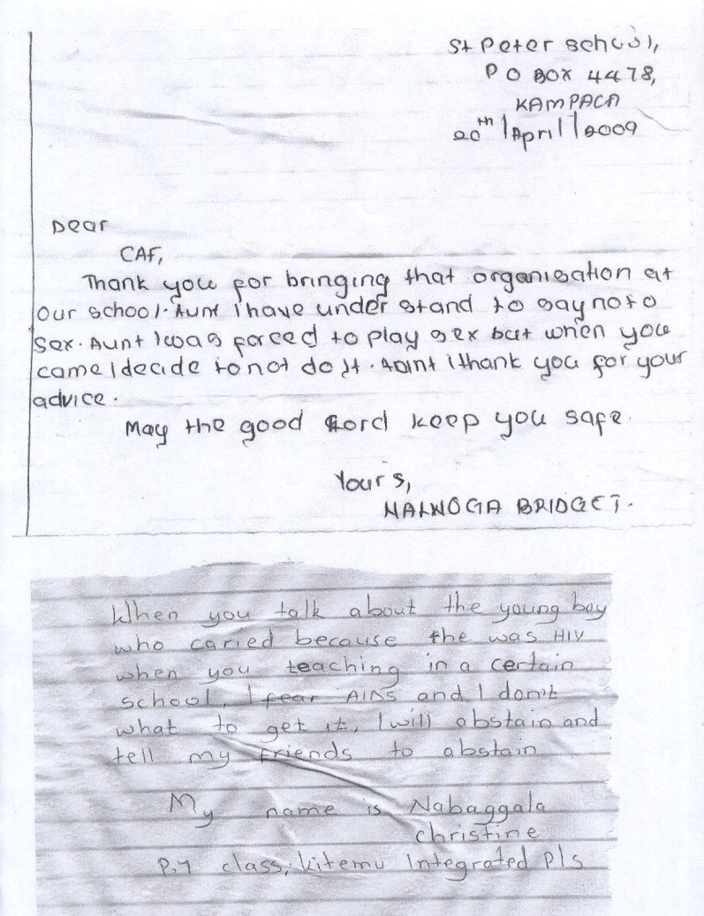

***3.1.6 Increased Parent-Child Communication***

The stakeholders interviewed reported that the Project had contributed to increased parent- child communication through the promotion of parent-child dialogues and through the *Smart Choices* parenting sessions. Parents during the discussions acknowledged the existence of a communication gap between themselves and their adolescent children. Stakeholders attributed this gap to the belief held by many parents that *one shouldn’t talk about sexual issues with his/her own children*. Others reported that parents *feared* or *were uncomfortable* talking to their adolescents about issues relating to sexuality and adolescents were also uncomfortable about opening up and talking to their parents. Community leaders and teachers reported that through the Project parents were beginning to open up to their children and the children were also beginning to do the same. A community leader reported that:

*“This Project was very good and helpful to us because our children were not opening up to us.”*

An Adult Facilitator explained that: “*During the training … youth reported that their parents and teachers were harsh when they asked them about issues on sexual behavior.”* Another facilitator reported:

*“A girl came to me recently, she had been raped by her uncle and got pregnant but she never disclosed this to her parents. She came to me for advice and I am now counseling her to see that she opens up to her parents.”*

Stakeholders in all the five districts appreciated the Project’s efforts to impart communication skills to both adolescents and parents through parent-child dialogues and through the educational sessions with the youth. In the survey the youth’s communication with their parents was assessed. Table 23 presents the findings:

**TABLE 23 : PARENT-CHIL D CO MMUNICATION**

|  |
| --- |
| **Number and percentage of females who responded “ Yes” to Number and percentage of males who responded “ Yes” to the the statements related to parent-child communication statements related to parent-child communication** |
| Talked Talked Talked with Feel **No. of** Talked Talked Talked with Feel **No. of** with with parents or comfortable **Females** with with parents or adults comfortable **males** parents parents or adults about talking with parents or parents or about abstinence talking with  or adults adults abstinence parents adults adults from sex parents about about sex about from sex about about sex about protection from  protection protection protection HIV/AIDs and  against from against other STIs  HIV/AIDS HIV/AIDs HIV/AIDS and other and other and other STIs STIs STIs |
| **Participant n N n n N n n n characteristics (%) (%) (%) (%) (%) (%) (%) (%)** |
| **Age (years)**  **10-14** 291 504 503 519 778 162 361 333 334 595 (37.4) (64.8) (64.7) (66.1) (27.2) (60.7) (55.8) (56.1)  **15-24** 377 571 550 539 694 412 603 586 556 822 (54.3) (82.3) (79.3) (76.9) (50.1) (73.4) (70.4) (67.6) |

|  |  |  |  |  |  |  |  |  |  |  |
| --- | --- | --- | --- | --- | --- | --- | --- | --- | --- | --- |
| **Schooling status when first reached** |  | | | | | | | | | |
| **In-school** | 569 | 935 | 934 | 916 | 1,300 | 413 | 760 | 719 | 695 | 1136 |
|  | (43.8) | (71.9) | (71.8) | (70.5) |  | (36.4) | (66.9) | (63.3) | (61.2) |  |
| **Out-of-school** | 97 | 139 | 118 | 131 | 171 | 162 | 203 | 191 | 194 | 278 |
|  | (56.7) | (81.3) | (69.0) | (76.6) |  | (58.3) | (73.0) | (68.7) | (69.8) |  |
| **No. of sessions** |  |  |  |  |  |  |  |  |  |  |
| **1-3** | 349 | 569 | 554 | 572 | 822 | 337 | 533 | 517 | 495 | 812 |
| **4-6** | (42.5) | (69.2) | (68.6) | (69.7) |  | (41.8) | (66.1) | (64.1) | (61.0) |  |
|  | 320 | 508 | 491 | 478 | 652 | 238 | 432 | 396 | 401 | 617 |
|  | (49.1) | (77.9) | (75.3) | (73.3) |  | (39.0) | (70.7) | (64.8) | (65.0) |  |
| **District** |  |  |  |  |  |  |  |  |  |  |
| **Kampala** | 195 | 300 | 320 | 308 | 483 | 148 | 253 | 262 | 236 | 432 |
|  | (40.4) | (62.1) | (66.3) | (63.9) |  | (34.3) | (58.6) | (60.6) | (54.6) |  |
| **Wakiso** | 81 | 162 | 157 | 163 | 233 | 85 | 170 | 167 | 165 | 265 |
|  | (34.8) | (69.5) | (67.4) | (70.0) |  | (32.1) | (64.2) | (63.0) | (62.3) |  |
| **Mukono** | 144 | 229 | 221 | 213 | 264 | 125 | 191 | 184 | 170 | 242 |
|  | (54.5) | (86.7) | (83.7) | (80.7) |  | (51.7) | (78.9) | (76.0) | (70.2) |  |
| **Luwero** | 134 | 188 | 183 | 173 | 241 | 144 | 200 | 183 | 175 | 262 |
|  | (55.6) | (78.0) | (75.9) | (71.8) |  | (55.0) | (76.3) | (69.8) | (66.8) |  |
| **Mpigi** | 116 | 199 | 175 | 194 | 254 | 81 | 161 | 124 | 150 | 229 |
|  | (45.7) | (78.3) | (68.9) | (76.4) |  | (35.4) | (70.3) | (54.1) | (65.5) |  |

*Preserving the African Family in the Face of HIV/AIDS*

*Child Health and Development Centre Page 58*

More than 60% of the youths felt comfortable communicating with their parents about protection from HIV/AIDS, STIs and about abstaining from sex. This suggests progress was made by the Project in bridging the communication gap between parents and their children. Letters from some of the youth narrated how they had learnt to communicate better with their parents.

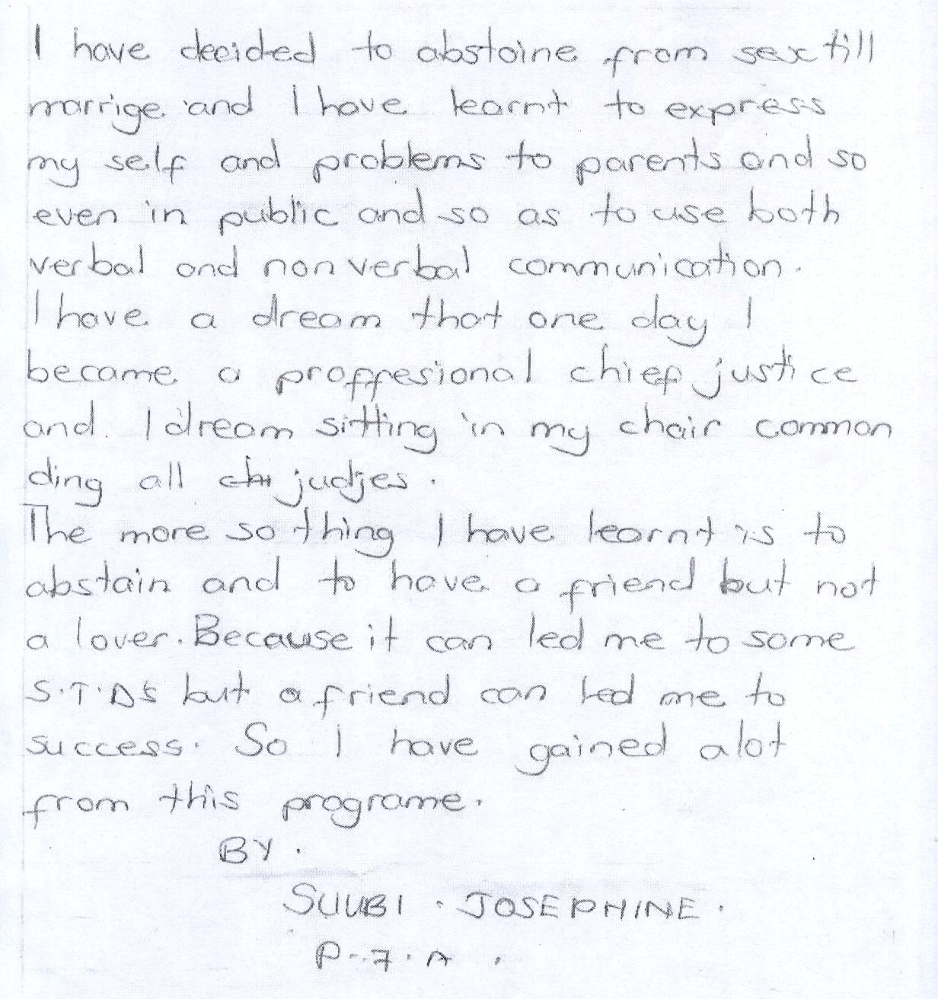

The parents reported that the Project had helped them understand their roles and the importance of talking to their children. A parent reported that:

*“Originally, I did not communicate well with my children but now I do it. And my children are now open with me. My adolescent daughter told me of a boda-boda cyclist who used to visit when I was at work, promising her and the young ones money. I discouraged her from giving him an opportunity to talk to her and I searched for the boda-boda man and had a word with him.”*

Several parents, especially mothers, reported positive developments in this area. The survey also sought to establish youth’s assessment on their ability to communicate openly. Table 24 shows the findings from the survey:

*Preserving the African Family in the Face of HIV/AIDS*

*Child Health and Development Centre Page 59*

**TABLE 24 : CO MMUNICATION SK ILLS**

|  |
| --- |
| **Number and percentage of females who responded “ *Yes*” to Number and percentage of females who responded “ *Yes*” to statements on communication skills statements on communication skills** |
| Send the right Talk about sex Sustain a Total No. Send the right Talk about sex Sustain a Total No. message without without being conversation of females message without without being conversation of males necessarily embarrassed on HIV/AIDS necessarily embarrassed on HIV/AIDS  talking talking |
| **Participant n (%) n (%) n (%) n (%) n (%) n (%) Characteristics** |
| **Age (years)**  **10-14** 476 (61.2) 279 (35.9) 574 (73.8) 778 393 (66.1) 223 (37.5) 437 (73.4) 595  **15-24** 474 (68.3) 389 (56.1) 569 (82.0) 694 605 (73.6) 554 (66.2) 688 (83.7) 822 |
| **Schooling status when first reached**  **In-school** 826 (63.5) 556 (42.8) 991 (76.2) 1,300 776 (68.3) 562 (49.5) 890 (78.3) 1136  **Out-of-school** 123 (71.9) 111 (64.9) 149 (87.1) 171 219 (78.8) 204 (73.4) 233 (83.8) 278 |
| **No. of sessions attended**  **1-3** 522 (63.5) 366 (44.5) 619 (75.3) 822 543 (67.4) 438 (54.3) 622 (77.2) 806  **4-6** 428 (65.6) 303 (46.5) 525 (80.6) 652 455 (74.5) 329 (53.8) 503 (82.3) 611 |
| **District**  **Kampala** 313 (64.8) 213 (44.1) 361 (74.7) 483 286 (67.3) 232 (54.6) 341 (80.2) 425  **Wakiso** 141 (60.5) 90 (38.6) 161 (69.1) 233 189 (71.6) 130 (49.2) 184 (69.7) 264  **Mukono** 168 (63.6) 128 (48.5) 213 (80.7) 264 181 (75.1) 131 (54.4) 214 (88.8) 241  **Luwero** 161 (66.8) 131 (54.4) 198 (82.2) 241 188 (72.3) 160 (61.5) 208 (80.0) 260 |

**Mpigi** 168 (66.1) 107 (42.1) 211 (83.1) 254 154 (67.5) 115 (50.4) 179 (78.5) 228

There were differences in the responses between the youth aged 10-14 and 15-24 in both sexes with regard to communication skills. Differences were pronounced when it came to issues such as talking about sex without embarrassment. Only one third of the youth aged 10-

14 in both sexes reported that they could talk about sex without embarrassment, compared to

56% of the females and 66% of the males aged 15-24. More than 70% of the youth could sustain a conversation on HIV/AIDS and could send the right message without necessarily talking.

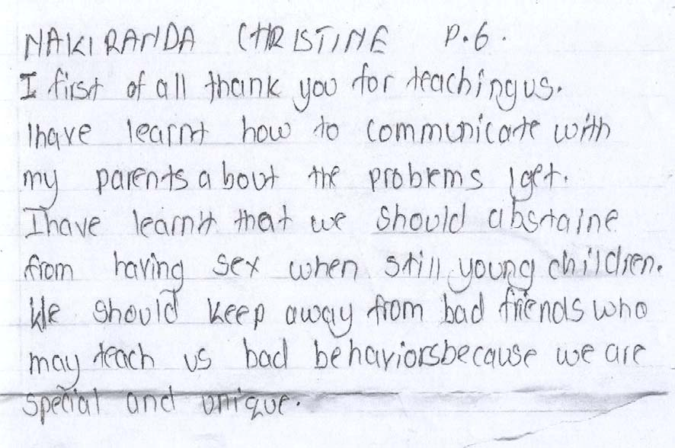

***3.1.7 Developed Life Skills***

Teachers and other adults in the community reported the Project had raised young people’s awareness about themselves. According to the parents some of the youth now set their own life goals and worked towards achieving their dreams. Teachers, parents and community leaders all revealed that prior to the introduction of the Project young people were not focused, they went to school because their parents told them to and many of the girls dropped out early in order to get married or due to pregnancy. Boys dropped out of school to engage in petty jobs. The survey explored the life skills developed by the youth and Table 25 presents the findings:

*Preserving the African Family in the Face of HIV/AIDS*

*Child Health and Development Centre Page 62*

**TABLE 25 : LIFE SKILLS AMONG YO UTH**

|  |
| --- |
| **Number and percentage of females who responded “ Yes” to Number and percentage of males who responded “ Yes” to statements on life skills statements on life skills** |
| Able to Walk Able to Able to Not give in **No. of** Able Walk away Able to Able to Not **No.** recognize away refuse abstain to sexual **females** to and stay refuse abstain give in **of** situations and stay sexual /remain intercourse recog away from sexual until to **males** leading to away intercourse faithful nize situations intercourse marriage sexual  sex from until situat that can interco situation marriage ions encourage urse  s that leadi sex  can ng to encourag sex  e sex |
| **Participant N n n n n n n n n n**  **Characteristics (%) (%) (%) (%) (%) (%) (%) (%) (%) (%)** |
| **Age (yrs)** |
| **10-14** 444 690 687 753 691 778 371 526 499 556 526 595 (57.1) (88.7) (88.3) (96.8) (88.8) (62.4) (88.4) (83.9) (93.4) (88.4) |
| **15-24** 491 642 630 649 619 694 672 757 728 6 97 694 822 (70.7) (92.5) (90.8) (93.5) (89.2) (81.8) (92.1) (88.6) (84.8) (84.4) |
| **Schooling status when first reached** |
| **In-school** 812 1169 1172 1240 1157 1300 805 1022 981 1016 987 1136 (62.5) (89.9) (90.2) (95.4) (89.0) (70.9) (90.9) (86.4) (89.4) (86.9) |

|  |  |  |  |  |  |  |  |  |  |  |  |  |
| --- | --- | --- | --- | --- | --- | --- | --- | --- | --- | --- | --- | --- |
| **Out-of-school** | 122 (71.3) | 161 (94.2) | 143 (836) | 162 (94.7) | 151 (88.3) | 171 | 236 (84.9) | 258 (92.8) | 243 (87.4) | 234 (84.2) | 230 (82.7) | 278 |
| **No. of sessions**  **attended** |  |  |  |  |  |  |  |  |  |  |  |
| **1-3** | 515 | 736 | 734 | 784 | 727 | 822 | 589 | 726 | 696 | 699 | 677 | 806 |
|  | (62.7) | (89.5) | (89.3) | (95.4) | (88.4) |  | (73.1) | (90.1) | (84.6) | (86.7) | (84.0) |  |
| **4-6** | 421 | 579 | 584 | 620 | 585 | 652 | 454 | 557 | 531 | 555 | 543 | 611 |
|  | (64.6) | (91.6) | (89.6) | (95.1) | (89.7) |  | 74.3) | (91.2) | (86.9) | (90.8) | (88.9) |  |
| **District** |  |  |  |  |  |  |  |  |  |  |  |  |
| **Kampala** | 299 | 437 | 434 | 450 | 421 | 483 | 302 | 379 | 353 | 363 | 351 | 425 |
|  | (61.9) | (90.5) | (89.8) | (93.2) | (87.2) |  | (71.1) | (89.2) | (83.1) | (85.4) | (82.9) |  |
| **Wakiso** | 134 | 190 | 205 | 230 | 204 | 233 | 182 | 219 | 220 | 236 | 222 | 264 |
|  | (57.5) | (81.5) | (88.0) | (98.7) | (87.6) |  | (68.9) | (83.0) | (83.3) | (89.4) | (84.1) |  |
| **Mukono** | 168 | 243 | 227 | 256 | 236 | 264 | 197 | 223 | 214 | 220 | 212 | 241 |
|  | (63.6) | (92.0) | (86.0) | (97.0) | (89.4) |  | (81.7) | (92.5) | (88.8) | (91.3) | (88.0) |  |
| **Luwero** | 175 | 224 | 217 | 229 | 217 | 241 | 203 | 249 | 239 | 226 | 231 | 260 |
|  | (72.6) | (92.9) | (90.0) | (95.0) | (90.0) |  | (78.1) | (95.8) | (91.9) | (86.8) | (88.8) |  |
| **Mpigi** | 160 | 240 | 236 | 240 | 234 | 254 | 160 | 214 | 202 | 209 | 205 | 228 |
|  | (63.0) | (94.5) | (92.9) | (94.5) | (92.1) |  | (70.2) | (93.9) | (88.6) | (91.7) | (89.9) |  |

More than 70% of the 15-24 year old were able to recognize situations leading to sex and 57% of the girls and 62% of the boys aged 10-14 years could do the same. More than 80% of youth in all ages and sex could walk away from situations that can encourage sex, were able to refuse or not to give in into sexual intercourse. These suggest that the majority of youth had developed some life skills.

Another set of skills that were directly addressed by the *Smart Choices* curriculum were decision making skills. The evaluation sought to establish from the youth their assessment of having developed these skills and Table 26 shows the findings:

**TABLE 26 : DE CISION MAKING SKILLS**

|  |
| --- |
| **Number and percentage of females who responded “ *Yes”* to Number and percentage of males who responded “ *Yes*” to statements on decision making skills statements on decision making skills** |
| Rarely make Decide on Do not Does not No. of Rarely make Decide on Do not Does not No. of up their mind something often matter Females up their mind something often matter males without off the top decide on what their without off the top decide on what my  thinking of of my head something friends thinking of of my head something friends  consequences they will think once consequences they will think once regret later they decide regret later I decide on on something  something |
| **Participant N N n n n N n n characteristics (%) (%) (%) (%) (%) (%) (%) (%)** |
| **Age (years);**  **10-14** 575 276 519 465 778 434 192 418 336 595 (74.0) (35.5) (66.7) (59.8) (72.9) (32.3) (70.3) (56.5)  **15-24** 521 197 522 418 694 605 247 595 517 822 (75.1) (28.4) (75.2) (60.0) (73.6) (30.0) (72.4) (62.9) |
| **Schooling status when first reached;**  **In-school** 958 425 915 771 1,300 817 349 810 676 1136 (73.7) (32.7) (70.4) (59.3) (71.9) (30.7) (71.3) (59.5)  **Out-of-school** 137 49 124 112 171 220 88 200 176 278 |

|  |  |  |  |  |  |  |  |
| --- | --- | --- | --- | --- | --- | --- | --- |
| (80.1) | (28.7) | (72.5) | (65.5) | (79.1) | (31.7) | (71.9) | (63.3) |

|  |  |  |  |  |  |  |  |  |  |  |
| --- | --- | --- | --- | --- | --- | --- | --- | --- | --- | --- |
| **No. of**  **sessions;**  **1-3** | 608 | 248 | 553 | 492 | 822 | 584 | 253 | 585 | 486 | 806 |
|  | (74.0) | (30.2) | (67.3) | (59.9) |  | 72.5) | (31.4) | (72.6) | (60.3) |  |
| **4-6** | 490 | 227 | 489 | 393 | 652 | 455 | 185 | 428 | 367 | 611 |
|  | (75.2) | (34.8) | 75.0) | (60.3) |  | (74.5) | (30.3) | (70.0) | (60.1) |  |
| **District** |  |  |  |  |  |  |  |  |  |  |
| **Kampala** | 340 | 166 | 312 | 288 | 483 | 283 | 163 | 279 | 259 | 425 |
|  | (70.4) | (34.4) | (64.6) | (59.6) |  | (66.6) | (38.4) | (65.6) | (60.9) |  |
| **Wakiso** | 137 | 75 | 134 | 144 | 233 | 155 | 83 | 147 | 152 | 264 |
|  | (58.8) | (32.2) | (57.5) | 61.8) |  | (58.7) | (31.4) | (55.7) | (57.6) |  |
| **Mukono** | 212 | 85 | 216 | 156 | 264 | 189 | 74 | 180 | 142 | 241 |
|  | (80.3) | (32.2) | (81.8) | (59.1) |  | (78.4) | (30.7) | (74.7) | (58.9) |  |
| **Luwero** | 205  (85.1) | 61  25.3) | 184  (76.3) | 153  (63.5) | 241 | 234  (90.0) | 56  (21.5) | 232  (89.2) | 184  (70.8) | 260 |
| **Mpigi** | 204 | 88 | 197 | 144 | 254 | 179 | 63 | 176 | 117 | 228 |
|  | (80.3) | (34.6) | (77.2) | (56.7) |  | (78.5) | (27.6) | (77.2) | (51.3) |  |

Approximately three quarters of the youth in all age groups and sexes indicated that they had developed decision making skills. They reported that they rarely made up their minds without thinking of the consequences and more than 70% reported they do not often decide to do something that they will regret later. Between 55% and 60% of the youth reported that it did not matter what their friends thought once they decided on something. Suggesting that while peers did have an influence on youth’s decision making, more than half of them reported that they were not

bound by what their friend’s thought. At baseline, more females (15.6%) than males (5.1%)

reported they were forced or pressured to have the first sexual intercourse (Baseline Report

2005).

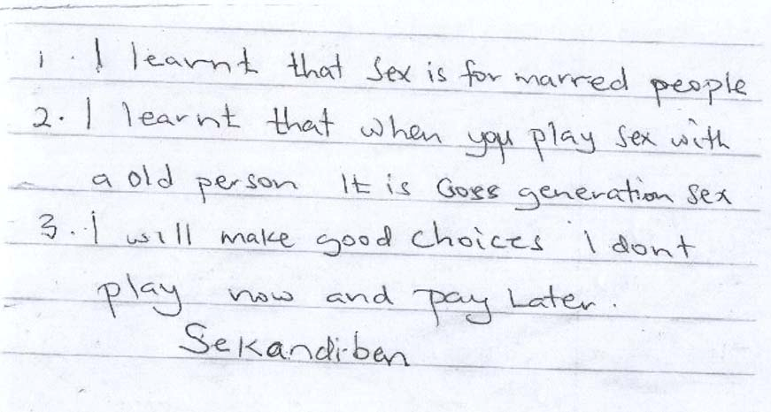

***3.1.8 Increased Self Worth***

Teachers reported there was increased self-worth among their students who had participated in the Project. One of the teachers reported that:

*“In our cultures we rarely say things to young people that promote their self-worth. In fact most of the statements made at home erode their self-worth…I was very pleased when I realized that the Project deliberately attempted to increase young people’s self-worth.”*

A community leader expressed similar views:

*“This Project has made an important contribution to the development of self-worth among the girls especially. You know parents sometimes say things like you are good for nothing or you are not gaining much from school you are better off married and things like that… Girls then begin to feel useless and develop a low self-esteem.”*

The survey assessed youth’s self-worth and Table 27 presents the findings:

*Preserving the African Family in the Face of HIV/AIDS*

*Child Health and Development Centre Page 67*

**TABLE 27 : SE LF WORTH**

|  |
| --- |
| **Number and percentage of females who responded “ *Yes*” to Number and percentage of males who responded “ *Yes*” to statements on self-worth statements on self-worth** |
| Feel they Able to Have Being Feel No. of Feel they Able to Have Being Feel No. of have a do plenty of happy is nervous females have a do things plenty of happy is nervous males number things interests important over number as well interests important over  of good as well and to family nothing at of good as most and to family nothing at qualities as most hobbies all qualities other hobbies all  other people people |
| **Participant n n n n n n n n n n characteristic (%) (%) (%) (%) (%) (%) (%) (%) (%) (%)** |
| **Age (years)**  **10-14** 665 679 691 751 357 778 519 518 545 573 298 595 (85.5) (87.3) (88.8) (96.5) (45.9) (87.2) (87.1) (91.6) (96.3) (50.1)  **15-24** 629 632 647 666 281 694 767 759 777 779 367 822 (90.6) (91.1) (93.2) (96.0) (40.5) (92.3) (92.2) (94.5) (94.8) (44.6) |
| **Schooling status when first reached**  **In-school** 1134 1150 1173 1262 571 1,300 1010 1005 1052 1092 526 1136 (87.2) (88.5) (90.2) (97.1) (43.9) (88.9) (88.5) (92.6) (96.1) (46.3)  **Out-of-** 159 160 164 154 69 171 273 269 267 257 135 278  **school** (93.0) (93.6) (95.9) (90.1) (40.4) (98.2) 96.8) (96.0) (92.4) (48.6) |

**No. of sessions attended**

|  |  |  |  |  |  |  |  |  |  |
| --- | --- | --- | --- | --- | --- | --- | --- | --- | --- |
|  | | | | |  |  |  |  |  |
| (85.8) | 91.3) | (89.0) | (97.6) | (52.0) | (93.0) | (90.8) | (92.5) | (97.4) | (51.3) |

|  |  |  |  |  |  |  |  |  |  |  |  |  |
| --- | --- | --- | --- | --- | --- | --- | --- | --- | --- | --- | --- | --- |
| **1-3**  **4-6** | 720 | 739 | 747 | 790 | 356 | 822 | 729 | 724 | 752 | 763 | 381 | 806 |
| (87.6) | (89.9) | (90.9) | (96.1) | (43.3) |  | (90.4) | (89.8) | (93.3) | (94.7) | (47.3) |  |
| 576 | 574 | 593 | 629 | 284 | 652 | 557 | 553 | 570 | 589 | 283 | 611 |
| (88.3) | (88.0) | (91.0) | (96.5) | (43.6) |  | (91.2) | (90.5) | (93.3) | (96.4) | (46.3) |  |
| **District** |  |  |  |  |  |  |  |  |  |  |  |  |
| **Kampala** | 397 | 413 | 421 | 452 | 218 | 483 | 351 | 370 | 383 | 395 | 212 | 425 |
|  | (82.2) | (85.5) | (87.2) | (93.6) | (45.1) |  | (82.6) | (87.1) | (90.1) | (92.9) | (49.9) |  |
| **Wakiso** | 212 | 208 | 212 | 228 | 106 | 233 | 249 | 241 | 251 | 250 | 129 | 264 |
|  | (91.0) | (89.3) | (91.0) | (97.9) | (45.5) |  | (94.3) | (91.3) | (95.1) | (94.7) | (48.9) |  |
| **Mukono** | 241 | 233 | 246 | 252 | 108 | 264 | 227 | 220 | 227 | 232 | 113 | 241 |
|  | (91.3) | (88.3) | (93.2) | (95.5) | (40.9) |  | (94.2) | (91.3) | (94.2) | (96.3) | (49.9) |  |
| **Luwero** | 229  (95.0) | 228  (94.6) | 236  (97.9) | 240  (99.6) | 76  (31.5) | 241 | 248  (95.4) | 240  (92.3) | 251  (96.5) | 254  (97.7) | 94  (36.2) | 260 |
| **Mpigi** | 218 | 232 | 226 | 248 | 132 | 254 | 212 | 207 | 211 | 222 | 117 | 228 |

More than 80% of all the youth in the survey reported that they felt that they had a number of good qualities, that they were able to do things as well as most other people and felt that their happiness was important to their families. These findings are encouraging in that they suggest the majority of youth had a strong sense of self-worth.

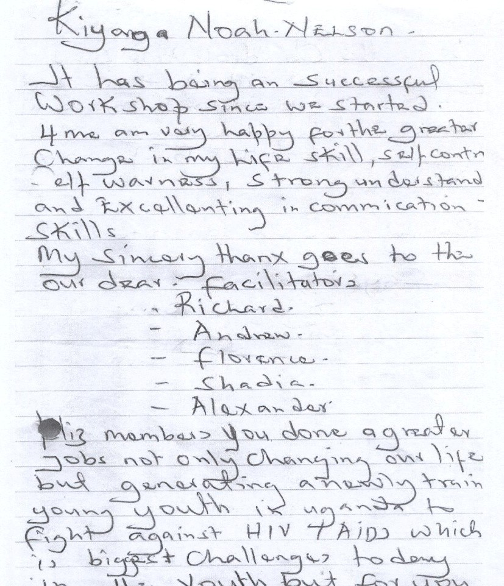

***3.1.9 Reduced Vulnerability among Poor Girls***

The Project supported some vulnerable girls in the districts to attend vocational skills training. Community leaders and parents all welcomed this support. The leaders explained that some youth’s living conditions were very poor and as a result they resorted to transactional and cross generational sex for survival. Narratives by the girls who had undergone the training revealed their vulnerability prior to the skills training. There were those orphaned at an early age and lived with elderly sickly grandparents, others previously survived selling firewood and water which they fetched miles away while others lived from hand to mouth.

Members of local advisory committees who participated in the selection of these girls commended the Project for reducing the vulnerability of the girls by supporting them to acquire vocational skills that enabled them to avoid sexual exploitation. A member of the Local Advisory Committee observed that:

*“The Something for Something Love message was good for these vulnerable youth because it opens their eyes to the risks of HIV/AIDS if they decide to have sex in exchange for gifts.”*

The *Smart Girls* expressed appreciation for the opportunity to train some of them who were now self-employed and earning an independent income. One of them narrated that,

*“I learnt to plait hair and sometimes people call me to go to their homes and plait them and I*

*earn money to help us at home with my grandparent. For hair styles like Pencil, I plait for*

*6000= while the twist hair style I plait it for10000=.”*

In Luwero vulnerable girls reported that they had received training in weaving sweaters and were now employed.

***3.1.10 Positive Changes in Gender Based Beliefs and Attitudes***

Community leaders and parents reported that gender based beliefs and attitudes made youth vulnerable to HIV infection. Cultural beliefs such as *real men should have more than one sexual partner* or that *young women should be submissive to men if they are ever to get married* were reportedly common. The survey explored youth’s gender based beliefs and attitudes, and the findings are presented in Table 28:

**TABLE 28 : GENDER AND H IV**

|  |
| --- |
| **Number and percentage of females No. and percentage of males who who responded “ *Yes*” to the responded “ Yes” to the statements statements related to gender and related to gender and HIV**  **HIV** |
| Boys Girls Boys are Total Boys Girls Boys are Total domin should better No. of dominate should better No. of ate obey than girls females girls obey than girls males girls their at their at  boy making by making friends important friends important  decisions decisions |
| **Participant n n n n n n characteristics (%) (%) (%) (%) (%) (%)** |
| **Age (years)**  **10 -14** 322 327 310 778 312 333 385 595 (41.4) (42.0) (39.8) (52.4) (56.0) (64.7)  **15 – 24** 244 233 257 694 389 421 541 822 (35.2) (33.6) (37.0) (47.3) (51.2) (65.8) |
| **Schooling status when first reached;**  **In-school** 500 481 489 1,300 555 579 724 1136 (38.5) (37.0) (37.6) (48.0) (51.0) (63.7)  **Out-of-** 63 77 78 171 145 173 201 278 |

**school** (36.8) (45.0) (45.6) (52.2) (62.3) (72.3)

**No. of sessions**

|  |  |  |  |  |  |  |  |  |
| --- | --- | --- | --- | --- | --- | --- | --- | --- |
| **attended**  **1-3** | 331 | 323 | 319 | 822 | 416 | 440 | 530 | 812 |
|  | (40.3) | (39.3) | (38.8) |  | (51.2) | (54.2) | (65.3) |  |
| **4-6** | 235 | 237 | 249 | 652 | 292 | 322 | 407 | 617 |
|  | (36.0) | (36.3) | (38.2) |  | (47.3) | (52.2) | (66.0) |  |
| **District** |  |  |  |  |  |  |  |  |
| **Kampala** | 198 | 179 | 164 | 483 | 224 | 230 | 281 | 432 |
|  | (40.3) | (36.5) | (33.4) |  | (51.9) | (53.2) | (65.0) |  |
| **Wakiso** | 80 | 58 | 78 | 233 | 121 | 148 | 167 | 265 |
|  | (34.3) | (24.9) | (33.5) |  | (45.7) | (55.8) | (63.0) |  |
| **Mukono** | 81 | 79 | 100 | 264 | 95 | 102 | 150 | 242 |
|  | (30.5) | (29.7) | (37.6) |  | (39.3) | (42.1) | (62.0) |  |
| **Luwero** | 102  (41.6) | 128  (52.2) | 123  (50.2) | 241 | 144  (55.0 | 149  (56.9) | 186  (71.0) | 262 |
| **Mpigi** | 114 | 125 | 111 | 254 | 125 | 133 | 153 | 229 |
|  | (44.7) | (49.0) | (43.5) |  | (54.6 | (58.1) | (66.8) |  |

It was gratifying to note that less than half of the females in the survey believed that males were better than females at making important decisions; that females should obey their boyfriends and that males dominate females. More than half of the males in the survey, however, believed these statements to be true, an indication that more work needs to be done in this area.

***3.1.11 Increased Access by Youth to Care and Support Services***

Facilitators, leaders and officials working with NGOs and CBOs interviewed reported that the Facilitators had developed some linkages with service organizations where youth could be referred for care and support services. Teachers and community leaders reported that young people in their communities did not often share their concerns with adults especially concerns that had to do with their sexual and reproductive health. Teachers reported that the students and pupils were more open with the Peer Facilitators as the following quote illustrates:

*“I have noticed that the children in this school like the Peer Facilitator and are more open with him when it comes to problems that they are facing he has approached me more than once about different problems that children were facing that none of us knew about in this school.)*

According to the Peer Facilitators, youth often approached them wanting to be referred for treatment of STIs and the like. Facilitators in some of the districts worked closely with service providers to whom they referred youth for treatment, counseling and guidance and HIV Testing. Teachers, parents and Facilitators all reported that young people in their districts needed counseling and guidance. The parents considered this need in the context of support for the HIV+ youth while the teachers and the Facilitators considered it in the context of character

development. The parents expressed appreciation to the Project for making such services accessible to their children.

**3.2 The Effectiveness of Approaches Used in Implementing the**

**Project**

The evaluation explored the effectiveness of the approaches used in the implementation of the Project. Five main approaches were adopted by the Project. These were based on: communities, a set curricula, schools, peer and adult Facilitators and partnerships.

***3.2.1 Community Based***

The Project adopted a community-based approach and this eased the implementation of the Project. Peer and Adult Facilitators were selected from the communities in which they served. This enabled them to access youth and adults in their communities more easily. They were familiar with the communities in which they were working and were also familiar with the problems faced by youth in their

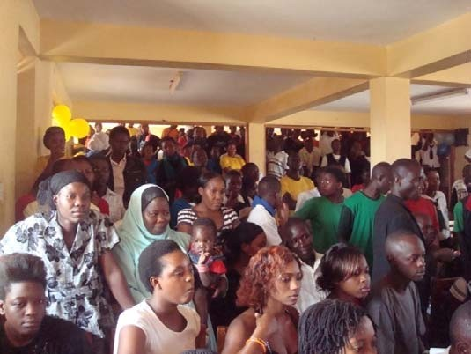

communities. Being insiders and having been selected by the communities they served meant they were trusted by those whom they served. Community leaders helped with the mobilization of the out-of- school youth given that they were scattered in different places and not organized. They also played an important role in identifying and organizing venues where the Facilitators met with the out-of- school youth and this contributed to the success of the Project.

*Community members attending one of the Projec t ac tivitie s*

Involvement of local community structures was foundational to the Project and served as its entry point into the communities. Discussions with local leaders, CBO’s staff and district officials revealed that the Project had succeeded in involving various community leaders, local government officials and officials working with NGOs in the implementation of Project activities. In some of the districts, the Project attempted to create community structures known as Local Advisory Committees (LACs) made up of local leaders but these did not quite take root due to challenges of capacity building and support to enable them play an active role. Members of the LAC interviewed reported that they had expected to be trained and facilitated to hold regular meetings. District officials expressed concern that the Project had not opened up offices in each of its districts and registered as an NGO to make the Project more visible. The Project policy was not to open up offices as this would not be sustainable.

***3.2.2 Curriculum Based***

The Project was curricula based. This approach was appreciated by stakeholders because it enabled the systematic delivery of a common set of skills and knowledge across districts. The manuals and workbooks used to support the delivery of the curricula were also appreciated by both the Facilitators and youth. Because the curricula addressed critical gaps in knowledge and skills including: knowledge of HIV/AIDS and STIs, decision making skills, communication skills, self-worth, attitudes to risky behavior, social norms among others. It was appreciated by all stakeholders including the youth.

***3.2.3 School Based***

A school based approach was considered appropriate to implement the Project because the majority of youth were in schools due to universal primary and secondary education. School teachers and administrators acknowledged that while schools teach HIV/AIDS and life skills as part of the formal curriculum and extra curricula activities, the *Smart Choices* curriculum was more detailed and interactive and students enjoyed it very much. The survey revealed that more than 90% of female and male youth got information about HIV/AIDS from schools suggesting that schools were important venues for accessing information on sexual and reproductive health.

**TABLE 29 : SOURCES O F INFORMATIO N FOR T HE FEMAL E YOUTHS**

|  |  |
| --- | --- |
| **No. and percentage of females who reported…** | |
| **Participant characteristics** | School TV Radio Doctors Church/ Newspaper/ Friends Parents/ Siblings/ Boy Pamphlets/ Billboards Total mosque Magazines Adult Teen or fliers No. of  relatives relatives girl females friend |
| n n n N n n n n n n (%) n n  (%) (%) (%) (%) (%) (%) (%) (%) (%) (%) (%) | |
| **Age in years** | |
| **10-14** 721 182 265 211 92 107 198 278 42 03 06 11 778 (92.7) (23.4) (34.1) (27.1) (11.8) (13.8) (25.4) (35.7) (5.4) (0.4) (0.8) (1.4) | |
| **15-24** 584 156 270 204 111 107 177 233 39 10 14 08 694 (84.1) (22.5) (38.9) (29.4) (16.0) (15.4) (25.5) (33.6) (5.6) (1.4) (2.0) (1.2) | |
| **Schooling status when first reached** | |
| **In school** 1209 308 459 352 161 187 324 472 77 13 15 17 1300 (93.0) (23.7) (35.3) (27.1) (12.4) (14.4) (24.9) (36.3) (5.9) (1.0) (1.2) (1.3) | |
| **Out of-school** 93 31 75 62 42 26 50 42 04 0 05 02 171 (54.4) (18.1) (43.9) (36.3) (24.4) (15.2) (29.2) (24.6) (2.3) (0.0) (2.9) (1.2) | |
| **No. of sessions attended** | |
| **1-3** 727 170 293 213 114 112 228 285 50 11 08 10 822 (88.4) (20.7) (35.6) (25.9) (13.9) (13.6) (27.7) (34.7) (6.1) (1.3) (1.0) (1.2) | |
| **4-6** 578 170 243 202 89 102 147 228 31 02 12 09 652 (88.7) (26.1) (37.3) (31.0) (13.7) (15.6) (22.5) (35.0) (4.8) (0.3) (1.8) (1.4) | |

|  |
| --- |
| **Districts** |
| **Kampala** 436 117 127 150 68 88 175 191 24 10 03 05 483 (90.3) (24.2) (26.3) (31.1) (14.1) (18.2) (36.2) (39.5) (5.0) (2.1) 0.6) (1.0) |
| **Wakiso** 204 25 43 40 29 24 23 71 15 0 0 0 233 (87.6) (10.7) (18.5) (17.2) (12.4) (10.3) (9.9) (30.5) (6.4) (0.0) 0.0) (0.0) |
| **Mukono** 233 81 79 83 39 46 53 111 19 03 05 09 264 (88.3) (30.7) (29.9) (31.4) (14.8) (17.4) (20.1) (42.0) (7.2) (1.1) (1.9) (3.4) |
| **Luwero** 215 57 152 68 44 40 73 40 07 0 05 04 241 (89.2) (23.7) (62.2) (28.2) (18.3) (16.6) (30.3) (16.6) (2.9) (0.0) (2.1) (1.7) |
| **Mpigi** 218 60 137 74 23 16 52 101 16 0 07 01 254 (85.8) (23.6) (53.9) (29.1) (9.1) (6.3) (20.5) (39.8) (6.3) (0.0) (2.8) (0.4) |

**TABLE 30: SOURCES O F INFO RMAT ION FOR MALE YOUTH S**

|  |  |
| --- | --- |
| **No. and percentage of males who reported…** | |
| **Participant characteristics** | School TV Radio Doctors Church/ Newspaper/ Friends Parents/ Siblings/ Boy Pamphlets/ Billboards Total mosque Magazines Adult Teen or girl fliers No. of  relatives relatives friend males |
| n n n n n n n n n n n n  (%) (%) (%) (%) (%) (%) (%) (%) (%) (%) (%) (%) | |
| **Age in years** | |
| **10-14** 550 150 232 166 81 89 117 188 34 0 5 0 5 08 595 (92.4) (25.2) (39.0) (27.9) (13.6) (15.0) (19.7) (31.6) (5.7) (0.8) (0.8) (1.3) | |

|  |
| --- |
| **15-24** 653 213 370 252 136 129 202 191 21 18 09 13 822 (79.4) (25.9) (45.0) (30.7) (16.5) (15.7) (24.6) (23.2) 2.6) (2.2) (1.1) (1.6) |
| **Schooling status when first reached** |
| **In school** 1061 294 461 320 165 180 242 332 46 20 09 15 1143 (93.4) (25.9) (40.6) (28.2) (14.5) (15.8) (21.3) (29.2) (4.0) (1.8) (0.8) (1.3) |
| **Out of-school** 140 67 138 96 53 38 77 47 09 03 05 06 283 (50.4) (24.1) (49.6) (34.5) (19.1) (13.3) (27.7) (16.9) (3.2) (1.1) (1.8) (2.2) |
| **No. of sessions attended** |
| **1-3** 688 209 326 231 131 131 190 220 28 14 07 10 812 (84.7) (25.7) (40.1) (28.4) (16.1) (16.1) (23.4) (27.1) (3.4) (1.7) (0.9) (1.2) |
| **4-6** 524 155 279 207 91 88 130 165 27 10 07 12 617 (84.9 (25.1) (45.2) (29.5) (14.7) (14.3) (21.1) (26.7) 4.4) (1.6) (1.1) (1.9) |
| **Districts** |
| **Kampala** 374 135 157 154 74 89 98 115 23 11 01 08 432 (86.6) (31.3) (36.3) (35.6) (17.1) (20.6) (22.7) (26.5) (5.3) (2.5) (0.2) (1.9) |
| **Wakiso** 204 47 65 58 35 32 44 73 16 02 0 03 265 (77.0) (17.7) (24.5) (21.9) (13.2) (12.1) (16.6) (27.5) (6.0) (0.8) (0.0) (1.1) |
| **Mukono** 210 64 92 78 48 31 61 78 05 09 01 04 242 (86.8) (26.4) (38.0) (32.2) (19.8) (12.8) (25.2) (32.2) (2.1) (3.7) (0.4) (1.7) |

*Preserving the African Family in the Face of HIV/AIDS*

*Child Health and Development Centre Page 77*

|  |  |  |  |  |  |  |  |  |  |  |  |  |  |
| --- | --- | --- | --- | --- | --- | --- | --- | --- | --- | --- | --- | --- | --- |
| **Luwero** | 228 (87.0) | 69 (26.3) | 164 (62.6) | 69 (26.3) | 42 (16.0) | 51  19.5) | 68 (26.0) | 42 (16.0) | 04 (1.5) | 01 (0.4) | 06 (2.3) | 04 (1.5) | 262 |
| **Mpigi** | 197 | 49 | 127 | 65 | 23 | 16 | 49 | 78 | 07 | 01 | 06 | 03 | 229 |
|  | (86.0) | (21.4) | (55.5) | (28.4) | (10.0) | (7.0) | (21.4) | (34.1) | 3.1) | (0.4) | (2.6) | (1.3) |  |

*Preserving the African Family in the Face of HIV/AIDS*

*Child Health and Development Centre Page 78*

***3.2.4 Facilitator Based***

Because Facilitators were core to the Project and members of the communities they served, they were able to garner support and acceptance for the Project more easily. Students readily listened, opened up and confided in them. Being outsiders to schools, they were preferred more than teachers and this enabled them to address young people’s needs and answer their questions. This approach yielded role models for the youth within the communities. The use of community based Facilitators had potential for sustainability because they could continue with some activities after the Project ended.

educational backgrounds and levels of competence. This had implications for their work. Some needed more training and support than others. In recognition of this reality, the Project provided regular refresher trainings on topics identified through support supervision and monthly review meetings.

|  |  |  |
| --- | --- | --- |
| Discussions |  | revealed |
| Facilitators | had | different |

*Peer Fac ilitators attending a training session*

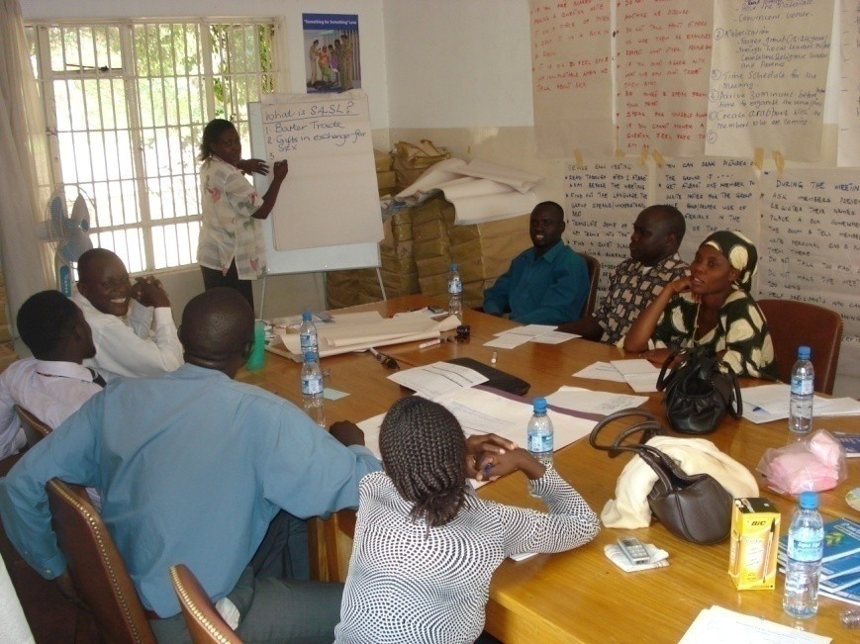

Supervision by DCs and Peer Mentors also identified areas for PF improvement. In addition, *STI brochures*, *Ten Most Asked Questions*, and *condom fact sheets* were provided to address commonly requested information in more detailed knowledge and consistency across the Project.

All Peer Facilitators received a stipend and for some this was their only income. It would be difficult to expect Facilitators to continue with the kinds of activities that they were involved without any form of financial support. Alternative ways of remunerating the Facilitators were being explored in some of the districts to enable them to continue with some of the Project activities.

***3.2.5 Partnership Approach***

The Project forged partnerships with other agencies to fulfill its objectives. This approach made it possible to access services outside the scope of the Project such as medical care, STI diagnosis and treatment, counseling and vocational training among others. Some of the partnerships established by the Project, however were not formalized. Partnerships were useful where organizations the Project partnered with provided complimentary services or were engaged in similar activities. The Project partnered with AMREF which was working on HIV prevention. Again in Luwero district, the Project partnered with the Buganda Kingdom where the district level leader attended many Project events and helped oversee activities in the district. The local community also provided fuel for PFs to implement the Project in the area.

District staff however expressed concern that CAF did not partner with the District Administrations during Project implementation. In nearly all the districts, there were some officials that were involved in Project activities. Staff from the departments of community development for example participated in Project’s activities especially in community mobilization and sensitization. Partnering directly with local government departments at district level would in some instances have complicated Project implementation in that government departments are usually underfunded and poorly resourced. Most district leaders prefer to have some control over the Projects in their districts for that very reason. In the circumstances the partnerships formed had to be strategic.

**3.3 Activities Planned and Implemented to Achieve the**

**Objective**

The core Project activities were the curriculum guided sessions targeting ages 10-24 by Peer Facilitators. Other activities at community level reinforced the core activities. The Project design acknowledged from the start that addressing youth alone in the Ugandan context would not be sufficient to bring the desired behavior change and sustain it. It was important to involve parents and adults in the community in order to create a supportive environment for behavior change. Adult Facilitators carried out supportive activities such as parenting workshops, parent-youth dialogues among others. The Project planned and implemented both the core and supportive activities in each of the districts.

Implementation of Project activities was initially slow but accelerated in the final two years. Emphasis, however, was on curriculum guided sessions, since this was the primary goal of the USG funding. The support activities on the other hand were not well coordinated with those targeting the youth. While activities by Peer Facilitators were managed by district coordinators, adult and community activities were managed by the

prevention manager through adult Facilitators. The dichotomy in field activity management structure prevented appropriate and complete integration of all Project activities at the community level.

Reports reviewed revealed that the Project reached the targeted 350,000 youth by the time it closed **(**Annual report, FY 2010**)**. Figure 3 shows that the majority of youth were reached in the final year of the Project.

**FIGURE 3: PROJECT PROGRESS TOWARDS ACHIEVING THE TARGETED NUMBER OF YOUTH REACHED**

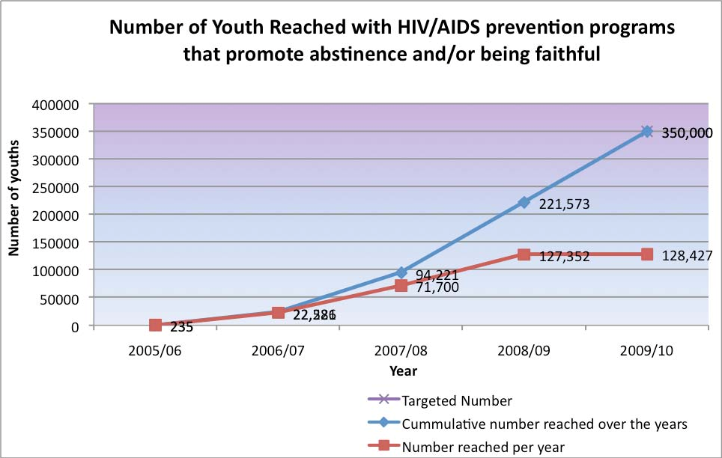

There were substantial increases in the number of youth reached by the Project in its final two years of operation. The evaluation noted that driven by the numbers targeted, the Project increased the number of youth that individual Facilitators had to reach on a monthly basis from 75 to 100 youth. As a result the Facilitators had to conduct more sessions. This ultimately affected the quality of their work. For example only 30% of the youth reached in the final year of implementation reported having been reached 6 times. This suggests that either they did not cover all the content in the curriculum or that it was

hurriedly covered. Facilitators also reported that this expanded their geographical coverage

The coordination between the Peer Facilitators who conducted the guided sessions and the Adult Facilitators who implemented some of the support activities was minimal. Because the Project Manager managed adult activities in the CAF Uganda CAF Uganda office there was no evidence of joint planning and operations. While clearly the Project Manager and Project staff were aware of all core activity implementation schedules and presumably made an attempt at coordination, devolving all implementation activity management to the District Coordinator level would have ensured the reinforcement that the Project design desired to bring about. The overall Project implementation plan did not systematically bring the activities implemented by the Peer Facilitators and those implemented by the Adult Facilitators together to achieve the desired impact.

**3.4 Effectiveness of the Monitoring and Supervision**

**Mechanisms**

The Project had several mechanisms in place for monitoring and supervision of the Project activities; these included spot checks, support supervision, monthly reports, and several checklists for various activities. Among these were the checklist for pre-event planning, attendance log for multi-session events, post-event information form, ABY event log, community event for youth, event log for big events, and event log for general information. Other tools that were available for data collection were the training activity monthly report, the tool for supervision scheduling, checklist to guide the supervision process, supervisor’s summary report, the quality assessment tool, Project assessment tool, questionnaire for curriculum based activities, referral log and pre and post assessment forms and pre and post training evaluation forms. The presence of these numerous forms suggested that an attempt had been made to put an information management system in place.

According to the Project staff at CAF Uganda office in Kampala and the Peer and Adult Facilitators, most of the monitoring and supervision of their work at the district level was conducted by the District Coordinators. In addition, they sometimes received impromptu visits from staff at the CAF Uganda, and US CAF Uganda office. Interviews with the Prevention Project Officer and Peer Mentor at the CAF Uganda CAF Uganda office revealed that they conducted supervisory visits to each of the districts at least once a month. During the support supervision visits CAF staff reported that they used a checklist to guide the supervision process. The supervision checklist covered elements like critical skills in conducting the curriculum based event, community satisfaction with Project and documentation, reporting and performance on targets. CAF staff reported that after supervisory visits they met with the Peer and Adult Facilitators to discuss issues they observed during the supervision and subsequent actions to be taken.

***3.4.1 Support Supervision***

Peer Facilitators developed work plans which showed activities they were planning to implement, dates and venues. Copies of the work plans were given to the DCs who in turn forwarded them on to the staff at CAF Uganda CAF Uganda office. Peer Facilitators appreciated the support they received from the District Coordinators. One of them explained that:

*“We have a work plan, which shows where we are going to work, the date, and when we are in the field. The District Coordinators make a follow up and come. The DCs also mentor us. Where we have a challenge and need help our DC helps out. He is good and responsive.”*

One of the Peer Mentors who was once a Peer Facilitator explained that support supervision was very helpful and a non-threatening means of mentoring the Peer Facilitators. Those conducting the support supervision did not always sit and watch the Peer Facilitator conduct the session especially when they were aware that the Peer Facilitator found a particular topic that they were handling challenging. They helped with the session so that the Peer Facilitator learnt from them how to handle such sessions in the future. One of the Peer Facilitators reported that:

*“I used to lack self-confidence but through support supervision I developed confidence because every time I was given feedback I tried my best to improve and when I got positive feedback from the mentor or the DC I was encouraged and gradually I become more confident.”*

Peer Facilitators reported that they found the support supervision beneficial in that it built their confidence especially when they got positive feedback from their supervisors. They also reported that staff from the CAF Uganda CAF Uganda office also provided support supervision, sometimes. In Wakiso and Mpigi, for example, Peer Facilitators reported that the DCs kept in close touch with them and helped them a lot with their work.

***3.4.2 Spot Checks***

Discussions with Peer Facilitators, District Coordinators and CAF Uganda CAF Uganda office staff revealed that the DCs and CAF office staff carried out spot checks. These were mainly in the form of inspections to verify that the Peer Facilitators were carrying out their activities according to the work plans developed. Approximately a third of the teachers interviewed who knew the Project reported that Project staff had visited their schools to inquire about the CAF activities taking place. One DC explained how he

conducted these monitoring visits to verify both the conduction of sessions as well as the content of material delivered by Peer Facilitators:

*“When I implement spot checks, I just go to the school. I decide in the morning that I will visit such an area. When I go to the school I talk to the teachers or the community leaders. I ask for their perceptions about the impact or any changes in the area as a result of the Project.”*

Another DC added:

*“You just go to the place when they are not aware and you ask some of the youth about*

*CAF so as to establish if they really went there.”*

The Project Manager reported that this was a useful exercise in that it enabled Project staff to cross check and verify the Peer Facilitators and District Coordinator reports with others in the community. Peer Facilitators, explained however that sometimes they were forced to change their work plans at very short notice because schools for example changed their programs. Then those carrying out the spot checks accused them of not following their work plans. Despite these kinds of confusions due to scheduling challenges CAF saw these monitoring visits as critical toward maintaining Project data integrity.

***3.4.3 Monthly Review Meetings***

Monthly review meetings convened by the District Coordinators were attended by the Peer and Adult Facilitators and sometimes by the CAF Uganda CAF Uganda office staff. According to the District Coordinators and Peer Facilitators during such meetings they discussed their progress, some challenges they met during implementation, lessons learnt and the way forward as illustrated by the following extract from an interview with one of the District Coordinators:

*“We have monthly review meetings where the Peer Facilitators report on their progress and raise any challenges they are facing, we discuss possible solutions”.*

Discussions with Peer Facilitators revealed that they found these monthly reviews meeting helpful because it was a forum where they all gathered and discussed their

progress. It was also a forum where they learned from each other as illustrated by the following extracts:

*“In these meetings we also discussed some of the topics that we were finding difficult to handle and we got help. I remember in one meeting another Peer Facilitator who was not finding the same difficulties I was finding offered to come to my session and help me with the topic.”*

*“In some review meetings the Peer Mentor from the headquarters helped us change our approach to a topic that we were all having problems with.”*

*“I remember when I expressed a problem I was having with the topic of gender the DC*

*offered to come and help me.”*

The Prevention Project Officer reported that she attended the monthly review meetings and it was an opportunity for her to keep up with what was happening in the field.

***3.4.4 Monitoring Forms***

The Peer Facilitators reported that they filled out log forms documenting the youth reached, and wrote reports that contained the activities implemented, challenges and the way forward. These reports and completed log forms were forwarded to the District Coordinators who, in turn, compiled the reports for all Peer Facilitators in the districts before forwarding them to the CAF Uganda CAF Uganda office. According to the Peer Facilitators these forms and reports were the basis for their monthly honorarium as illustrated by the following extraction from PF focus group discussion:

*“All Peer Facilitators had to fill out the forms otherwise they would not get the money for that month*.”

District Coordinators also reported that they filled post event forms that were designed for monitoring and evaluating the performance of the Peer Facilitators. The DCs carried these forms to schools and asked the youth what they learnt during the sessions with the Peer Facilitators as explained by one of the DCs:

*“I go to the Peer Facilitators to collect the post event forms, go back to the school to verify whether they were at those schools and ask the students to write what they learnt. I*

*then fill out the M&E submission tool to capture the information of the events then give them to the Project Coordinator.”*

The Peer Facilitators reported that they collected data on youth attendance by filling out the attendance log after every session conducted with the youth.

***3.4.5 Monthly Reporting***

The Peer Facilitators had the responsibility of writing monthly reports which they submitted to the District Coordinators. The Adult Facilitators also made activity reports monthly and attached the accountabilities for each activity and these were submitted to CAF Uganda office.

***3.4.6 Technical Meetings***

Peer Facilitators also attended technical meetings. Some referred to them as technical exchanges. During these meetings they shared ideas with CAF management and sometimes underwent in-service training. Such meetings also provided an opportunity to discuss issues relating to the Project with the Project management; information about Project successes, challenges and recommendations for change. Discussions with the Peer Facilitators, District Coordinators, and Project staff revealed that the data collected during monitoring and supervision was used to improve the implementation of the Project and of the *Smart Choices* curriculum. The Facilitators who had been with the Project longer reported that they had made recommendations that were incorporated in the curriculum. According to the DCs and the Project staff this information was also used in support supervision as one of the DCs pointed out:

*“When we go for support supervision, we sit in the sessions fill out the support supervision form and assess the Facilitators. The assessment is then used to help the facilitator on a one-on-one basis.”*

***3.4.7 Utilization of Monitoring Data***

Monitoring data was collected in various ways on different aspects of the Project which allowed for cross checking. The intervals at which the data was collected was also ideal in the sense that activity data was collected during each of the activities, then the post event data was also collected at the end of each event, and the data was compiled in a monthly report. The fact that the data was collected at different levels by those directly involved was also helpful in that each of the players had a role in the data collection.

***3.4.8 Challenges***

Active and sustained involvement of community structures seemed to be a challenge to the Project. There were inherent weaknesses within the community structures themselves the main one being that they were not very functional as structures prior to the Project. Local Councils, while very instrumental in community mobilization and sensitizations usually have two or three individuals on the executive who are active and these are the ones who participate in any Project that comes to their locality. Local Council executives hardly hold any meetings as councils or council executives to brief other community members about what is taking place in their communities. Unlike the sub-county and district councils, the lower structures are not facilitated to meet and do not receive allowances. Active involvement of such structures in Projects therefore, would necessitate capacity building and support of these structures in order for them to play a more active role. Sustaining this nature of support was a challenge to the Project.

In addition, the involvement of individuals in the community who are active and motivated is pragmatic and works well but does not ensure the sustainability of the Project in the long run nor does it translate into the desired ownership of the Project by the communities

Various implementation challenges also undermined the delivery and effectiveness of the curriculum. One was the insufficient time allocated to cover the content. The Facilitators reported that the time allocated to cover the 12 sessions of the *Smart Choices* curriculum was not adequate. Another challenge was that the schools with their already full curriculum did not allocate sufficient time for full coverage of the *Smart Choices* curriculum. As a result, the curriculum was in most cases not implemented as planned and this undermined retention and consolidation of the knowledge and skills. Another challenge was that the support materials used were not translated into the local languages, yet the Facilitators reported that they conducted most of the training in the local language. The accuracy of the translation of the messages ultimately depended on the individual facilitator’s understanding of the materials and their language skills. Successful implementation of the curriculum presupposed that the Facilitators had fully understood the content and were able to communicate it to others. The evaluation noted however that not all Facilitators were at the same level of understanding

A major challenge with the school-based approach was that schools already had a full curriculum of their own which was examinable. The fact that the *Smart Choices* curriculum was outside the formal school curriculum and was being implemented by Facilitators who were not part of the school staff meant that it was treated as an extra- curricular activity. Time had to be found where it could be fitted in. This meant in some cases that the sessions with the students had weeks in between them. Some schools were

more willing than others to find this time. So its implementation depended on the good will of the school administrators and teachers. This also made it difficult for some of the Facilitators to plan their work.

According to the semi-annual report (2009/2010), the limited number of Adult Facilitators hampered progress of adult outreach activities, in terms of achieving the target numbers. This resulted from changes in number targets reached by Adult Facilitators per event from 50 to 25 people which called for training of additional AFs; an activity was only undertaken during the 1st half of the year 2009/2010 towards the end of the Project.

Health facilities in the Project area of operation were few and scattered which limited full and effective access to referral services. Follow up of referred youth presented as a challenge since associated expenses to escort youth to clinics were not part of the budget (Annual report 2008/2009). In addition, the evaluation found health centers in most cases did not have drugs and only provided pain killers.

Budgetary constraints precluded expansion into Kayunga district, which had requested for CAF outreach, logistical and transportation support to PFs to reach youth in the remote rural areas remained a challenge.

**3.5 Sustainability**

The evaluation explored the strategies adopted for sustainability of the Project. Strategies put in place to ensure sustainability of the Project included: the recruitment of community based Facilitators, integration of Project activities into sub-county work plans and establishing community structures such as local advisory committees and the involvement of the community in the implementation of the *Smart Girls’* aspect of the Project. It was evident; however, that the only sustainability strategy that was effectively built into the Project design was the recruitment of the community based Peer Facilitators and the involvement of the local leaders in the selection of the *Smart Girls*. All the other strategies were adopted and piloted in the last one and a half years of the Project and had not taken root by the closure of the Project

***3.5.1 Recruitment of Community Based Facilitators***

One strategy adopted for Project sustainability was the recruitment and training of Peer Facilitators who were already resident in the communities they served. Unless they moved out of the communities completely, it was assumed that with the skills and knowledge they now had, they would continue with some of the Project activities they were involved in. The PFs reported during the evaluation that they would continue to serve their communities as volunteers. There were also reports of neighboring

communities that were outside of the districts of Project operation which requested that the Project train their volunteers, who they would subsequently support. This suggests that once communities are convinced of the benefits of the Program they can explore ways and means to support Peer Facilitators to continue with the activities. Facilitators reported that they would continue with the Project activities but most likely on smaller scale.

***3.5.2 Formation of Community Based Organizations***

Discussions with stakeholders and PFs at the district level revealed that Peer Facilitators and District Coordinators in some districts had formed CBOs that they hoped would continue to implement the *Smart Choices* curriculum but at a cost. One of the Peer Facilitators explained:

*“We have been discussing with my colleagues about the possibility of setting up an organization which can continue with the Project activities. But we will need funding we can continue the activities but we would need to charge a small fee because we too have to survive.”*

Many of the PFs reported that they needed some form of income to continue the activities. In Wakiso for example; CBOs like Maya Teenage Centre were trained purposely to carry on activities when the Project ended. In Luwero, a CBO called OVCA planned to continue with the activities, if the materials are available. Other CBOs planned to solicit for funding and support to support the activities.

***3.5.3 Training of Teachers in the Use of the Smart Choices Curriculum***

In some schools, teachers and youth were trained to implement the *Smart Choices* curriculum, and in some schools ABY clubs were formed, as well as Anti-AIDS drama clubs. These are intended to continue to carry out Project activities beyond the funding period. In Mpigi district, in particular, volunteer teachers had been trained to carry on with the activities after the Project closure. Peer Facilitators and leaders were hopeful that this strategy would work.

***3.5.4 Integration of Project Activities into the Sub-County Work Plans***

The integration of Project activities into sub-county work plans was being piloted in two districts. In one sub-county in Wakiso, there were reports that plans were underway to release money to the Peer Facilitators within the sub-county to continue implementing their activities. This would enable the activities to be budgeted for as part of the work plan. One concern raised by district officials was that the Project did not from the start

integrate its activities into other existing district activities. Another concern raised was that the Project did not set up district offices.

***3.5.5 Establishment of Community Structures***

During the last one and half years of the Project, 30 Local Advisory Committees made up of local leaders were established in five districts; Kampala, Wakiso, Mpigi, Luwero and Mukono. They were established at sub-county level. Members of LAC interviewed reported that they were never trained and were therefore unclear what role they could play in future after the Project closure.

**4.0 CONCLUSIONS**

The main goal of this Project was to reach 350,000 in- and out-of-school youth aged 10-

24 with interventions that promote abstinence before marriage and faithfulness in marriage within a period of 5 years (2005-2010). CAF did not only set a large population target but also a high standard of participation: Youth were not counted as ‘reached’ unless they participated in all curriculum sessions. By December 2010 the Project had reached its targeted number of youth. This is very commendable considering that the majority of the youth were reached in the final two years of the Project, following PEPFAR ABY global program adjustments made by US government as well as staff changes and revisions to the initial programme and partner structure.

Through a standardized curriculum, the Peer Facilitators engaged in and out-of-school youth aged 10-24 years in activities that focused on life skills, goal setting, character development, self-respect, HIV/AIDS and other STIs prevention. The use of common curricula by the Project helped in ensuring to a great extent, that youth across the different districts were exposed to the same knowledge and skills. It also enabled the systematic delivery of set skills and knowledge and eased replication in the different districts. By covering a broad range of knowledge and skills like; gender, *Be a Man* and *Something for Something Love*, the curriculum addressed knowledge and skills not addressed in the school curriculum. The *Smart Choices* curriculum was modified overtime integrating new elements based on the changing needs of the youth in the country. The availability of student workbooks and the interactive methods used in the training sessions facilitated the acquisition of knowledge and skills. The segmentation of the curriculum by age enabled delivery of age appropriate messages.

Use of both Peer and Adult Facilitators was strategic for reinforcement of messages and activities. Having been recruited from the communities in which they served did to some extent ensure sustainability of some of the activities after the Project ended. Their selection was standardized in that it followed a set criterion. The Facilitators were well prepared for the tasks they performed. Their scores on the KAP survey were a testimony to the fact that they had the necessary knowledge and skills to conduct the training sessions with the youth. Being outside the school system enabled the PFs to be more open with the youth. At the same time, not being part of the school system made their work difficult since they had to negotiate access and time with the school administration which was not always easy.

Targeting both in and out-of-school youth aged 10-24 years was important in that while the two groups to some extent faced similar challenges, the out-of-school are usually more vulnerable in that they work in environments that are not safe for young people and

often resort to cross generational and transactional sex as part of their survival strategies. They are also more difficult to reach and in most cases are left out of programme interventions. It is therefore commendable that the Project attempted to reach them all the same. Those in school are easier to reach and with the UPE and USE policies, the majority of youth aged 10-18 are now in school. Schools provided conducive learning environments and captive audiences for the Project. The Projects key messages of primary abstinence, secondary abstinence and faithfulness within marriage were appropriate given the broad age range of the youth targeted.

The Project design took cognizance of the fact that youth needed a supportive environment both at home and in their communities to sustain the ABY messages and behavior change. The recruitment of adult Facilitators to implement activities aimed at creating a supportive family and community environment that reinforced messages of abstinence and fidelity was a good strategy. Other reinforcing activities like clubs, forum theatre, MDD, stakeholder’s workshops, camps among others all contributed reinforcement of the key messages. This strategy could have been further strengthened by a tighter coordination mechanism.

The community based approach adopted by the Project in its implementation was very appropriate for the complex intervention implemented. The Project involved the community at different levels and in different ways; it went through the existing local structures to gain community entry, the community was involved in the selection of Peer and Adult Facilitators, the vulnerable girls, mobilization for Project activities, identification and provision of venues, district officials were invited to officiate functions and participated in the stakeholders meetings. Involving communities was important for purposes of ownership and sustainability of the Project. However, where existing community structures were weak it posed a challenge. There were also other inherent challenges in the district systems, for example, some district officials expected allowances and others made unrealistic demands. Worth noting, is that different Projects work differently with districts and this tends to influence the districts’ response to different models.

By equipping vulnerable girls with marketable skills the Project show cased a possible strategy for reducing vulnerability to HIV among young females. The skills were acquired in three months and some of the girls were able to start work without any capital investment. This is very important in low resource settings like Uganda. Many vocational skills training for girls prepare them for employment by others or for work that requires additional capital investment. Skills in hair dressing were a good example, where the girls required almost no capital investment so the girls ventured into self-employment immediately.

Through partnerships with other organizations providing services such as VCT, treatment and counseling, Facilitators were able to refer youth to services that were outside the scope of the Project. The Project was also able to tap into resources that it did not have. For example it invited different people to give talks and encouragement to the youth during the youth camps. In areas where there were partnerships with other NGOs such as AMREF, ANPPCAN, the Projects worked together to reinforce each other’s activities. However, different organizations have different cultures and ways of doing things so partnerships at all levels could benefit from formal Memorandum of Understanding to guide the partnerships, specify roles and obligations.

The establishment of an M&E system with staff at the Kampala Project office was commendable. Numerous data was generated by the various monitoring tools and it was used to modify the curriculum, address challenges in the field and to inform refresher trainings. The data generated also informed quarterly Project reporting. Additional data was generated through the baseline survey undertaken in 2006 and a mid-term review in

2008. A lot of data was generated by the Project over the five year period. While it was evident that some of the data collected was used, there was also data collected that was not used on an ongoing basis. This suggests that monitoring and evaluation systems in Projects such as these also need to be reviewed from time to time in light of whether all the data that they are generating is necessary. Necessity in this case could be defined in terms of how the different data being collected is being utilized by the Project.

Various strategies were adopted by the Project for sustainability purposes. These included the recruitment of community based Facilitators, the training of teachers and *Smart Teens* in the *Smarts Choices* curriculum, establishment of LACs as community structures and the integration of the Project activities into the some sub-county work plans. Not all these strategies however, were built into the design of the Project. The majority were adopted and piloted in the last one and half years of the Project and had not quite taken root at the closure of the Project.

**Well-Conceived Programme Elements;**

• Involving the community at different levels and in different ways.

• Use of a Standardized and flexible curriculum.

• Use of Peer and Adult Facilitators recruited from the communities.

• Reducing girls’ vulnerability through skills training.



• Strategic partnerships with organizations that could provide services outside the scope of the Project and with those engaged in similar activities.

• An built-in M&E system.

• Targeting of in and out-of-school youth aged 10-24 years.

• Involvement of parents and other adults in the community in the creation of a supportive environment for the youth.

**Lessons Learned**

A number of lessons emerged from this Project.

HIV and AIDS prevention has multiple strands, the focus on specific aspects of prevention and life skills delivered through a combination of strategies including a set curriculum was a good lesson. The Project through a comprehensive intervention focused primarily on abstinence and fidelity for HIV prevention.

The standardization of messages was a good quality control mechanism for information related Projects because it helped to uphold standards and facts in delivered messages. In addition, the flexible and participatory curriculum development process involving stakeholders that was open for inputs and modifications was crucial in responding effectively to the changing needs of the target group. However, quality and standards could have been further strengthened, if training manuals were translated into the local language and adequate time availed to cover the content exhaustively.

Use of peers who were not part of the school system was an effective strategy which encouraged the target population to open up. However, such a strategy requires a more formalized approach to gaining access to the schools rather than individual negotiations by the PFs. A formalized approach may involve negotiations with the Ministry of

Education (MOE) and district education officials through whom entry to schools can be sanctioned.

It is important for a Project targeting in-school youth with a set curriculum to be organized around the school system so that its activities are incorporated in the school programme otherwise activities will only be considered as extracurricular and not obligatory for the school to implement.

Creation of a supportive environment for Projects involving youth was a good strategy for sustaining behavior change. It recognized that youth do have challenges and that they require the support of their communities to sustain the adopted behavior. Whereas informal networks may work well, Projects that utilize community led models need to understand community dynamics and the inherent challenges that may exist within existing community structures. The need to build capacity of existing community structures in order for them to function properly maybe a necessity.

Vocational skills training is a good example of reducing vulnerability to HIV infection through transactional sex. However, different skills have different utilities. Hair dressing and catering skills were good examples of skills acquired by girls that did not require initial start-up capital so the girls started earning an income immediately after their training.

Formalizing Partnerships with different organizations even with variations in activities but with the same targets, is a good approach. It enables different organizations to carry out activities that they have comparative advantage, while building synergy. Partnership between schools and peers for example are important in increasing access to information by young people.

Incorporation of an exit plan in the Project design is a good practice – not only for sustainability and phase out, but also for the preparation of the beneficiaries for the post Project period.

**Key lessons to learn;**



• Focus on specific aspects of prevention and life skills delivered through a combination of strategies including a set curriculum is a good practice.

• Standardization of messages is a good quality control mechanism for information related Projects.

• A flexible curriculum is crucial in responding to the changing needs

• Projects targeting in-school youth with a set curriculum need to be organized around the school system so that activities are incorporated in the school program.

• Creation of a supportive environment for Projects involving youth is a crucial for sustaining behavior change.

• Effective partnerships need to be formalized at organizational level.

• An M&E framework that lays out the data collection methods, mechanism for analysis and data use is important for effective M&E processes.

• An exit plan should always be incorporated in the Project design and disseminate it to stakeholders.

**5.0 REFERENCES**

Children’s AIDS Funds (2006), *Annual Report, October 1st, 2005 - September 30th,*

*2006*.Uganda

Children’s AIDS Funds (2007), *Annual Report, October 1st, 2006 - September 30th,*

*2007.*Uganda

Children’s AIDS Funds (2008), *Annual Report, October 1st, 2007- September 30th,*

*2008.*Uganda

Children’s AIDS Funds (2009), *Annual Report, October 1st, 2008- September 30th,*

*2009.*Uganda

2009 Chinaview, 2008 China view (2008) ‘*Complacency, extramarital affairs pushing up*

*Ugandan HIV infection rate’* [www.chinaview.cn](http://www.chinaview.cn).

Green Edward, 2003. *“Culture Clash and AIDS Prevention.” The Responsive*

*Community.* Vol. 13(4); 4-9.

Stéphanie Dolata and Kenneth N. Ross, 2010. *How Effective Are HIV-AIDS Prevention*

*Education Programmes?*’ IIEP Newsletter, vol. 28, no. 3. September 2010.

UNAIDS and Uganda AIDS Commission (2009). *'Uganda: HIV prevention response and modes of transmission analysis’.*

UNAIDS, 2010a. *Children and AIDS.* Fifth Stocktaking Report, 2010

UNAIDS, 2010b. UNAIDS report on the global AIDS epidemic, 2010. WHO/UNAIDS/UNICEF, 2010. *Towards universal access: Scaling up priority*

*HIV/AIDS interventions in the health sector, 2010*.

Wolfgang Hladik, J. Musinguzi, W. Kirungi et. Al., 2008. *The estimated burden of*

*HIV/AIDS in Uganda, 2005–2010*. AIDS 2008, 22:503–5

**6.0 APPENDICES**

**6.1 Data Collection Strategy**

**Survey: Data collection will take 10 days**

|  |  |  |  |  |  |  |
| --- | --- | --- | --- | --- | --- | --- |
| ***District Respondents In-School Out Of- No. of Questionnaires Total no. of***  ***Youth School Youth Interviewers to be questionnaires to be administered per administered per day person per day*** | | | | | | |
| **Kampala** 1000 700 300 5 20 100 | | | | | | |
| **Wakiso** | 500 | 400 | 100 | 3 | 17 | 51 |
| **Mpigi** 500 400 100 3 17 51 | | | | | | |
| **Luwero** | 500 | 400 | 100 | 3 | 17 | 51 |
| **Mukono** 500 400 100 3 17 51 | | | | | | |
| **TOTALS** | **3000** | **2300** | **700** | **17** | **88** | **304** |

**Note;**

• Data collection will target a maximum of 25 participants for each school visited.

• The team in Kampala will administer 70 in-school and 30 out of-school questionnaires on a daily basis **(At least three schools will be visited each day).**

• The teams in the other four Districts will administer 40 in-school and 11 out of-school questionnaires on a daily basis **(At least two schools will be visited each day).**

• Administering of out of-school questionnaires will vary depending on the situation on the ground i.e. if clubs exist, we will target those and where they do not exist, a strategy will be devised.

• Random sampling will be done at data collection venues to select participants so as to ensure inclusion of both Male and Female Project beneficiaries.

• The teams in the Districts of Wakiso, Luwero, Mpigi and Mukono will spend two days in each parish visited while the team in Kampala will spend one day in each parish.

• The PFs operating in the parishes visited will help in the mobilization for field work and also serve as guides during the data collection exercise.

**QUALITATIVE ACTIVITIES (PER DISTRICT)**

|  |  |  |  |  |
| --- | --- | --- | --- | --- |
| ***Activities No. of No. of FGDs No. of KI No. of No. of***  ***Facilitators Interviews Narratives Activities*** | | | | |
| FGDs;  • Parents (Male and Female groups)  • PFs (Male and Female groups)  • Community leaders  • Local Advisory Committee  Key Informant Interviews;  • District Personnel  • District Coordinators  • Adult Facilitators  • other stakeholders (NGOs)  • Teachers  Narratives  2 with Smart Girls | 2 | 5 | 15 | 2 29 |

**6.2 List of Districts and Parishes Visited for Data Collection**

|  |  |  |
| --- | --- | --- |
| **District Number of In-School and Out-of-School Youth Interviewed**  **Parish** | | |
| **Luwero**  **Mpigi** | **Bwaise** | 22 |
| **Kasubi** 179 | |
| **Kazo** | 76 |
| **Kibuye** 103 | |
| Kisenyi | 93 |
| **Kyambogo** 13 | |
| **Kyanja** | 29 |
| **Lubya** 102 | |
| **Lukuli** | 37 |
| **Lungujja** 16 | |
| Makerere 1 | 80 |
| Makerere 2 18 | |
| **Masooli** | 73 |
| **Naguru** 57 | |
| **Nsambya** | 18 |
| **Bombo** 6 | |
| **Bukeeka** | 40 |
| **Kalule** 37 | |
| **Katikamu** | 18 |
| **Kavule** 20 | |
| **Kibirizi** | 3 |
| **Kikyusa** 10 | |
| **Kiwogozi** | 13 |
| **Kiziba** 112 | |
| **Kyaligondo** | 18 |
| **Kyampisi** 96 | |
| Luweero | 4 |
| **Mabaale** 49 | |
| **Nakatonya** | 25 |
| **Nyimbwa** 30 | |
| **Sambwe** | 5 |
| **Town Council** 6 | |
| **Wakanya** | 11 |
| **Golola** 34 | |
| **Kanoni** | 55 |
| **Kanyike** 40 | |
| **Kiriri** | 20 |
| **Kyabadaaza** 40 | |
| **Kyanja** | 29 |

*Preserving the African Family in the Face of HIV/AIDS*

*Child Health and Development Centre Page 100*

|  |  |  |
| --- | --- | --- |
| **Lugala** 40 | | |
| **Mukono**  **Wakiso** | **Maziba** | 16 |
| **Muyira** 20 | |
| **Nakijju** | 20 |
| **Ngeribalya** 52 | |
| **Wanjeyo** | 36 |
| **Ward A** 33 | |
| **Ward B** | 26 |
| **Ward D** 21 | |
| **Gulu** | 59 |
| **Kiyoola** 47 | |
| **Namumira** | 103 |
| **Nsanja** 103 | |
| **Ntawo** | 91 |
| **Nyenje** 102 | |
| **Bulamu** | 4 |
| **Bbuto** 3 | |
| **Bwebajja** | 41 |
| **Bweyogerere** 81 | |
| **Gayaza** | 51 |
| **Kabubbu** 12 | |
| **Kajjansi** | 6 |
| **Kigogora** 1 | |
| **Kileku** | 5 |
| **Kisubi** 40 | |
| Kitende | 22 |
| **Kyankima** 41 | |
| Lweza | 8 |
| **Masajja** 81 | |
| **Masooli** | 5 |
| **Namasuba** 11 | |
| **Namulanda** | 2 |
| **Nangabo** 12 | |
| **Wampewo** | 71 |

*Preserving the African Family in the Face of HIV/AIDS*

*Child Health and Development Centre Page 101*

**6.3 Data Collection Tools**



Copy of FGD GUIDE FOR FACILITATORS 2



QUESTIONNAIRE-PE ER FACILITATORS.do

FGD GUIDE FOR PARENTS AND COMM

Story Collection

Guide.doc



INTERVIEW GUDE FOR OTHER STAKEHO

INTERVIEW GUIDE FOR PROJECT STAFF

Questionnaire for

Youths.doc



*Preserving the African Family in the Face of HIV/AIDS*

*Child Health and Development Centre Page 102*

***Key:***

**6.4 Implemented Activities against the Planned Activities**

**Gaps in the column of implemented activities indicate:**

• that either it could not be established in the data whether the activity was done or not

• Or that the data showed that the activity was not implemented.

|  |  |  |
| --- | --- | --- |
| **OBJECTIVE PLANNED ACTIVITIES IMPLEMENTED ACTIVITIES** | | |
| **Engage in-school and out-of-school youth ages 10-24 in activities that focus on life skills, goal setting, character development, self-respect, vocational skills, HIV/AIDS and other STI prevention with a focus primarily on abstinence and fidelity for HIV prevention.**  CAF did this through Peer Facilitators and the Adult Facilitators who implemented *Smart Choices* curriculum for 10-14 year olds and for the 15-24 curricula and through the Faithfulness curriculum for the married. The curricula addressed life skills, goal setting, character development, self-respect, HIV/AIDS and STI prevention.  Vocational skills implemented through the training of *Smart Girls* who were attached to vocational training institutions  All other activities that were designed to reinforce the | Training of peer and volunteer Facilitators The Peer Facilitators acknowledged that they were trained and even described the nature of the training, its content and duration. | |
| Refresher trainings for the Facilitators | They also noted that they received various refresher  trainings. |
| Train PFs in forum theatre and organizing theatre shows | |
| Conduct educational sessions for youth through selected curricula | Almost all the respondents noted that the Peer Facilitators undertook **educational sessions for youths** using the smart choices curriculum for both the in-school and the out of-school youth. |
| Support clubs for outreach activities The PFs noted that they worked with the clubs formed to organize activities such as debates, quiz competitions, sports and MDD. Other respondents like the teachers too acknowledged the existence of the clubs. | |
| Organize life skills Camps | The PFs and the parents observed that camps were held for the reached youths. |
| Establish a tracking system for the referred youth The PFs observed that they followed up on the referred youths to establish whether they were assisted or not | |

*Preserving the African Family in the Face of HIV/AIDS*

*Child Health and Development Centre Page 103*

|  |  |  |
| --- | --- | --- |
| Teaching vocational skills and life skills for out of-school youth | | • The interviewed vulnerable girls acknowledged were facilitated to receive vocational skills.  • The *Smart Choices* curriculum that covered various life skills was implemented for out of-  school youths. |
|  | Training of coordinators to manage the • The DCs acknowledged that they were trained implementation, training in YEAH messages and and they were managing the implementation of TOT activities. They were also conversant with their  roles.  • They further noted that they had been trained as  TOTs. | |
| University outreach activities, development of IEC materials for university level out reaches e.g. Scenario based fact sheets for youth participants |  |
| Workshops for youth/ adult males | |
| Workshops for youth/adult females |  |
| Translation of AB materials | |
| Disseminate copies of *Smart Choices* curricula and work books | Some teachers noted that they had copies of the  *Smart Choices* curricula. |
| Initiate formal agreements with schools to conduct out reaches | |
| Orient student leaders in peer influence | One teacher noted that *Smart Teens* were trained to carry on with the AB messages. |
| Promote sports for behavior change Sports activities were reported implemented by almost all the respondent categories. | |
| Training in networking with CBOs and FBOs |  |
| Expansion of media outreach using existing | |

*Preserving the African Family in the Face of HIV/AIDS*

*Child Health and Development Centre Page 104*

|  |  |  |
| --- | --- | --- |
| channels | | |
|  | Printing of resource information for distribution to youth. |  |
| Youth conferences to discuss life skills issues and reinforcing messages of healthy sexual choices, abstinence and fidelity. | |
| Sensitizing service providers on youth friendly services |  |
| Youth street campaigns involving one to one discussions and materials distribution. | |
| **Educate and equip adults and peers who influence youth (pastors, parents, community leaders, teachers and peer mentors) with skills to reinforce the abstinence and be faithful messages**.  CAF trained Adult Facilitators to implement the faithfulness curriculum; | Trainings for adult educators to conduct curricula based educational activities with the adults. | The Adult Facilitators too held **educational sessions**  **for the adults** in the community using the  ‘Faithfulness’, ‘Something for Something Love’ and the ‘Parenting’ curricula |
| Refresher trainings for adult Facilitators The Adult Facilitators acknowledged having received refresher trainings | |
| Training of trainers in selected curricula | The DCs acknowledged that they were trained as trainers. |
| Print and disseminate parenting and faithfulness materials | |
| Parenting workshops and parenting youth dialogues focusing on parenting skills, HIV/AIDS facts and life skills among others. | They were reported implemented though for a limited time. |
| Seminars for pastors and youth leaders. | |
| Quarterly community level adult/youth dialogues around AB issues. | One Adult Facilitator noted that he had conducted  one though all the others including the DCs noted that they had not been implemented. |
| Production of the parent-youth dialogue guide | |
| Conduct District stakeholders meetings and sub | These were held and acknowledged by all the key  informants. |

*Preserving the African Family in the Face of HIV/AIDS*

*Child Health and Development Centre Page 105*

|  |  |  |
| --- | --- | --- |
|  | county level leaders meetings. |  |
| Establish local committees and youth advisory The Local Advisory Committee existed and committees. even participated in the study | |
| Training the Local Advisory Committee |  |

|  |  |  |
| --- | --- | --- |
| **Emphasize sexual responsibility in targeted programs for male youth and adults to reduce the incidence of coercive, cross generational and transactional sex and increase the number of males who practice abstinence before marriage and fidelity within marriage.**  Implemented by Adult Facilitators: Something for Something Love, and the *Be a Man*, towards the end of the Project they implemented the *Parenting* curriculum. *Faithfulness* curriculum addressed faithfulness in marriage, through promoting skills for health relationships, *Something for Something Love* addressed cross generational sex, *Be a Man* addresses gender issues and sexual responsibility for the males | Conduct partner – reduction activities | |
| Hold Community/adult dialogues | |
| Hold 3 day workshops for the young married ages  15-29. |  |
| Support vulnerable females to acquire livelihood The vulnerable girls (*Smart Girls*) had been skills supported to acquire livelihood schools. | |
| Orient institutional officers on HIV prevention | Done through the stakeholders meetings. |
| Equip the LAC to identify and support vulnerable females |  |

*Preserving the African Family in the Face of HIV/AIDS*

*Child Health and Development Centre Page 106*