Maximus supported Paediatric Oral Dental Health Project across CAFU supported Health Facilities.
Contents
Background: 2
HCWs Training: 2
Objectives of the Training included; 2
Methodology 3
Contents of the Training manual. 3
In are simplified form, the training manual includes; 3
A ORAL ANATOMY 3
B. DENTAL CARIES 3
C. ORAL HEALTH PROMOTION 3
D. OTHER DENTAL /ORAL PROBLEMS 3
Planned Date of Visit 4
Facility 4
Date visited 4
Remarks 4
PART B: TREATMENT OF THE SELECTED CHILDREN 4
Overall challenges. 6
Conclusion: 6
PICTURE GALLERY 7

List of Tables:
Table 1: Project activities 4
Table 2: Table of HCWs training 4
Table 3: Achievement on the children seen against target 5
Table 4: Project results 5
Table 5: Picture gallery 7

Background:
Supported by Maximus foundation, Children’s AIDS Fund Uganda (CAFU) with RUN-DENTAL services implemented a follow on Oral dental health project in July/August 2017 with the goal of improving the general wellbeing and nutrition of children living with HIV at the 7 CAFU supported Independent Health Facilities (Family Hope Center Kampala -FHCK, Family Hope Center Jinja-FHCJ, Alive Medical Services - AMS, Nurture Africa -NA, Namugongo Fund For Special Children - NFSC, Kabwohe Clinical Research Center - KCRC and Bushenyi Medical Center - BMC).
The previous project had indicated that most of the children that had secondary and tertiary dental complications predominated by severe tooth decay were due to poor oral hygiene and limited oral health services. Of significance was that most of dental problems like chronic marginal gingivitis were preventable and could have been eliminated by health education and “tooth brushing”. It was concluded that for sustainability and long term prevention of dental health problems, the health care workers (HCWs) should be provided with basic dental health education for on-going dental health Education to the Orphans and Vulnerable (OVCs) during the routinely provided health education sessions done at health care visits for other ailments including HIV treatment.
Site based training was chosen as the best mode of training for the HCWs for the long term impact of the Maximus-Dental Health intervention. In conjunction with the lead implementer RUN-DENTAL, the sites were informed to select the staff for training and mobilize the children for examination, education and treatment on the appointed dates.

HCWs Training:
A one day training workshop was carried out at each 6 of the 7 CAFU IHFs. Only NFSC was left out at their request that the intervention be deferred to another date as they could not mobilize the children during school period. There was an overwhelming enthusiasm by the HCWs to the training and a total of 107 Health Care Workers attended the training.

Objectives of the Training included;
- Understanding the basics of oral anatomy including the function and development of teeth
- Recognizing and recording different types of oral and teeth problems
- Recognizing the signs and symptoms of common dental problems i.e. gum disease and dental caries
- Understanding the basics of oral health promotion within communities
- Understanding how to diagnose common dental problems and recommend relevant treatment and referral
- Recognizing other conditions with oral signs or problems among HIV positive children.

Methodology
- A one day workshop was carried out at each site and involved all the staff present on that training day.
- RUN Dental facilitated the training with the use of a projector for illustrations.
- Each participant did a pre and post evaluation test.
- Each IHF received a soft copy of oral training manual by Sunny Med Trust.

Contents of the Training manual.

In are simplified form, the training manual includes;

A ORAL ANATOMY
- Anatomy of the jaw
- Functions of teeth
- Development of teeth
- How teeth are formed

B. DENTAL CARIES
- Tooth decay

C. ORAL HEALTH PROMOTION
- The oral health message
- Common risks and influences
- Oral health in the community
- Oral health habits and skills

D. OTHER DENTAL /ORAL PROBLEMS
- How HIV affects the mouth
- Oral cancer
- Other dental/oral conditions
- Cultural practices with oral health implications.

Table 1: Project activities

Planned Date of Visit |  | Facility | Date visited | Remarks
Monday: | 4th July, | Family Hope Centre, Kampala | 24th July 2017 | Although the implementation dates changed, HCWs were ready for training but children were absent
Tuesday: | 5th July, | KCRC, Kabwohe, Sheema. | 14th July 2017 | They had the highest achievement of 98% on the patient target.
Monday: | 17th July, | BMC Bushenyi | 12th July 2017 | As planned
Tuesday: | 18th July, | NFSC, Namugongo, Wakiso | Postponed | Postponed to August holiday
Wednesday: | 19th July, | Nurture Africa, Nansana Wakiso | 26th July 2017 | As planned
Thursday: | 20th July, | Alive Medical services, Namuwongo, Kampala | 4th August 2017 | Adjusted to clinic day for children
Friday: | 21st July | FHCJ, Jinja

Table 2: Table of HCWs training
 | IHF | No. of staff Trained
1 | BMC | 14
2 | KCRC | 14
3 | NA | 17
4 | AMS | 34
5 | FHC-KAMPALA | 15
6 | FHC-JINJA | 13
7 | NFSC-NAMUGONGO | HCWs were not trained.
TOTAL |  | 107

NB: RUN Dental will provide more illustrational dental educational materials for better understanding of the subject for staff and dental charts for the children upon request

PART B: TREATMENT OF THE SELECTED CHILDREN
Run Dental staff visited each IHF on appointed dates and conducted planned activities in conjunction with the IHF staff.
Activities:
- RUN DENTAL staff provided oral health education to children and care givers.
- this was followed by screening all children present for oral dental problems
- dental extractions were done for all children with severe cases of dental lesions as emergency treatment.
- Zinc oxide eugenol (sedative filling) was done for all children that needed it.
- Post-operative instruction and medication was given.
- Referrals of case needing specialised dental care and those with other lesions besides dental
- Secondary intervention will be carried out on the arrangements in the report.
- Primary documents examination sheets including referral information will be kept for future reference.

Table 3: Achievement on the children seen against target
ITEM | FHCK | FHCJ | AMS | NA | NFSC | BMC | KCRC | Total
Target Number of Children | 70 | 60 | 100 | 80 | 40 | 80 | 88 | 518
Children Seen | 0 | 36 | 100 | 51 | 0 | 70 | 86 | 343
Achievement | 0% | 60% | 100% | 64% | 0% | 88% | 98% | 66%
NOTES. The number of children screened was low against target at some of the IHFs because most children were at school at the time of project implementation and indeed FHC-Kampala and NFSC failed to mobilise their children.

Table 4: Project results
CHILDREN'S AIDS FUND UGANDA
DENTAL HEALTH FOR OVC PROGRAMME MONITORING AND EVALUATION FRAMEWORK
Program structure | Indicator | Targets | Achievement | Remarks
Goal: Relieving oral pain to improve nutrition and the general wellbeing of children living with HIV.
Result 1: Health care workers will be trained
Activity 2.1: Interface with Health Facilities to offer oral health training on oral hygiene practices, identification and effective referral of dental problems | # of health workers trained at Health Facilities | 32 | 107 staff trained | Staff trainings were well attended at all the 6 IHFs that participated and achieved its objectives as indicated by the average increment of knowledge of 40% on the test done before and after the training.
Result 3: Children provided with dental services, education, tooth paste, brushes, extractions and fillings
Activity 3.1: Interface with Health Facilities to carry out dental care | # of health education meetings/ sessions held with Health Facilities | 7 | 6 | 6 training sessions were conducted and remaining one session for NFSC Namugongo will be conducted during the next children's holiday break in August/September
 | # of children screened for dental caries at the health facilities | 518 | 343 | A total of 343 children were screened an achievement of 66% on target. However, this will significantly increase after the remaining 2 sites NFSC and FHCK are done.
 | # of children who received a toothbrush at the health facilities | 518 | 418 | All children screened received toothbrushes. In addition, toothbrushes for those absent but were known and identified were left at the facility.
 | # of children who received toothpaste at the health facilities | 518 | 418 | Tooth paste was also distributed as above.
 | # of children treated for carious teeth by tooth extractions at the health facilities | 60 | 67 | The number of children who needed extractions was low compared to previous projects probably due to education provided in previous projects.
 | # of children treated for carious teeth by temporary fillings | 85 | 56 | Although the achievement is low, the number is expected to rise with when the remaining are visited.
 | # of children treated for carious teeth by permanent fillings | 85 | 248 | Among the children treated were 163 teeth that required permanent filings a huge number compared to the target of only 85. This has cost implications as this is the most expensive intervention that cost a total of UGX 4.9 Million which negatively impacts the available funds for the interventions at the 2 sites (FHCK and NFSC) that were unable to mobilize children this time around. However, the alternative is tooth extraction and permanent tooth loss.
 | # of children referred for secondary interventions | ?TBD | 113 | All the 113 children that were referred received some dental treatment from the project. They were referred for both dental and non-dentals conditions.

Overall challenges.
The dates shifted forward by 2 weeks due to release of funds later than initially planned. The dates of implementation dates could not be confirmed before the funds were available. The major challenge however, was the difficulties experienced while mobilising children at all the IHFs as children are normally at School at the time of the project was done. FHCK and NFSC sites were unable to mobilise their clients.

Conclusion:
- HIV children at the CAFU supported sites still depict severe forms of oral dental health conditions. An evaluation of the interventions done to date is warranted to determine magnitude of the required interventions
- Follow up and support of the trained HCWs is important to promote oral dental health among the HIV children.
- The sites that were left out will be attended to in August/September holiday. However, the balance of funds will only cater for a small number of cases.

PICTURE GALLERY

Table 5: Picture gallery
:
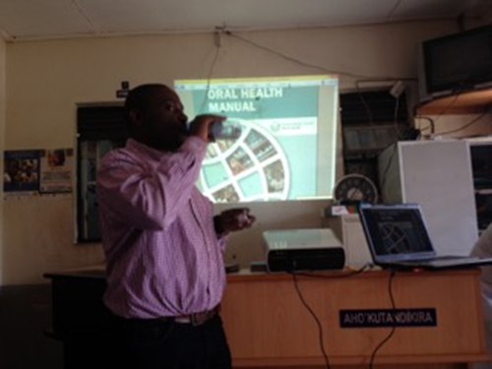 | 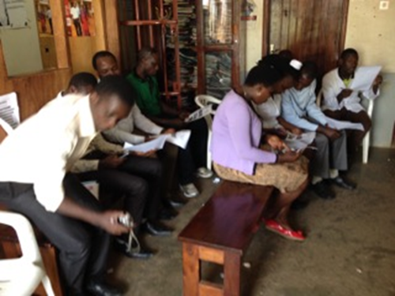
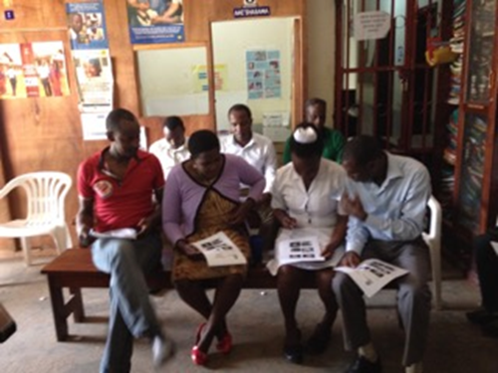 | 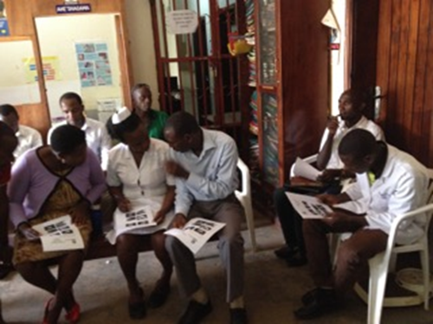
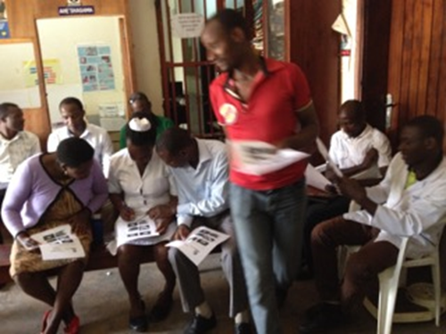 | 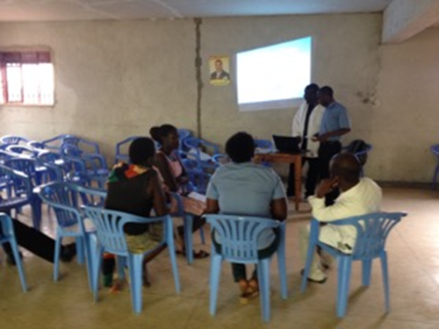
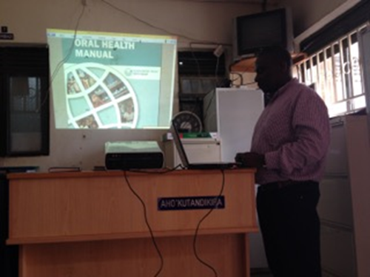 | 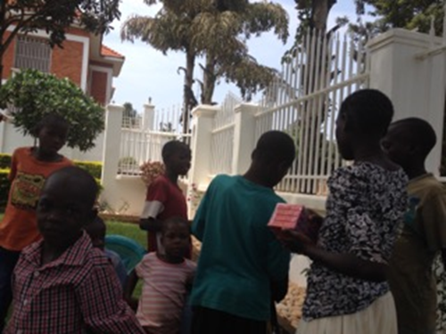
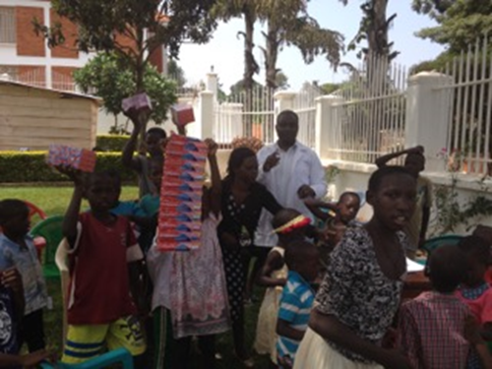 | 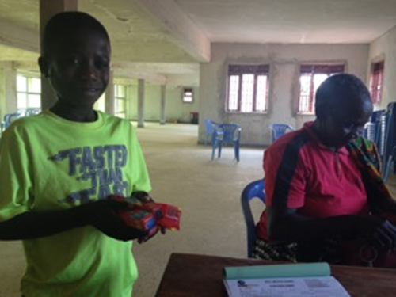
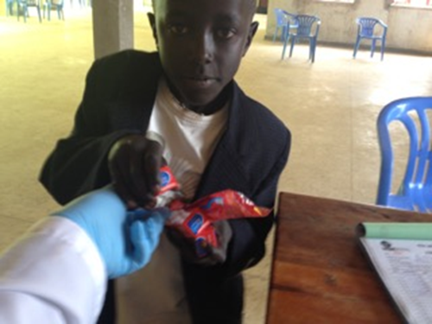 | 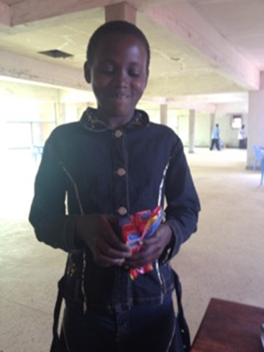
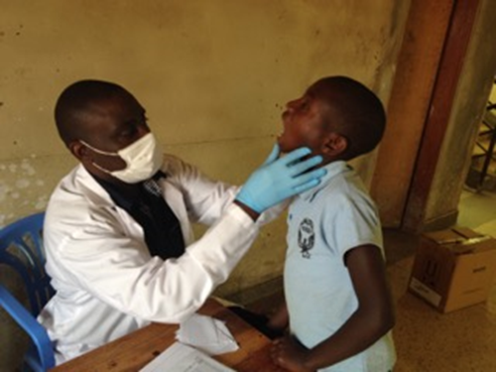 | 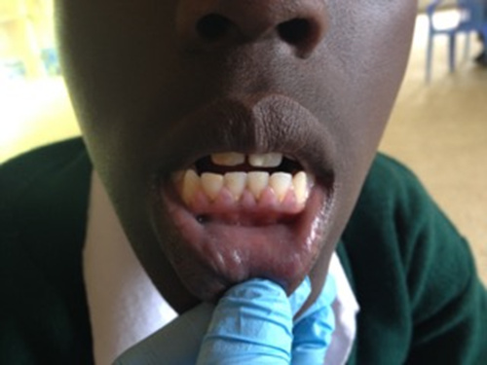
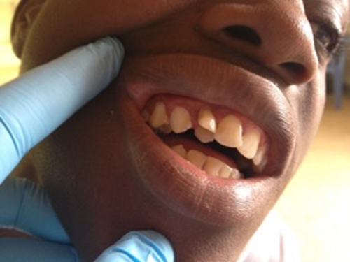 | 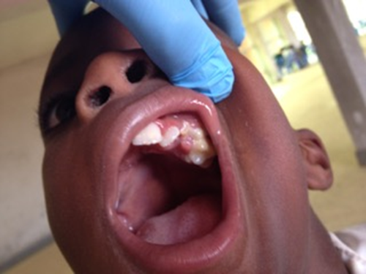
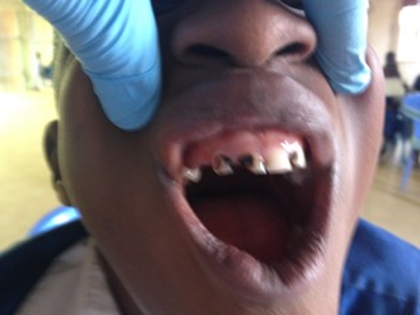 | 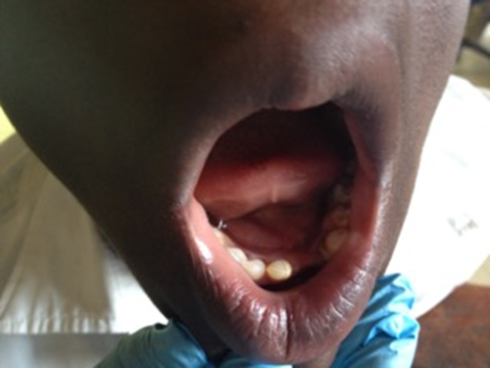
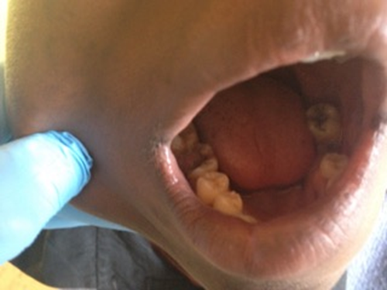 | 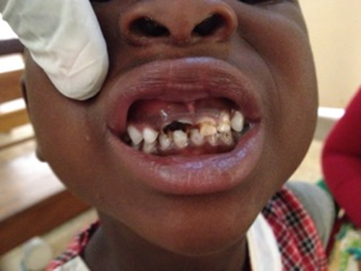
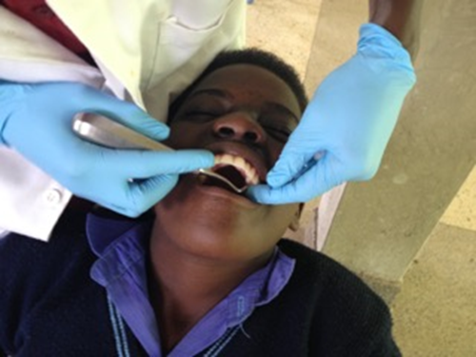 | 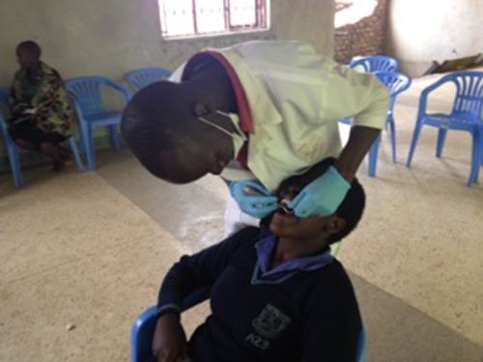
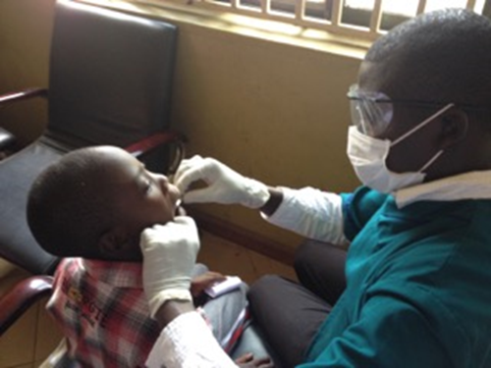 | 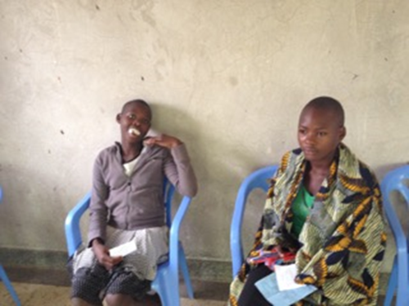
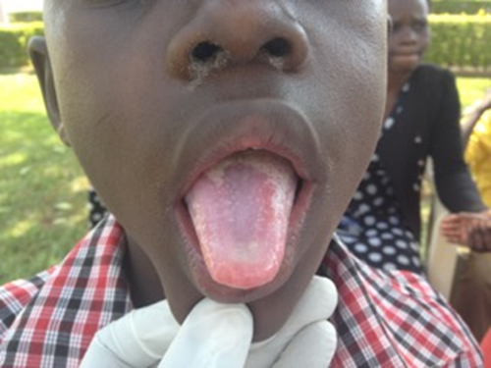 | 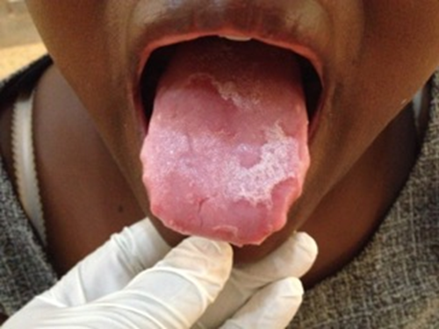
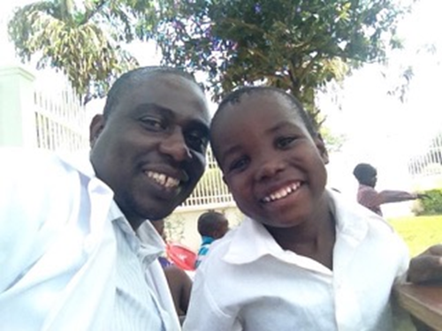 | 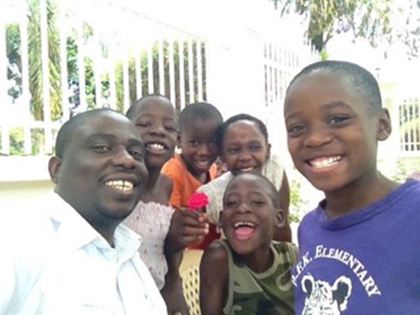
Every child deserves a bright smile

