End of Project Report
New Hope Project; July 1st 2012 to March 31st, 2018
Cooperative Agreement Number: NU2GGH000624-05
CHILDREN’S AIDS FUND – UGANDA
Submitted by:
Children AIDS Fund Uganda
Plot 36, Ntinda II Road, Naguru, Kampala;
P.O. Box 7633, Kampala, Uganda.
Phone: +256-414-235666
Fax: +256-414-235684
Email: info@cafu.ug, jbitarabeho@cafu.ug

Acknowledgements
Children AIDS Fund Uganda (CAFU) wishes to express heartfelt appreciations to the people of the United States of America for their offer to support development outside the US through the through the respective US government agencies. CAFU appreciates the PEPFAR support through CDC and to CDC for both the funding and technical support; both programmatic, monitoring and evaluation and others areas throughout the project life since the July 2012. The support enabled CAFU to contribute to the improved quality of life through provision of comprehensive HIV/AIDS care, treatment, prevention and support services for the PLHIV and their families including specific support to orphans and vulnerable children due HIV/AIDS.

CAFU appreciates the government of Uganda for the supportive environment in general and the Uganda ministries of health (MoH) and that of gender labor and social development (MoGLSD) for the technical guidance, leadership, material support in form of manuals, guidelines and other reference materials during the provision of HIV/AIDS, OVC and related services.

To our New Hope Partners, we say thank you for the partnership and corporation in guiding and supporting ourselves during the implementation. We shared and learnt a lot from each other all through the project life.

To all the project staffs; kudos for the good ride and the achievements attained herein reported.

To all the beloved (PLHIV) clients in care and on treatment and the OVC beneficiaries for seeking services either through the CAFU founded as well as CAF supported health facilities and directly to the OVC beneficiaries through CAFU headquarters, we say thank you for allowing CAFU to contribute to your improved quality of life observed over the project period as reflected in the this report.

Table of Contents
Acknowledgements 2
Table of Figures 4
List of Tables 4
Acronyms 4
Executive Summary 6
Introduction 8
Cooperative Agreement Background 9
New Hope Project Goals and Objectives 10
Goal I, Objectives 11
Goal II, Objectives 11
Project Direct Services Deliveries 11
HIV Counseling and Testing Services (HTS) 11
Adult treatment (HTXS) and Pediatric treatment (PDTX) 13
Viral Load Suppression Levels of PLHIV on treatment served and assessed for Viral Load 16
Adult and Pediatric Care and support (PDCS) including TB/HIV Co-infection management (TB/HV) 18
Elimination of Mother to Child Transmission (e-MTCT) and EID 20
Orphans and Vulnerable Children services (OVC) 21
Health Systems Strengthening (HSS) 33
Laboratory management 35
Monitoring, Evaluation and Reporting and IT Infrastructure Support 36
Project Management and Governance 37

Table of Figures
:
Figure 1: HTS out puts, Jul'12 to Mar'18 13
Figure 2: Annual HIV+ yield, Jul'2012-Mar'2018 13
Figure 3: New on ART by IP year, Jul' 12-Mar'18 15
Figure 4: TX_CURR Versus Active in care by IP year, Jul'12-Mar'18 15
Figure 5: Clients provided PHDP services 19
Figure 6: Number of PLHIV provided TB services, Jul'12_Mar'18 20
Figure 7: Pregnant Women Provide ART for PMTCT, Jul'12-Mar'18 21
Figure 8: Children<15 years provided HIV/AIDS Services at IHF's supported by CAFU 24
Figure 9: OVC Beneficiaries served 25
Figure 10: Individuals Supported thru OVC program to access HIV services (HTS) 26
Figure 11: Old Toilets t St Ludigo Gimbbo Primary School in Wakiso District 27
Figure 12: New Toilets at St Ludigo-Gimbo Primary School in Wakiso District 28
Figure 13 Renovated Classroom Block at Kigalagala Primary in Bussedde Jinja District 30
Figure 14: Two 10,000 liter Water tanks at Naguru Katari Primary School in Nakawa Division Kampala District 30

List of Tables
Table 1: Viral Load Suppression Levels of PLHIV on treatment served and assessed for Viral Load 18
Table 2: Staff trained, by course type during the project period 35
Table 3: IT items procured type during the project period 36

Acronyms
EGPAF Elizabeth Glaser Pediatric AIDS Foundation
CAFU Children’s AIDS Fund Uganda
CRS Catholic Relief Services
USAID RHITES-EC USAID Regional Health Integration to Enhance Services in East Central Uganda Activity
IHF Indigenous Health Facilities
CBO Community based organization
PITC Provider initiated testing and counseling
DSDM Differentiated Service Delivery Model
OPD Out Patient Department
PMTCT Prevention of Mother to Child Transmission of HIV
MBCP Mother Baby Care Point
PHDP Positive Health Dignity and Prevention
IP Implementation Partner
VSLA Village Savings and Loans Associations
IGA income generating Activities
UPMB Uganda Protestants Medical Bureau
UCMB Uganda Catholic medical Bureau
HMIS Health Management Information System
OVCMIS Orphans Vulnerable Children Management Information System
MoH Ministry of Health
MGLSD Ministry of Labor Gender and Social Development

Executive Summary
Children’s AIDS Fund Uganda (CAFU) was established in 2002 by Children’s AIDS Fund International; a US based non-partisan and non-profit NGO and registered in Uganda in 2005 as a National NGO. The five year cooperative agreement code named New Hope Project was awarded in July 2012 to CAFU by CDC to provide high-quality, comprehensive HIV/AIDS treatment, and prevention services through effective programming, integration, decentralization, strategic partnerships/collaboration and referral and linkages. All HIV/AIDS and other health and OVC services were provided in line with guidelines from the line ministries of health (MoH) and gender, labor, social development (MGLSD). The program was implemented through 8 Private None for Profit (PNFP) health facilities until middle of final year. However, there were significant changes in the final year of the projects due to new PEPFAR implementation strategies of regionalization that resulted in New Hope project losing 2 implementing sites in western region and 2 in East Central region effective October 2017.
The project was implemented under the following but interrelated underlined themes. HIV Counseling and Testing Services: A total of 116,554 HIV tests were done from which 12,827 new HIV positives were identified; hence achieving an overall yield of 11%. Adult treatment and Pediatric treatment: Cumulatively, CAFU was able to put a 12,468 HIV+s on ART hence performing at 76% against a cumulative annual target for new on ART of 16,300. Nearly all (13,480) clients of those (13,516) in care were on treatment; hence attaining the 2nd UNAIDS target of providing ART to 90% of those PLHIV in care by the year 2020. Viral Load (VL): Out of 19971 PLHIV with VL assessed, 18,229 (91.3%) had VL suppression levels. e-MTCT and EID: a total of 2131 HIV positive pregnant women were identified and started on ART for PMTCT. TB/HIV Co-infection management: a total of 2089 PLHIV were diagnosed with TB and all were given treatment for TB. OVC: the program was implemented with greater engagement of the district and community structures within the local government and CBOs. Over the project period, a total of 8,104 OVC beneficiaries were provided with OVC services. CAFU supported establishment of VSLAs and related activities including establishment of IGAs that enrolled 2600 caregivers altogether. A total of 1055 VSLA members established IGAs and 1,002 (95%) registered success noted by transitioning 2,664 OVC initially under direct education support from CAFU to direct parent support. 1150 OVC were supported for apprenticeship training under various artisans followed by business and life skills training.

Introduction
Children’s AIDS Fund Uganda (CAFU) was established in 2002 by Children’s AIDS Fund International; a US based non-partisan and non-profit NGO and registered in Uganda in 2005 as a National NGO.
Vision: An AIDS free and productive generation
Mission: To limit suffering of HIV impacted families through equitable access to comprehensive HIV/AIDS service and supporting the development of health and productive families.

CAFU programs/services
CAFU programs and services include: HIV and TB care, treatment and support services for adults, children and adolescents, pregnant and breastfeeding women and their families, HIV prevention services; health systems strengthening (HSS); services for OVC and capacity building that involves supporting and training in grants management, production and skills training for clients and training in HIV health services provision.
CAFU implemented the HIV combination prevention strategy, which advocated for the use of more than one evidence based approach to Prevention of HIV transmission. This included Condom distribution, with information on their correct and consistent use; Positive Health Dignity and Prevention interventions such as Effective ART, with adherence support through patient follow up by expert clients and community volunteers, psychosocial support through support group activities and individual and couple counseling and testing, Family Planning (FP) counseling, disclosure counseling, risk reduction education and assessment and treatment of STIs.

Purpose of five year project report
The project report is compiled by CAFU management to reflect Performance of the CAFU five year New Hope project implementation in one document.

Cooperative Agreement Background
In July 2012, CAFU was awarded a five year cooperative agreement by CDC to provide high-quality, comprehensive HIV/AIDS treatment, and prevention services through effective programming, integration, decentralization, strategic partnerships/collaboration and referral and linkages.

The family-centered model that emphasized improving the status of the entire family was followed in providing quality HIV/AIDS care, treatment and prevention services. In addition, other health care services such as; antenatal care, Family planning information (FP), childhood inoculations and growth monitoring, screening for Cancer of the cervix and treatment of STIs were provided. For non-available services, clients were referred while through collaboration with Reproductive Health Uganda, FP service services were provided.

In the third year of implementation, comprehensive OVC services were provided in line with the national strategic programme plan of interventions for orphans and other vulnerable children; during which OVC beneficiaries received services in all the six core programme areas through either direct service delivery or linked to services providers. Through referrals and linkages, services that were outside the OVC core service areas like nutritional rehabilitation were referred for specialized services.

The cooperative agreement and program activities were implemented through a total of 8 private not for profit (PNFP) indigenous health facilities (IHF) that included 2 CAFU founded sites (code named FAMILY HOPE CENTRES (FHC) one located an Jinja in Jinja district (FKCJ) and the other in Kampala capital city authority (FHCK) while the other 6 were affiliated PNFP IHFs. The six PNFP IHFs were; Bushenyi Medical Center in Bushenyi district, Kabwohe Clinical Research Center in Kabwohe district, Buwenge NGO hospital in Jinja district and two (Nurture Africa and Namugongo Fund for Special Children) from Wakiso districts and Alive Medical Services in Kampala. The six PNFP IHFs were supported through a sub granting mechanism.

Starting with 4 Faith Based Organizations (FBO) sites in 2012, the cooperative agreement increased by 4 more to a total of 8 IHFs in 2013. Beginning Oct 2017, the cooperative agreement was impacted by donor led regionalization implementation strategy that required only one PEPFAR implementing partner (IP) per region. As a result, 4 New Hope grant sites were transitioned to regional IPs. The 2 IHFs in the Southwest Uganda region transitioned to the Elizabeth Glaser Pediatric Foundation (EGPAF) Regional Health Integration to Enhance Services in South Western Region of Uganda (USAID-RHITES-SW) effective October 1, 2017 while the 2 in East Central Uganda transitioned to University research corporation (URC) USAID RHITES-EC Regional Health Integration to Enhance Services in Ease Central Region of Uganda (USAID RHITES-EC) both funded by PEPFAR through USAID effective October 1, 2017. Similarly, some of the OVC services provided by CAFU in the geographical locations that transitioned from CDC to USAID were also transitioned to the USAID funded implementing partners that included; catholic Relief Services (CRS) that implements OVC in parts of Wakiso to World Education Inc./ Bantwana (WEI/B in Jinja District.

New Hope Project Goals and Objectives
New Hope had two project goals for the implementation:
- To provide comprehensive HIV/AIDS care, treatment and prevention services in the IHFs
- To contribute to the national response (the scale-up of) of reaching out to the critically and moderately vulnerable children in Uganda
CAFU planned to make a contribution to the two goals by working towards achieving the under listed project objectives:

Goal I, Objectives
- To strengthen the capacity of IHFs to effectively implement and sustain combination HIV prevention programs in targeted Districts
- To strengthen and scale-up HIV treatment, care and support services for infected and affected individuals in targeted districts
- To strengthen Health Systems within IHFs and targeted district, including the national government‘s capacity

Goal II, Objectives
- To improve socio –economic status of OVCs, youth and their caregivers
- To improve food security and nutrition status of OVCs and their house hold members
- To increase availability of protection and legal services for OVCs and their house hold members
- To increase access to psychosocial support & Basic care for OVCs and their family members
- To Improved access to health services for efficiency and effectiveness along the continuum of care
- To Improve access and coordination of community-based services

Project Direct Services Deliveries

HIV Counseling and Testing Services (HTS)
Mobilization for HTS was done with engagement of: trained peers and peer leaders, CBOs and index clients to reach out to respective household members through partner notification and identification. The facility based models included PITC strategy. PITC was instituted at all facilities to cover all health services delivery points such as; TB clinics, OPD , nutrition clinics, STI clinics, inpatient wards and PMTCT. The community testing included, Outreaches and mobile testing services, targeting hot spots for KPs and PPs, reaching men at work places and Home based testing for partners, contacts and children of index clients. Figure 1 and 2 below provide HTS performances over the project period. It should be noted that whereas HIV positive represent individuals testing positive for HIV, HIV tests simply represent the number of tests done.
Over the project period, beginning Jul’12 and ending Mar’18, a total of 116,554 HIV tests were done and 12,827 new HIV positives were identified giving an overall yield of 11%. Although the numbers of tests done steadily increased over the project period, the HTS performance against was highest over the project period of Oct’12-Sep’13 at 182% and Oct’14-Sep’15 at 358%. This was due to the low HTS target of 6,000 and 5,735 HIV tests respectively. Conversely the performance against target was lowest the period Oct’15-Sep’16 in which CAFU performed at 56% due to a very high target of 43,132 HIV tests. Overall, HIV tests conducted against target was 90%.
Some of the challenges encountered during HTS implementation included:
- Persistent expectation of transport refund by clients to access HTS.
- Some clients including the female sex workers and truck drivers did not value HTS and considered it a waste of their time and would rather be engaged in their businesses.
- Most of adolescents would only be served over holiday time.
- It was also a challenge testing men even through for the index client testing strategy as they claimed to be too busy at their work places.
- Non-disclosure especially by female index clients to their spouses hampered index clients testing. This was associated with various social-economic including fears of exclusion from economic resources and GBV in male dominated society.
- Some clients did repeat tests on walk in basis although they already knew their status. This group constituted those that refused to immediately start on ART and or were lost to follow up.
- Slow uptake of APN services by facility teams. APN that was a component of surge strategy introduced when New Hope was in close out period.

Figure 1: HTS out puts, Jul'12 to Mar'18

Figure 2: Annual HIV+ yield, Jul'2012-Mar'2018

Adult treatment (HTXS) and Pediatric treatment (PDTX)
The ART services delivery included maintenance on ART of clients that are already on ART and linking the newly identified HIV+s into care and/or enrolment onto treatment. CAFU use trained peer educators for effective linkages, strengthen QI initiatives on linking HIV+ identified and improve pre testing screening and psychosocial support including identifying of PLHIV already in care during HTS to avoid registering HIV re-testers as newly identified HIV+.
The peer led strategy was used to continuously improve retention of clients on treatment throughout the 5 year period. Participatory approaches were used by CAFU in identifying peer leaders from clients groups such as; youths, mothers, men, adolescents and KP/PP for training in supporting peers on treatment related issues and adherence to treatment and routine/scheduled visits to the clinic for health outcome indicators monitoring. CAFU also rolled out DSDM at IHFs and supported its implementation to continue improving retention of clients on treatment. The DSDM at IHFs included: Fast truck drug refills, Facility based groups of Mother baby care points, adolescent clinic days, and facility based individual management; drug distribution in the community through community drug distribution points and client lead ART delivery; use of the appointment book to identify and track missed appointments; pre appointment Phone call reminders for mother-baby pairs; use of expert clients and peers to provide psychosocial support; Continuous Health education sessions on PHDP; utilization of a mother baby care point and Cohort monitoring by health workers and retention monitoring at MBCP. IHFs were supported to integrate continuous quality improvement initiatives into the health services provision to track DSDM uptake and for patient adherence and VL monitoring.

Cumulatively, CAFU was able to put a 12,468 HIV+s on ART hence performing at 76% against a cumulative annual target for new on ART of 16,300, figure 3. CAFU continuously improved enrolling PLHIV in care onto treatment and by end of the project in March 2018, nearly all (13,480) clients of those (13,516) in care were on treatment; hence attaining the 2nd UNAIDS target of providing ART to 90% of those PLHIV in care by the year 2020, figure 4.

The challenges encountered during treatment services included: newly identified HIV+s preferring to start treatment later at facilities of their choice, preference of to start treatment later due to stigma related issues and denial/acceptance of results. Such, clients were provided further psychosocial preparations to start treatment when they were ready. Repeat HIV testers that were already enrolled onto ART in other clinic also posed a challenge to the linkage teams since the team unknowingly tenaciously followed up these presumably newly identified HIV+s for linkage to care and to treatment only to discover frustratingly later that they were experienced ART clients already on treatment elsewhere.

Figure 3: New on ART by IP year, Jul' 12-Mar'18

Figure 4: TX_CURR Versus Active in care by IP year, Jul'12-Mar'18

Viral Load Suppression Levels of PLHIV on treatment served and assessed for Viral Load
Overall; considering all PLHIV on treatment whose viral load was last assessed, 91.3% of them have their viral load suppressed (having <1000copies/ml) indicating an attainment of the 3rd 90 of the global HIV/AIDS ambitious target by 2020. However, an assessment of viral load suppression levels by age group categories shows that only those PLHIV that are aged 25 and above years have their viral load suppressed (Table I). The reasons for the non-suppressions levels for those PLHIV whose viral load is not suppressed rotate around non-adherence to treatment and stigma.
The factor causing non-adherence includes:
- Poor time management of clients failing to adhere to the timing when they take their medication.
- Nutrition challenges and/or lack of food at the time of taking medication leading to clients postponing medication to the time after having eaten some food.
- Drug fatigue and clients giving themselves drug holidays is noted. It noted that when some of the clients feel their health is good, they postpone treatment to later dates of their choice.
- PLHIVs that frequently travel have been noted to either forget to take with them the drugs or take less drugs compared to the anticipated period of stake away from the place keep their drugs.
- Inadequate supportive environment especially for HIV+ children in boarding schools fearing to take their medication due to a peer pressure from fellow students/pupils. One noted scenario of a child that shouted at a colleague who was taking medication. The child displayed the medication shouting “come and see this sick one taking medication all the time”. The child to whom the shouting was done had to change school.
- Peer influences at home and the child on treatment querying “why he/she is always taking medication while the rest aren’t” and eventually this concerned child on treatment starts dodging medication.
- Some caretakers delay providing treatment to the children either at home or while at school. While at school, it is challenging for the school nurse to follow-up the children on treatment for medication. It is the child that has to go the school nurse for medication and the children either forget or just dodge. At home, the challenge is mainly encountered by those very busy caretakers adhering to the child’s treatment schedule. Sometimes the school schedule interferes with time for taking medication especially when they delay in class during evening preps.
- Those who take medication with meals also face challenges if for some reason the meal is late.
- Some few young men (20-24 year old) engage in alcoholism and that leads them to forgetting to take their medication.
- Transition young adults (20-24)also face challenges with stigma, and job schedules which are inconsistent especially those with non-routine jobs like drivers jobs and those working night jobs in bars, shops and restaurants
As a result stigma, non-disclosure by the adult client and to the children on treatment by the caretaker for the children to know that they are HIV+ is still noted by the service providers. This is also negatively affecting adhering to treatment given that the clients continue to seek for an opportunity when they have to hide while taking their medication and the continued querying by the children why they continue to take medication all the time. Fear to take medication by HIV+ children while other children are watching is noted as high by the service providers.
There is however challenges in monitoring and providing adherence support especially to children that are in different boarding schools that are scattered and more so distant from the location of the health facility providing the HIV/AIDS treatment and support services.
Age Group in years | <1000 copies/ml | >1000 copies/ml | Total with VL assessed | % with viral load suppressed
<10 | 522 | 130 | 652 | 80.1
10_14 | 535 | 120 | 655 | 81.7
15_19 | 374 | 132 | 506 | 73.9
20_24 | 657 | 110 | 767 | 85.7
25+ | 16141 | 1250 | 17391 | 92.8
All Ages | 18229 | 1742 | 19971 | 91.3
Table 1: Viral Load Suppression Levels of PLHIV on treatment served and assessed for Viral Load

Adult and Pediatric Care and support (PDCS) including TB/HIV Co-infection management (TB/HV)

Positive Health Dignity and Prevention (PHDP): All the HIV positive clients in care were provided with PHDP package that comprised of: STI screening and treatment, disclosure counseling (supported disclosure), risk reduction counseling targeting discordant couples and prevention with positives, and routine HTS for discordant couples provided every after three months. Sexual partners in discordant relationships were provided ART following the national guidelines. Clients were provided with family planning (FP) information and all those in need of the FP services were referred or linked to the FP services providers, figure 5. A partnership was formed with RHU, to provide onsite Family planning services at the facility on a weekly basis and subsequently on a monthly basis.

Figure 5: Clients provided PHDP services
TB/HIV Co-infection management: In addition to emphasis by the health workers at the facilities to screen all PLHIV in contact with the health worker for TB, the community-facility referral and linkages system was as well engaged in screening and referring/linking suspected TB cases for medical investigations. Nearly all clients were screened for TB during the project period and all those diagnosed with TB were put on TB treatment, figure 6. Intensified case finding form was used and all presumptive TB cases were offered tests for TB and confirmed TB patients were started on TB treatment. A total of 2,089 PLHIV were diagnosed for TB and put on TB treatment over the project period. CAFU supported medical education sessions by health workers (HW) improving HW knowledge on TB identification/screening; sensitized HWs on use of intensified case finding tool by HWs including at community level; and sensitized and oriented expert clients/volunteers and village health teams in the community on sign and symptoms of TB and referral for TB investigation.

Some of the challenges included: incompleteness of data collection especially documenting of TB screening done by the health workers at facility, completeness of data entry into the TB register, and TB presumptive registers. One facility initially, did not have the capacity to conduct sputum Microscopy for TB and specimens were referred to FHCK.

Figure 6: Number of PLHIV provided TB services, Jul'12_Mar'18

Elimination of Mother to Child Transmission (e-MTCT) and EID
With an exception of program years (Oct’14-Sep’15) and (Oct’15-Sep’16); CAFU was able to meet its program year outputs beyond the respective set targets (Figure 7). Despite attainment of the respective set annual targets however, performance on this indicator over the project period reflects a dropping trend. The decreasing trend is mainly attributed to the continued lowering of set program year targets (Figure 7). However throughout the project period, a total of 2131 HIV positive pregnant women were identified and started on ART for PMTCT. The success factors that contributed to the performance included: use of expert clients and mentor mothers as a peer-to-peer strategy to encourage HIV+ pregnant women to enroll on the program to protect their unborn children from HIV as well as provision of psychosocial and adherence support for mothers already on ART; Use of linkage facilitators (LFs) that have been oriented on the program at respective sites to follow-up the pregnant HIV+ women in the respective LF communities; weekly performance tracking through continuous quality improvement of the PMTCT strategies by the health teams for monitoring and service delivery; M&E mentorships and support provided to health teams on data collection completeness especially filling of the primary tool (ANC register); taking action on feedback by CDC and METS technical teams for programs and data quality improvement; adequate supply of ARV and test kits through quarter; availability of the national electronic monitoring system for eMTCT has improved weekly tracking such as the weekly option B and the monthly retention reports done through SMS and project technical team weekly SMS reminders to the PMTCT focal persons at the supported health facilities

.

Figure 7: Pregnant Women Provide ART for PMTCT, Jul'12-Mar'18

Orphans and Vulnerable Children services (OVC)
Introduction for the OVC services
New Hope mechanism did not include comprehensive OVC program intervention in the First year (2012) until the 3rd year (2015) when a minimal initial budget to implement an OVC package was availed to CAFU. Until then, CAFU only provided care and treatment services to all the children that were enrolled for HIV/AIDS care and treatment services. Comprehensive OVC implementation started with the inclusion of OVC budget allocation effective 1st April 2015 and continued throughout the rest of the rest of the project life. However, CAFU transitioned all OVC beneficiaries to CRS and IDI, the respective IP’s for OVC implementation in the previous CAFU OVC implementing geographical areas as detailed below.

Transition of OVC to other IP’s
CAFU transitioned OVC implementation in 2 of the 9 sub counties Wakiso and Nangabo in Wakiso District to Catholic Relief Services (CRS) a USAID funded IP during the Jan-Mar 2018 reporting period. A total of 287 households (164 from Nangabo & 123 from Wakiso) with 1599 OVC beneficiaries (1146 <18 years and 453 18+ years) were affected.

Beginning FY18 (April 2018), CAFU transitioned 6 sub counties (3 from Kampala and 3 from Wakiso district) to IDI who is the IP for Kampala region. The transition to IDI affected a total of 5734 (4792<18 years of age) individuals. Of these, 3601 beneficiaries were transitioned in Kampala while 2,133 were transitioned in Wakiso district. The transitioned locations included 3 divisions in Kampala district (Makindye, Kawempe and Nakawa) and 2 sub counties and one division in Wakiso district (Masulita and Namayumba) and Nansana respectively. IDI contracted CAFU as a sub grantee to continue OVC implementation in the transitioned locations effective April 2018.
In Busedde Sub County in Jinja district, 362 OVC beneficiaries out of the total of 380 successfully graduated from vulnerability to self-sustainability. The remaining 18 beneficiaries did not graduate only because they were still undergoing apprenticeship skills training and were transitioned to Bantwana’s Better Outcomes for Children and Youth in Eastern Uganda for continued monitoring and support to complete their training.
Implementation of the OVC program
CAFU implemented the OVC program with greater engagement of the district and community structures such as the community development office, health & production departments, and community based trainers, village health teams (VHTs), para-social workers community based trainers (CBTs) and the child protection committees to; mobilize, coordinate and monitor OVC activities in their respective geographical locations. The VHTs and PSWs participated in follow up on OVC to provide psychosocial services including treatment adherence assessments and support to the OVC treatment supporters. CAFU worked with respective local government departments in respect of the OVC core program area to conduct appropriate training to equip all those that were involved to providing OVC services with the necessary skills for OVC quality services provision. The implementation process involved: 1) Introduction of OVC Activities to the Local Government stakeholders through holding of meetings with the respective government officials; 2) holding consultative meeting with OVC Stakeholders; 3) carrying OVC vulnerability assessment.

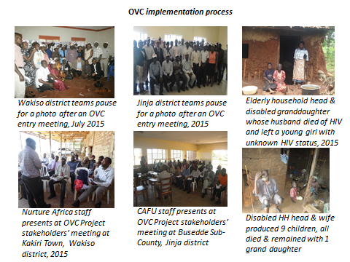

OVC Services Provided
Although New Hope Project has had HIV+ children below 15 years (Figure 8), Comprehensive OVC were only started October 2014 (Figure 9). The New Hope OVC geographical areas were larger than the Care and Treatment catchment areas. A noted drop in the number of children provided HIV/AIDS care and treatment services during Oct’17_Mar’18 period was due to the transitioning of services and beneficiaries to other IPs funded by other PEPFAR donor agencies other than CDC due to regionalization of HIV/AIDS care and treatment services.

Figure 8: Children<15 years provided HIV/AIDS Services at IHF's supported by CAFU
Individuals served under OVC program implementation.
As stated funding for OVC services package was designated beginning in the 2nd half of the program year Oct’14-Sep’15 (FY15). The drop in number of individuals served under OVC program from 8104 to 5735 at the end of the project was due to the transitioning of OVC implementation to other IPs. Overall, satisfactory (figure 9) performance was attained by CAFU in reaching the target number of individuals served under the OVC program.

Figure 9: OVC Beneficiaries served
During the program years beginning Oct’15 to Mar’18, CAFU supported provision of HTS to individuals from OVC households with specific program year outputs indicated in figure 9 below. HTS was offered to OVC enrolled households with members that did not know their HIV status.

Figure 10: Individuals Supported thru OVC program to access HIV services (HTS)
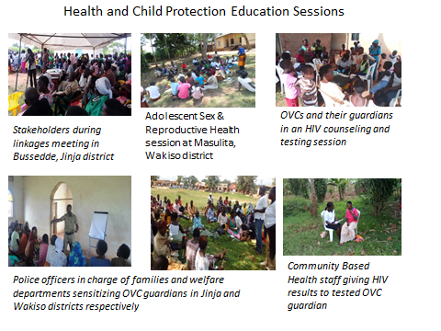
Social OVC Services
Education support to OVC was provided during the program years Oct’16-Sep’17 and Oct’17-Mar’18 reaching out to 1383 and 1766 OVC respectively. The education support included; provision of scholastic materials, payment of school fees and block funds to selected groups of OVC. All the 1766 benefitted from scholastic materials, 106 were supported through block granting to the schools in lieu of school fees. (Figures 12, 13 and 14) Under Safety; 1) Parenting skills were provided through the SINOVUYO approach to a total of 2600 (240 during Oct’16-Sep’17 & 2360 in Oct’17-Mar’18) individuals that included both parents/caretakers and their teens, 2) legal support was provided to 169 OVC all of whom came from Kampala areas of CAFU implementation. For stability of the OVC households, CAFU implemented VSLA activities altogether enrolling 2600 caregivers and supporting VSLA members to establish IGAs. A total of 1055 VSLA members have established IGAs and 1002 (95%) registering success as evidenced by ability to support their hold holds including paying school fees.
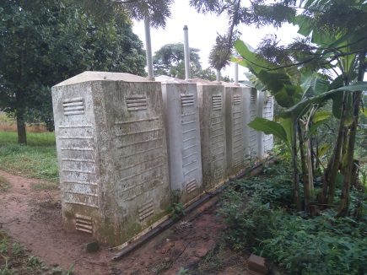 | 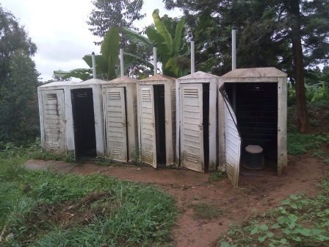 | 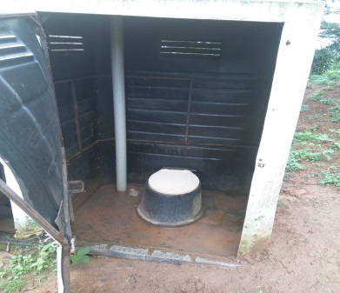
Old Pupils Toilets at Primary school before
Figure 11: Old Toilets t St Ludigo Gimbbo Primary School in Wakiso District

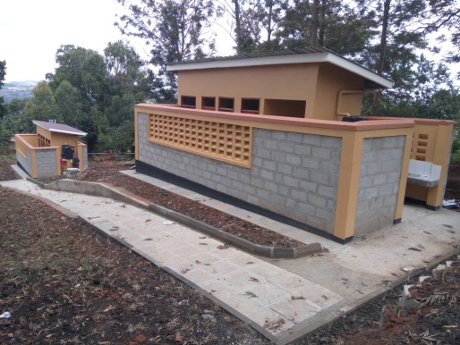 | 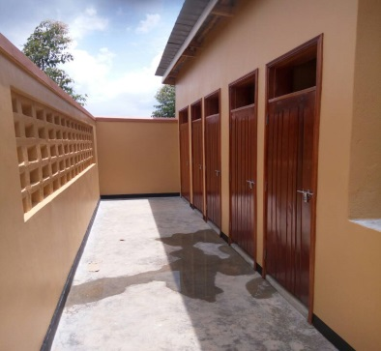 | 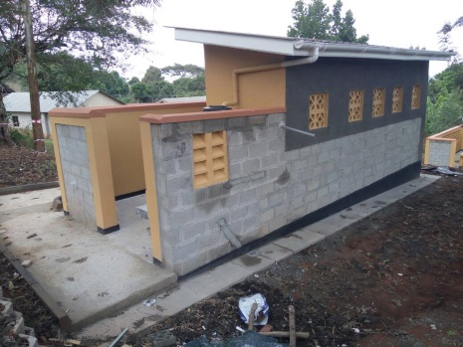
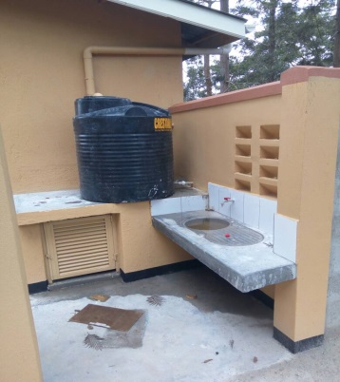 | 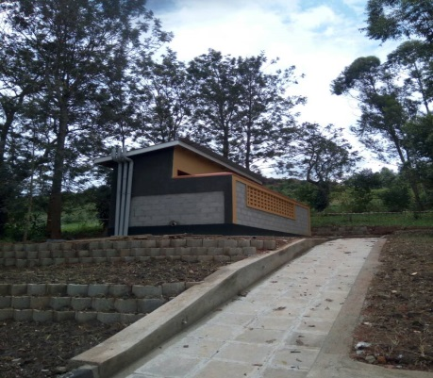 | 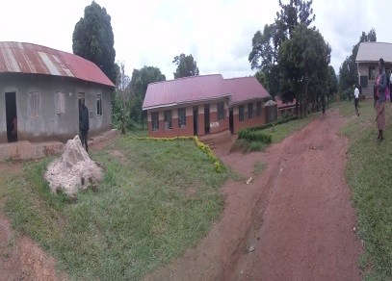
New Block funded male and female Toilets with disability rump and stanza, rain water harvesting tank and , wash basin fro hygiene
Figure 12: New Toilets at St Ludigo-Gimbo Primary School in Wakiso District

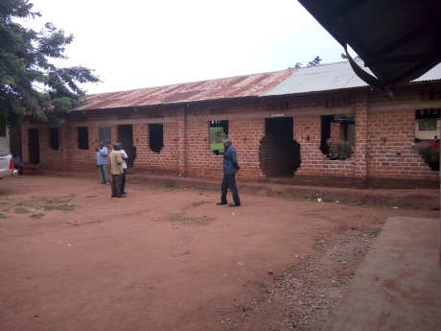 | 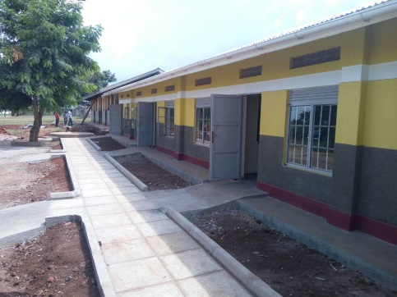
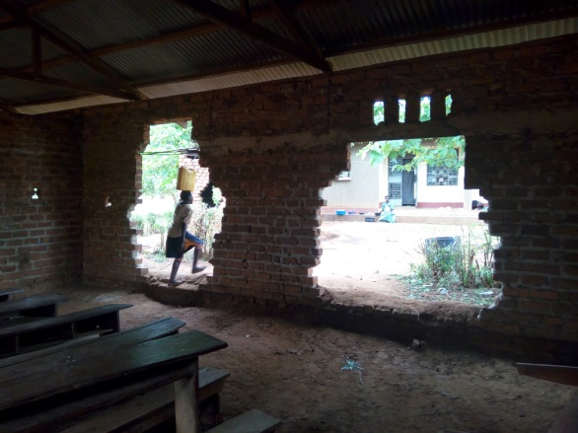
Before | After
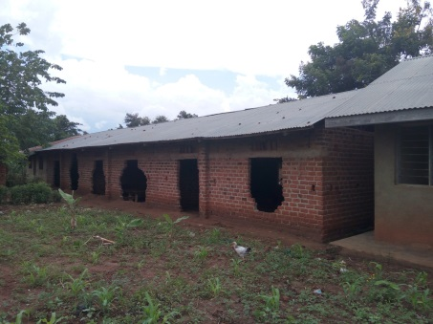 | 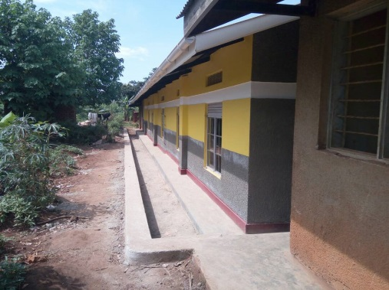
Before | After
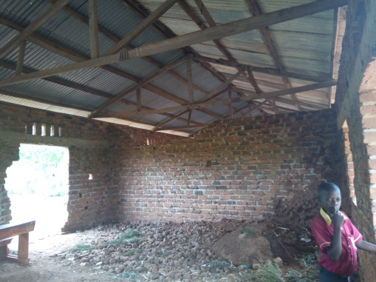 | 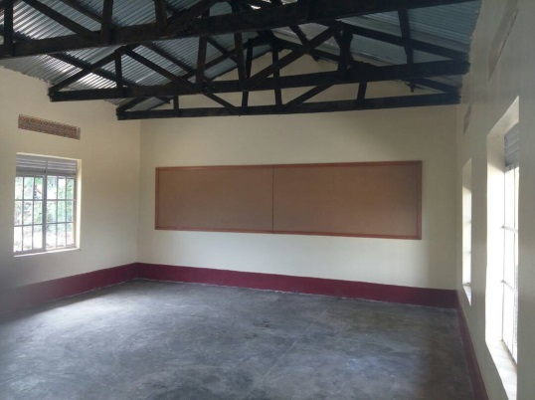
Befoe r | After
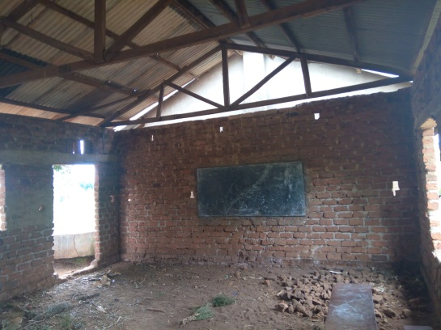 | 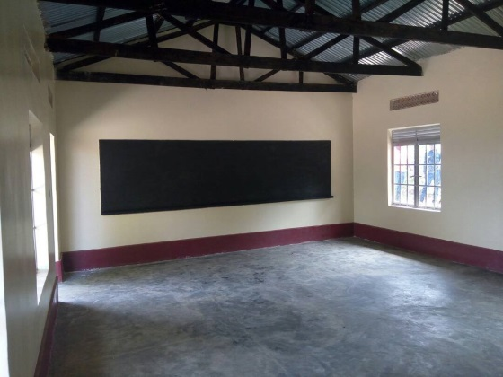
Befre | after
Figure 13 Renovated Classroom Block at Kigalagala Primary in Bussedde Jinja District

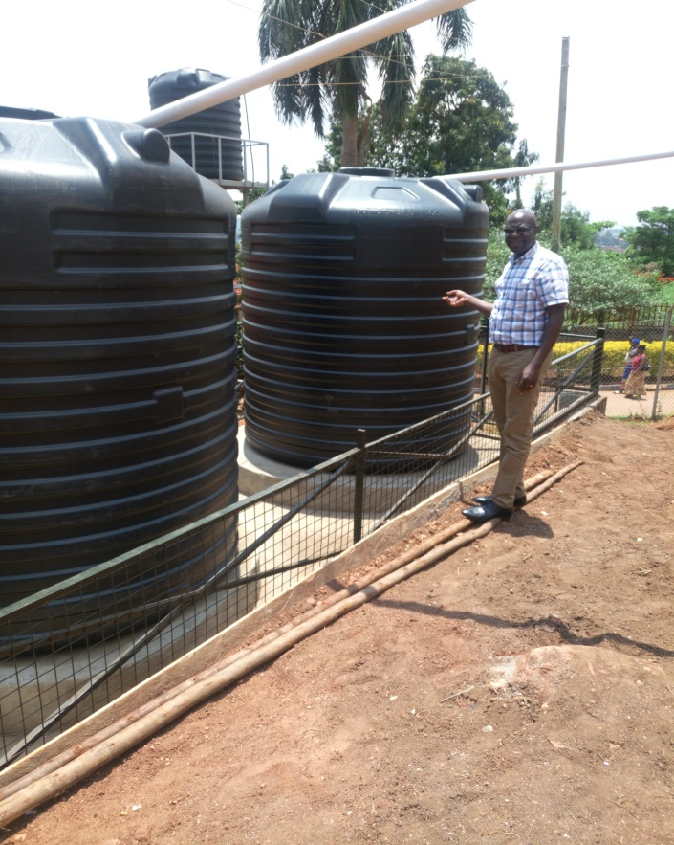 | 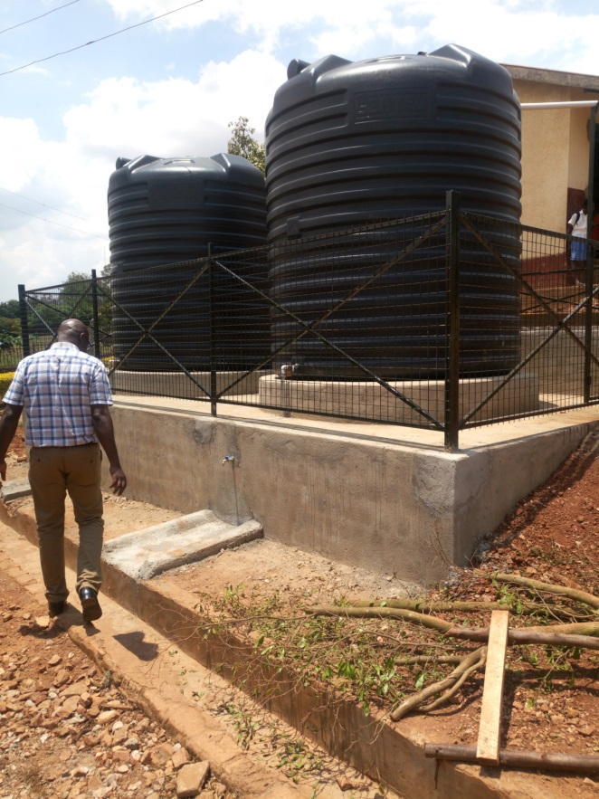
Two 10,0000 Liters rain water harvesting and storage tanks for hygiene and flush water Toilets erected with Block funds.
Figure 14: Two 10,000 liter Water tanks at Naguru Katari Primary School in Nakawa Division Kampala District
For

Program social OVC services successes scored include a total of 2664 OVC that initially received direct education support from CAFU transitioning to direct parent support for their education using proceeds from the VSLA. The VSLA activities were monitored by the community based trainers with support from CAFU and by end of the project; the VSLA groups had accumulated a total saving of 151,828,838 Uganda shillings (UGX) and had earned interest totaling to 33,312,238 UGX hence a 22% earning from the savings. It is from this good VSLA progress that the VSLA members were able to take up responsibilities such as: payment of school fees, provision of clothing and food and scholastic materials to their respective children. The VSLA savings has served as a valuable financial resource for members who have borrowed and started IGAs in these underserved geographical areas.
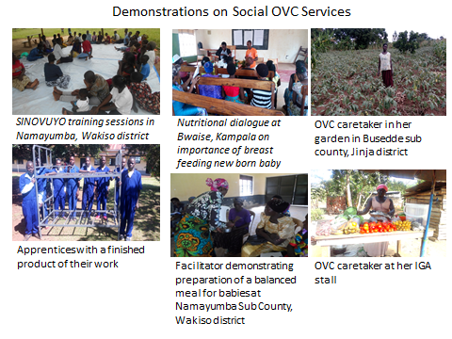
Apprenticeship skills building
Improving livelihood of youth through apprenticeship training is one of the key activities implemented by CAFU OVC project. By end of March 2018, a total of 1151 youths had been assessed and placed for training with different Artisans. The youths were taking on different courses that include: motor vehicle and motor cycle mechanics, tailoring, bakery, plumbing, hairdressing, wielding, video editing, catering, carpentry and joinery, cosmetology, events management, computer training, crafts shoe making, liquid soap making, bar soap making, knitting of sweaters, driving and pastries. Out of the 1151 apprentices, CAFU directly assessed and enrolled 328 while others were referrals from other partners that included: 100 from Reach Out Mbuya, 150 from Mild may Uganda, 150 from Baylor Uganda, 9 from UPMB and 426 from UCMB. The apprentice referrals resulted having a large target while there was no allocated funding. However, due to the regionalization and transitioning of services of activities from CAFU to other IPs, CAFU could cater all the apprentices including referrals under New Hope OVC program.
OVC capacity building and training of project stakeholders
To ensure improving progress of the OVC project towards attainment of OVC project objectives, CAFU carried out capacity building activities for project implementers and training for the project beneficiaries so as to provide appropriate knowledge and skills in the monitoring and management of project components respectively.
The capacity building outputs for implementers included:
- Training of 90 community volunteers in OVC implementation and OVC services provision
- Training of 3 (2 from Kampala and 1 from Wakiso district) community based trainers to support VSLA training and monitoring
- Training of 27 community volunteers for support follow-up of legal and other OVC cases within respective volunteer community and also strengthen linkages for OVC services.
The training outputs for OVC beneficiaries included:
- Orientation of 80 OVC guardians in; business, financial management, entrepreneurship and business management skills
- Training of 61 VSLA groups with a membership of 1257 (124 male, 1133 female) in VSLA approaches, methodologies, financial literacy, selection planning and management. The VSLA members have also been trained on parenting skills.
- Placed 1150 (511 female, 639 male) youth apprentices for artisan skills training for various courses aforementioned. Of these 734
- 850 OVC households involved in horticulture trained in horticultural farming methods
- 240 (120 teens and 120 caretakers/parents trained on parenting skills

Health Systems Strengthening (HSS)
Over the project period, CAFU supported the training of 146 health Care workers (HCWs) in various courses in respective staff services provision. These HCWs categories included: 16 medical doctors, 21 clinical officers, 15 enrolled nurse midwifes, 11 lab technologists, 8 lab technicians, 12 registered nurses, 7 counselors, 6 dispensers, 5 social workers, 4 nursing assistants, 3 registered midwife, 1 allied HW and other 33 HCWs that included either the support staff (including M&E teams) or the students on placement to ensure safety in a health setting and being equipped with appropriate health information so as to support clients in need at a given time and to improve respective skills in providing respective services. Table 1 below provides details of number of staff trained by course over the project period.

- The training courses included: HIV Data management Course; Advanced HIV/AIDS course; BIORISK; Clinical pharmacy in HIV/AIDS and ART for Pharmacy Health Workers (non-pharmacists) course; Comprehensive ART management for nurses / clinical officers’ course; Gender Based Violence; HIV prevention for program managers; HMIS Indicators; Lab management and ToT course; Laboratory Techniques and GCLP Training; LQMS; Monitoring and Evaluation; Open MRS training; PMTCT OPTION B+; QA/QI Training; TB / HIV co-infection and ART Management for Nurses & Clinical Officers.

Number of staff trained, by course type during the 5 year project period
Course Name | Number of Staff participating in Training
Advanced HIV/AIDS course | 9
BIORISK Training | 3
Clinical pharmacy in HIV/AIDS and ART for Pharmacy Health Workers (non-pharmacists) course | 8
Comprehensive ART management for nurses / clinical officers course | 1
Gender-Based Violence | 11
HIV Data management Course | 8
HIV prevention for program managers | 16
HMIS Indicators | 23
Lab management | 15
Lab management ToT course | 12
Laboratory Techniques and GCLP Training | 6
LQMS Training -CAF | 6
Monitoring and Evaluation (M&E) course | 10
Open MRS training | 9
PMTCT OPTION B+ | 20
QA/QI Training | 19
TB / HIV co-infection | 13
Updates in ART Management for Nurses & Clinical Officers | 15
Table 2: Staff trained, by course type during the project period

Laboratory management
The efficiency and quality of laboratory service at the supported IHFs was strengthened throughout the project period by:
- Conducting annual training of staff in biosafety and bio-risk as well as mentorships during which staffs were supported on quality testing and results dissemination.
- Distribution and institutionalization of new guidelines in HIV testing, viral loads, serum CRAG at facilities including training of staff on the use of the new guidelines.
- CAFU procured and distributed equipment such as microscopes and centrifuge as well as provided adequate stocks of lab supplies for chemistry investigations, blood test reagents and test kits among others for all the supported health facilities.
- Annual service contracts for equipment maintenance and servicing were provided.
- Supporting health facility laboratories in participating in EQA schemes that were conducted in HIV testing, CD4 and TB sputum microscopy. One site conducted Gen expert EQA.

Monitoring, Evaluation and Reporting and IT Infrastructure Support
IT infrastructure: Through the project CAFU setup and improved the IT infrastructure at each of the supported IHFs to augment M&E, communication and sharing of developments in HIV/AIDS interventions among other public health interventions, research and enabled skills development. This exemplifies one of the quality improvement measures undertaken. Specific equipment and supplies include 37 desk top computers, 27 laptops and 6 servers (Table 2) were procured among other items and appropriately distributed within the projects structures. All the supported IHFs established a local area network (LAN) connected to the internet.

Number of IT items procured type during the project period

IT item description | Number of items procured
Computer | 37
Copier | 4
Laptop | 27
Printer | 1
Server | 6
LCD Projector | 2
Grand Total | 77
Table 3: IT items procured type during the project period

Monitoring was done on a routine basis throughout the project life in assessing project performances against the given annual targets through weekly project reviews, monthly or quarterly basis. The weekly reviews focused on the PMTCT/eMTCT program and the quality improvement projects identified and implemented at the different health facilities. Quarterly performance reviews were conducted at all levels of the project from health facility level to CAFU level involving all respective stakeholder representation.
Project progress monitoring data was collected using both the available national tools from both the Ministries of Health and that of Gender Labor and Social Development (HMIS & OVCMIS tools).
Evaluation: Project baseline and Mid-term assessments were not a required objective but the end of project evaluation was not conducted due to tight timelines and poor preparedness for the assessments and evaluation. However, quarterly performance reviews were conducted to inform subsequent project implementation periods and for generating discussions for strategic improvements and innovations. Cascade analysis strategy was used to present, interpret and assess project performance on implementation strategies for program areas such as: test and start, TB services, PMTCT/eMTCT and OVC services.
Reporting on the project activities was done at all levels from the direct services providers using nationally available data collection tools to report on their activities up to CAFU level that had the responsibility to report and account for resources to the donor (CDC) and to MoH and MGLSD who are key oversight stakeholders and technical supervisors during the project implementation. Reporting on the project was done by posting data into both PEPFAR and national (Uganda) reporting systems. The PEPFAR reporting systems included DATIM and HIBRID, while those for Uganda included the DHIS2 and OVCMIS. All through the project life, data quality assessment were conducted involving; METS, MOH, MGLSD and CAFU technical staff as an approach to improve the quality of data reported through the aforementioned systems.

Project Management and Governance
The New Hope project was managed all through the 5 years by a strong team that included the support staff that made the environment conducive for the professionally trained and skilled staff under the leadership of the Executive Director supported by a senior management team (SMT) comprised of Director Finance, Director Medical services, Manager Human Resources & Administration and the Director Programs who also doubled as the project business official. The SMT direct oversight for provision of quality health care, treatment, prevention and support services to all the project beneficiaries by staff at their respective IHFs. A cumulative total of 222 staffs were over New Hope project life and (47) 21% exited the project along the way.

The board of directors (BOD) made of professionals and highly experienced members from varied professions provided the overall oversight and guidance to the senior management team through the Executive Director. The BOD supported continuous improvements in collaborative and interactive networks from both government and non-government entities including the private sector.

